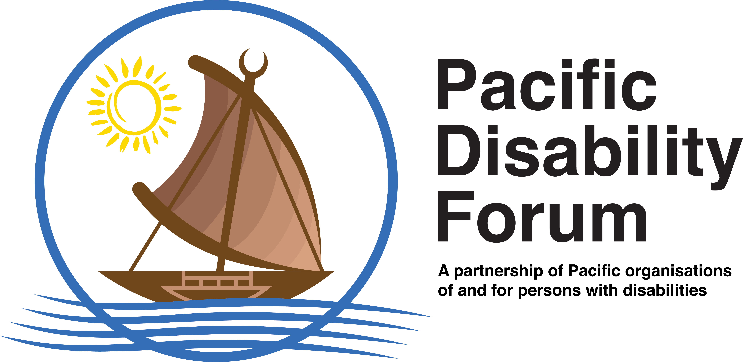
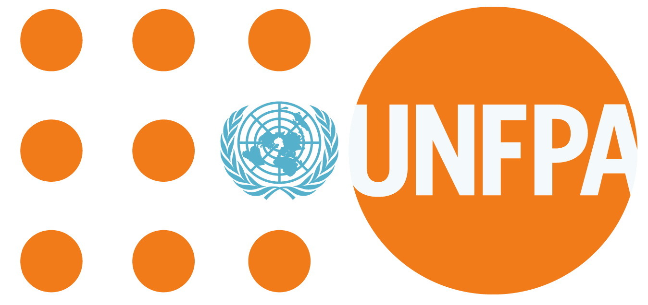
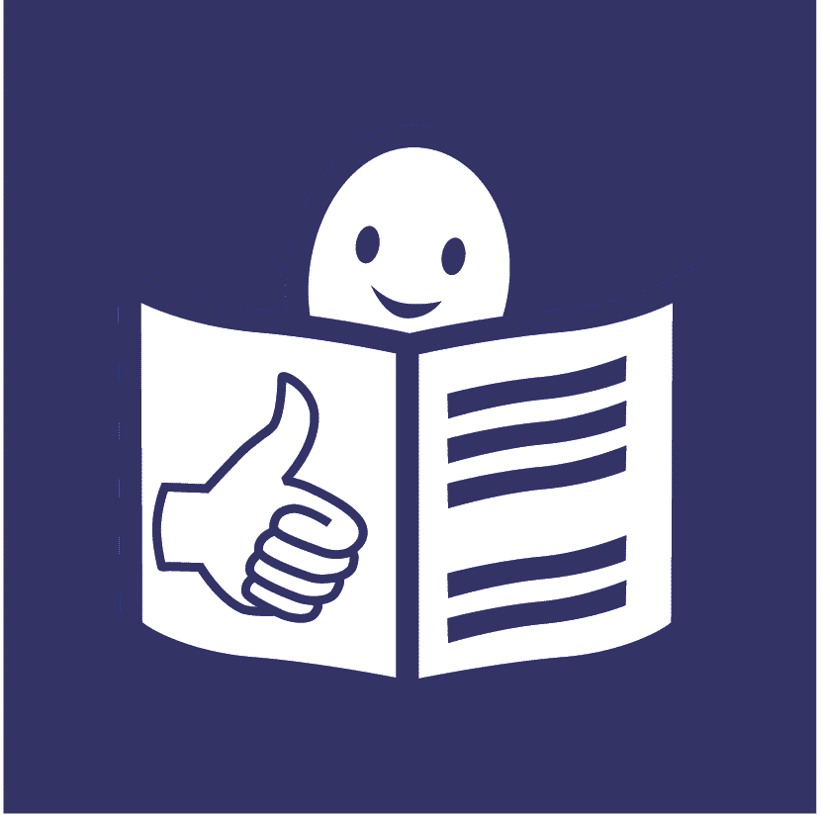

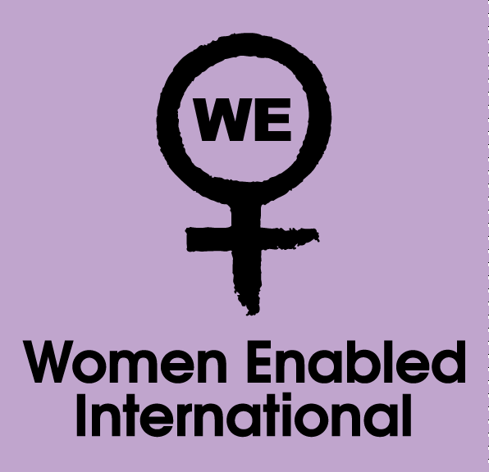
Easy to read

Information for women and girls with disabilities about your rights during Covid-19.

This is about your right to be safe from violence.
And your rights to do with your body, sex, relationships and having children.
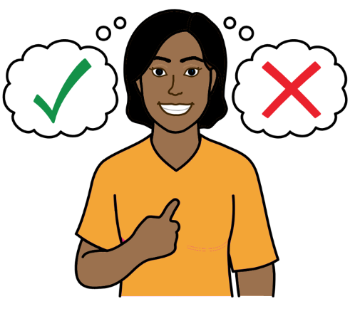

This leaflet is for people in the Pacific region of the world. Fiji, Kiribati, Samoa, Solomon Islands, Tonga and Vanuatu are some of the countries in the Pacific region.

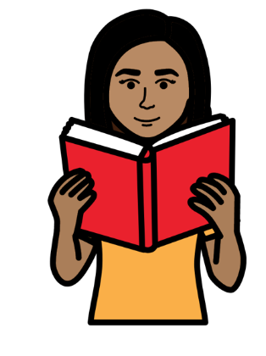
What is in this leaflet

Page

About this leaflet 3

- Your right to be safe from violence 5

- Your rights to do with your body, sex, 7 relationships and having children

- Some other rights that you have 9

Important documents about your rights 12

Some places to get support and 14 information from

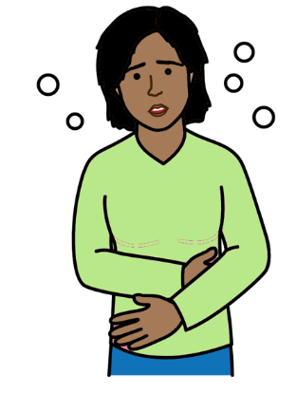
About this leaflet

This leaflet is about your rights during Covid-19.

Covid-19 is an illness that many people in the world have been getting.

This leaflet is about your rights to:

- Be safe from violence

- Make your own choices about your body, sex, relationships and having children

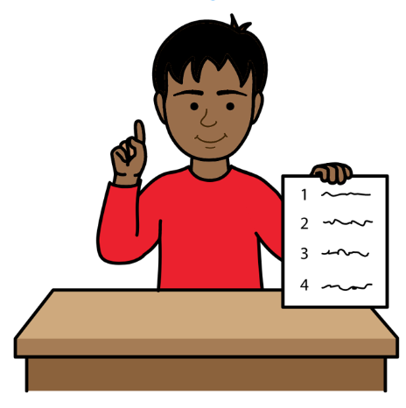

Rights are things that everyone has.

For example, everyone has the right to be safe and treated fairly.

This leaflet is about your rights and what should happen to you.

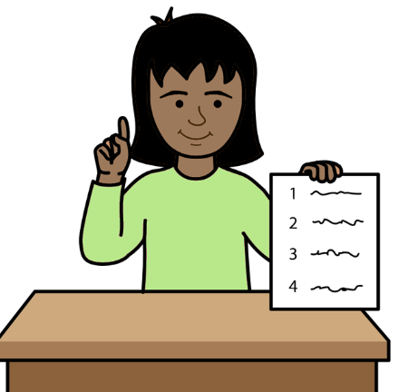
You still have the same rights during Covid-19.

They have not changed.

Your government should be working to make sure that you get your rights.

There are some important documents about your rights.

You can find out about them on page 12.

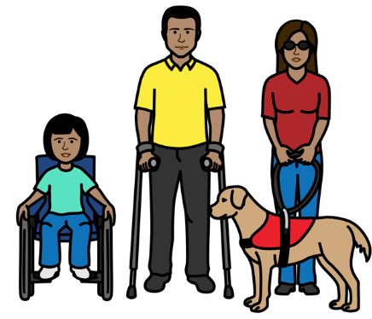

This leaflet is for women and girls with disabilities.

That also means people with disabilities who are not the gender that people say they are.

Gender is about being a woman, a girl, a man, a boy or someone else.

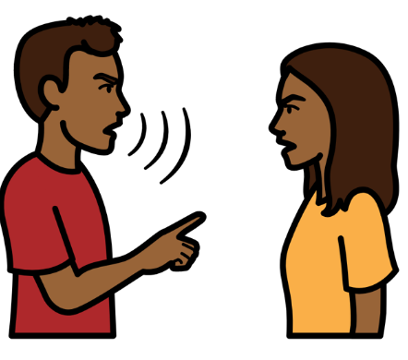
For example, someone might be told they are a boy. But they are not a boy. They are a girl or another gender. Your right to be safe from violence

Violence is when people might hurt you or do bad things to you.

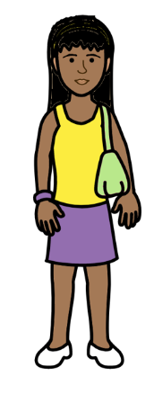

Violence could be many things like:
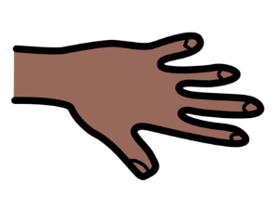

- Someone hurting your body

- Someone forcing you to have sex or do sexual things
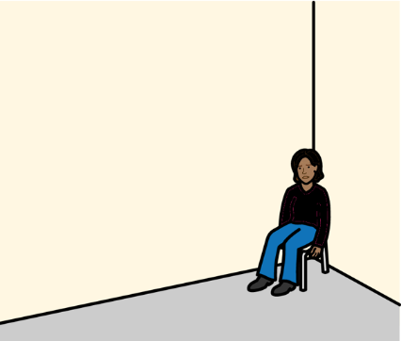

- Someone stopping you from getting the things you need.
Like support, food, medicine, money or wheelchairs

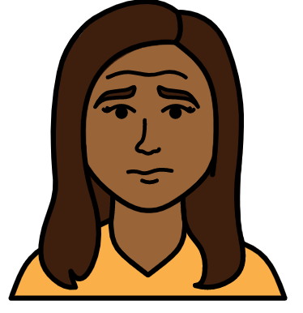

The violence we talk about in this leaflet is called gender-based violence.

It can happen to anyone.

But it usually happens to women and girls.
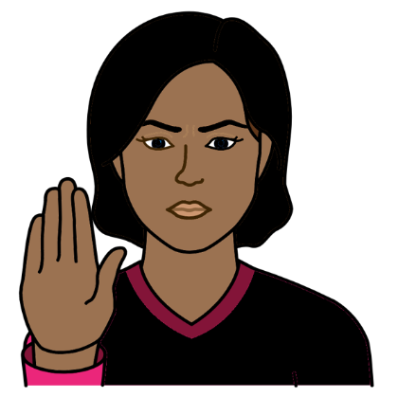
What are your rights?

You have the right to be safe from violence.

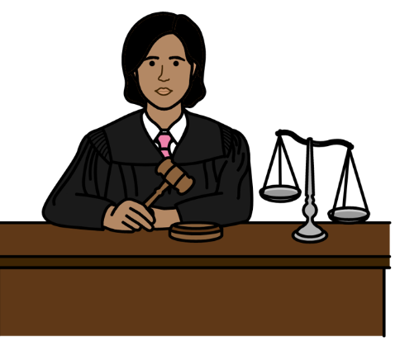

The government of your country must work to stop violence.

There should be laws to help stop violence happening.

The police and courts should punish people who are violent.

You should get the right support if violence happens to you.
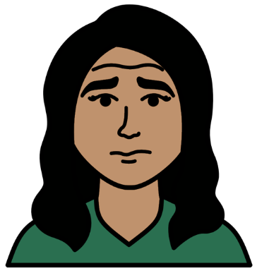
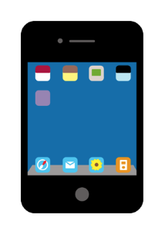
That might include:

- Support from the police and courts

- Someone to talk to about how you feel

- A safe place to go or a phone number to get help

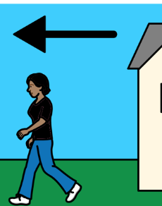
You can leave home to be safe from violence and get help.

You can do that even if the government says that people must stay at home because of Covid-19.

- Your rights to do with your body, sex, relationships and having children

You have the right to make your own choices about:
- Your body
- Sex and relationships
- Your health
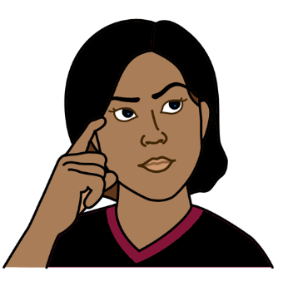
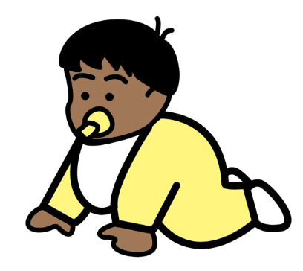
- Having children

This means you can choose for yourself if you want sex, relationships, health care or children.

Other people should not choose for you.
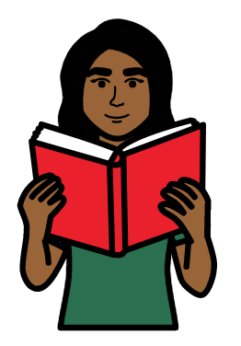
You should get all the information and support you need to make your own choices.

For example, you might want information about having sex or children.

Or you might want support or health care to stop you getting pregnant.

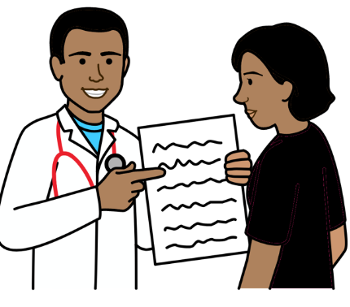

The information and support you get should be good.

It should be easy for you to get and use.

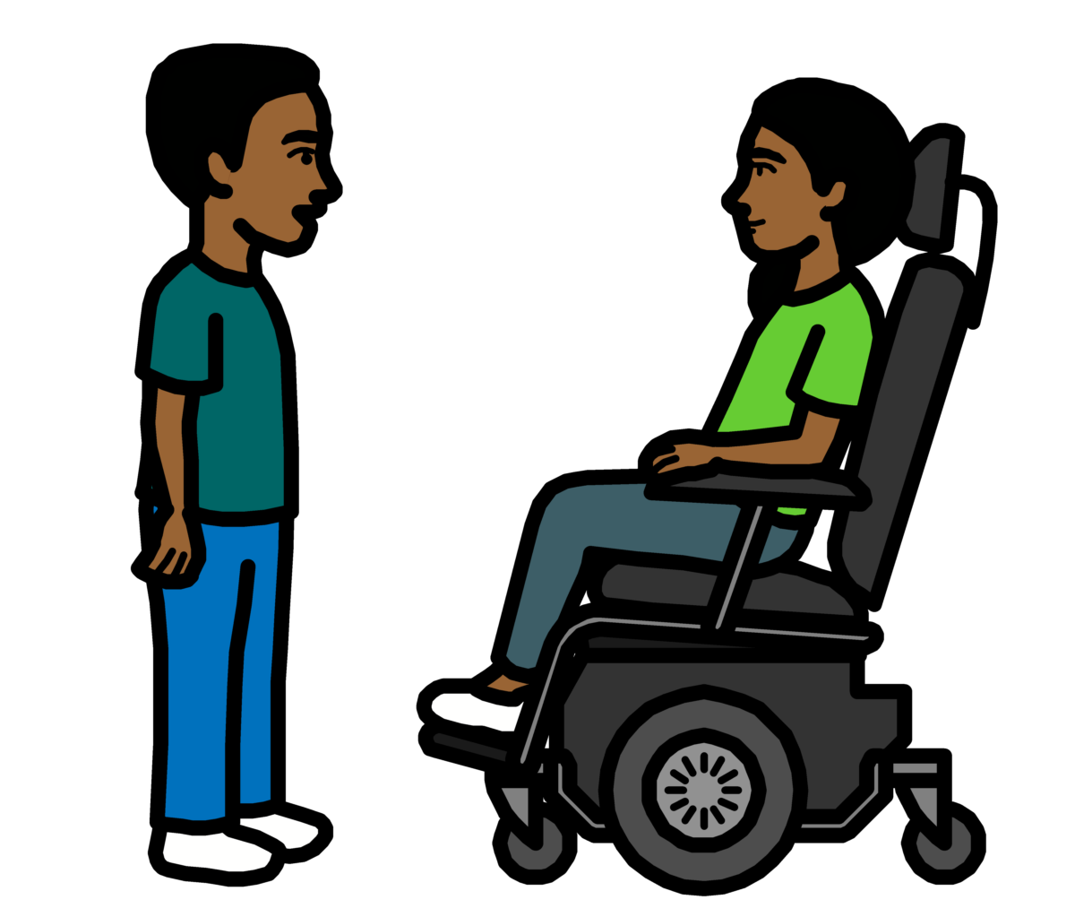
- Some other rights that you have

You have the right to be treated fairly.

You should not be treated worse than other people.

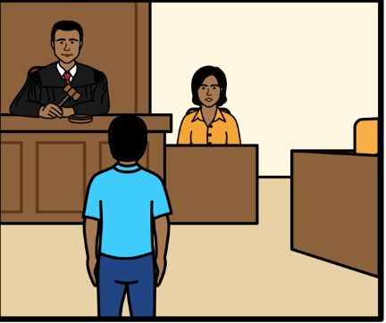

You have the right to get support from the police and courts if someone hurts you or tries to stop you getting your rights.

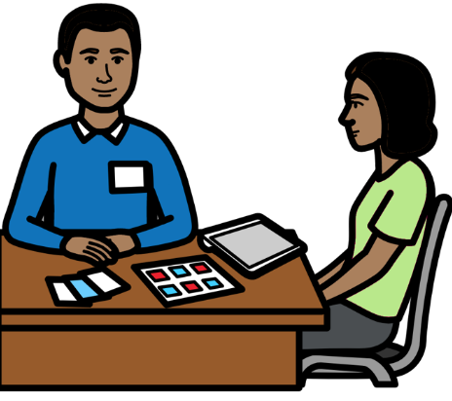

You might need support to do things because of your disability.

The support should be easy for you to get and use.

For example, you should get information in a way that is easy for you to understand.

That might be information in large writing, sign language or easy words if you need it.

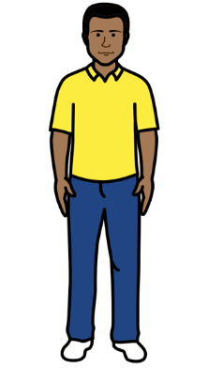
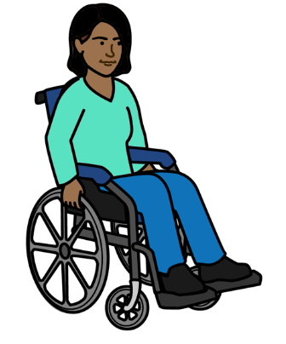
You should get the support you need for your disability.

For example, you can take a support person with you to the doctor or the hospital if you need to.

You can do this even if the rules say you have to go on your own.
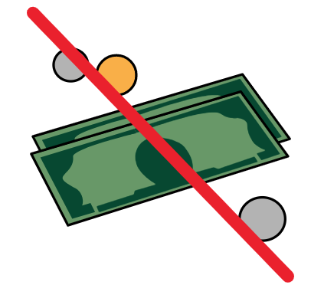

The support you get should be free.

Or it should not cost too much.

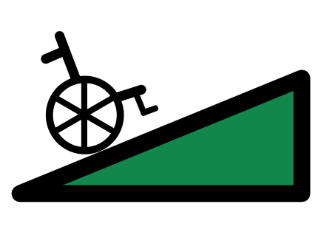
Health and support services should be easy for people with disabilities to use.

For example, health places should have ramps or lifts for people who find it hard to move around.

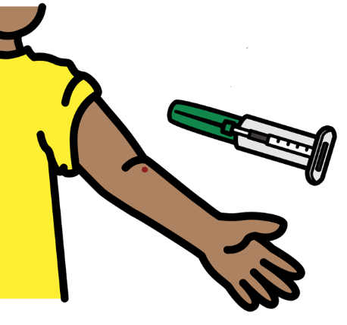

You have a right to health.

That means you should get the health care you need.

That includes health care and vaccines for Covid-19.

And health care to do with your body, sex and having children.

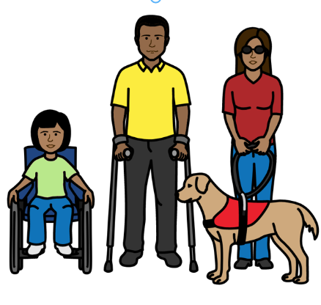
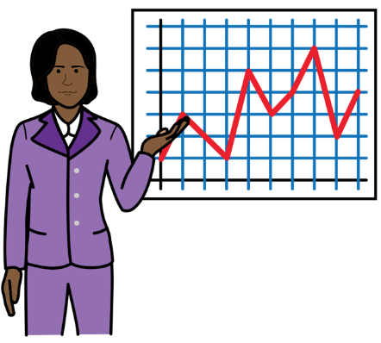

Health and support staff should get training about people with disabilities.

Important documents about your rights

This leaflet is about some important rights that you have.

The rights come from some documents that countries made together.

It might help you to know about 2 important documents.

- There is a document about the rights of people with disabilities in the world.

It is called the Convention on the Rights of Persons with Disabilities. Or CRPD for short.

- There is a document about the rights of all women in the world.
It is called the Convention on the Elimination of All Forms of Discrimination Against Women.
Or CEDAW for short.

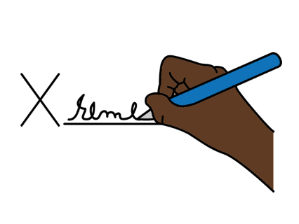
Many countries have promised to do what both documents say.

That includes:

- Federated States of Micronesia
- Fiji
- Kiribati
- Marshall Islands
- Samoa
- Vanuatu

Solomon Islands has promised to follow the document about treating women fairly.

Solomon Islands has not promised to follow the document about the rights of people with disabilities yet.

But the government said that it will follow the document in the future.

Tonga has not promised to follow either of the documents yet.

Some places to get support and information from

Fiji

  - An organization that supports the rights of people with disabilities. It is called Fiji Disabled People’s Federation (FDPF):
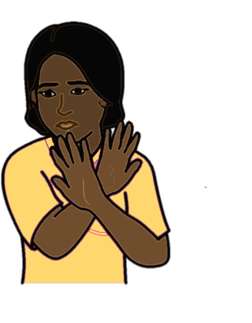
Call 331-1203

  - Support for women and girls if someone has been violent to them. It is called Women’s Crisis Center:

Call: 1560. This is a free number. It is open all day and night.

- An organization to support people with their health rights.
It is called the Reproductive and Family Health Association Fiji:
Call: 3306-175

Kiribati

- An organization that supports the rights of people with disabilities. It is called Te Toa Matoa:
Call: 73046331

- Support for women and girls if someone has been violent to them. It is called Kiribati Women and Children Support Center:
Call: 191, 75021000

Samoa

- An organization that supports the rights of people with disabilities.
It is called Nuanua O Le Alofa
(NOLA):
Call: 21147

- An organization to support people if violence happens to them. It is called Samoa Victim Support Group.

Call: 800-7874. This is a free number. It is open all day and night.

- An organization for mental health support. It is called Faataua le Ola:

Call: 800-5433. This is a free number. It is open all day and night.

- An organization to support people with their health rights. It is called Samoa Family Health Association:
Call: 685 26929
Solomon Islands

- An organization that supports the rights of people with disabilities.
It is called People with Disabilities Solomon Islands:
Call: 25608

- A number for people to call if someone that they know is violent to them.
Call: 26999 From 8am to 4:30pm

Call 20619 from 4:30pm to 8am
including weekends and
public holidays.

Tonga

- An organization that supports the rights of people with disabilities.
It is called Nuanau O’ E’ Alamaite, Tonga Association:
Call 772 9007

- Support for women and children if someone is violent to them or hurts them. It is called the Women and Children’s Crisis Centre.

Call: 22240. This number is open all day and night.

Vanuatu

- An organization that supports the rights of people with disabilities. It is called Vanuatu Disability Promotion and Advocacy Association:

Call 37997

- A number to call if someone you know has been violent to you. It is called the Women’s Centre Helpline:

Call 24000

There is also a document about what your support should be like.

It is on this website:

https://www.unfpa.org/sites/default/files/resource-pdf/English-PDF-v2.pdf

Pictures by The Picture Communication Symbols ©1981–2016 by Mayer-Johnson LLC a Tobii Dynavox company. All Rights Reserved Worldwide. Thousands of resources available for free at www.boardmakeronline.com.

