Humanitarian Action in the Pacific

“Towards Strengthening Local Action in the Pacific”

Pacific Resilience Partnership (PRP)
Technical Working Group on Localisation
March 2021

Cover Image: Fallen coconut trees. The aftermath of TC Harold on the Island of Vanua Levu.
Source: Viliame Cativakalakeba

Inside cover image: On the Island of Nauru.
Source: Pacific Island Forum Secretariat

......
,·· ......, ,:,I
' : ' 1-1........... ,..._

OCHA
.fi'm' . K oacif ic .'\8 FEDERA1'10:W

Paeir..:
D..,abl1L1T
Forul>l
S)IPPF::r-
@Pt.A.NGO ♦CIFAC
..
ffJr
HUMANITARIAN
ADVISORY GROUP
Uabilat
for Humulty"

4

Table of Contents

Overview 6
Executive Summary 6
Acknowledgement 8
Background 10
Introduction 11
Findings 12
Section A: Participants to the mapping survey 12
Section B: Organisational Systems and Capacity 15
Section C: Impact of COVID-19 20
Overview of challenges and opportunities for localisation 22
Section D: List of key findings 23
Overall, all actors 23
National organisations only 23
Impact of COVID-19 24
Conclusion 25
Discussion and Conclusion 25
Recommendations 26
Annexes 28
Annex 1 : Four thematic areas for Localisation Mapping survey 28
Annex 2 : Survey Questionnaire 30
Annex 3 : List of previous work and web links to reports 36

Humanitarian Action in the Pacific

5

Acronyms

CSO | Civil Society Organisations
DRR | Disaster Risk Reduction
FDPF | Fiji Disabled People’s Federation
FRDP | Framework for Resilient Development in the Pacific
HAG | Humanitarian Action Group
NGO | Non-Governmental Organisation
PIANGO | Pacific Islands Association of Non-Governmental Organisations
PRP | Pacific Resilience Partnership
TWG | Technical Working Group
WASH | Water, Sanitation and Hygiene
UN | United Nations
INGO | International Non-Government Organization
RNGO | Regional Non-Government Organization
PIFS | Pacific Islands Forum Secretariat
TA | Technical Assistance
EOC | Emergency Operations Centres
WHS | World Humanitarian Summit

Towards Strengthening Local Action in the Pacific

6

Executive Summary
The PRP in endorsing this mapping activity is committed to contribute evidence to uphold accountability to the commitments made at the Grand Bargain in Istanbul, May 2016 during the World Humanitarian Summit (WHS). This initiative builds on other essential work around localisation in the Pacific such as: Pacific regional consultation prior to the WHS, Pacific Resilience Partnership Meetings (PRP) and the Pacific Resilience Meeting 2019 (PRM).

This report also links to realising the Framework of the Resilient Development in the Pacific (FRDP) an integrated approach to addressing climate change and disaster risk management in the Pacific, specifically on goal 3 on ‘strengthened disaster preparedness, response and recovery’. The FRDP provides high level strategic guidance to different stakeholder groups on how to enhance resilience to climate change and disasters, in ways that contribute to and are embedded in a sustainable development lens.

This report places local non-government actors at both regional and national levels at the center of the localisation discourse in the region. In doing so, it recognises the pivotal, and complementary role NGO’s play to government and the distinct strength of humanitarian work currently in the Pacific.

The survey findings are presented in the following pages over four different sections.
- Section A: Covers WHO participated in the survey, which countries are represented and WHERE work is subsequently conducted. It also covers specific areas of work and outlines target beneficiaries. All actors covered in this section comprise national, regional and international organisations, including UN agencies.
- Section B: This section primarily focuses on national actors at the country level. It outlines existing systems, current capacity in the sector, familiarity with DRR and relevant policies, actor engagement in varying coordination mechanisms and current funding sources.
- Section C: Presents the impact of the COVID-19 pandemic on the NGO sector in the Pacific and other challenges identified in the survey.
- Section D: Presents a list of some key findings.

This survey was conducted over the period of July 20-31, 2020. During this period, 123 responses were received from nineteen (19) Pacific Island Countries and Territories. A number of responses were also received from Australia and New Zealand. Over 50% of survey responses received were from national organisations as illustrated in figure 1 below. Additionally, a large number of responses were received from INGO’s, and regional organisations at 31% and 13%, respectively. UN agencies also participated in this survey.

The following recommendations reflect the key priorities as identified by the respondents.

- Capacity development in specific areas such as gender, project management, financial management,
monitoring and evaluation and compliance.
- Support to strengthen organisational structures governance structures, risk management and compliance
mechanisms and capacity built to maintain these.
- Strategies to enable flexible and simplified funding mechanisms that are easily accessible to local actors.
- Support to maintain and strengthen shared ownerships with beneficiaries at community level.
- Ensure that the local actors particularly the NGO community are well represented in regional and national level coordination mechanisms.
- Local actors both at regional and national level continue to be meaningfully engaged and consulted on the development and review of relevant policies, frameworks, and legislation related to humanitarian action, disaster risk reduction and climate change.

Humanitarian Action in the Pacific

7

According to the survey, whilst much work has been accomplished in the region, much more remains to be done. This first initiative and report underpins the commitment of the PRP to progress localisation in the Pacific. It is only the beginning of a series of undertakings to strengthen humanitarian work amongst local actors in the Pacific.

We thank you for the global commitments that have been made and value the support of our partners and donors. Thank you for the work that has been progressed thus far and hope that you will stay the journey with us.

The Pacific Resilience Partnership Technical Working Group on Localisation is co - chaired by the Pacific Islands Association of NGOs (PIANGO), femLINKpacific and Fiji Disabled Peoples Federation (FDPF).

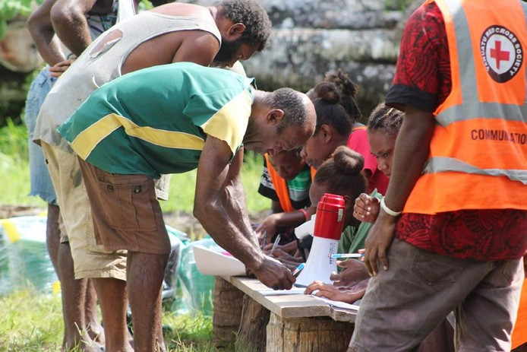
Local Volunteers Sign up for TC Harold relief efforts in Vanuatu.
Source: Vanuatu Red Cross

Towards Strengthening Local Action in the Pacific

8

Acknowledgement
The Pacific Islands Association of NGOs (PIANGO), femLINKpacific and Fiji Disabled Peoples Federation (FDPF) as co-chairs of the Pacific Resilience Partnership (PRP) Localisation Technical Working Group would like to acknowledge and thank the support provided by the following agencies which has enable the PRP Localisation Technical Working Group to produce this report.

- All participants and respondents to the survey
- Pacific Resilience Partnership Taskforce (PRP)
- Members of the PRP Localisation Technical Working Group
- Pacific Islands Association of NGOs (PIANGO)
- femLinkpacific
- Pacific Disability Forum (PDF)
- Habitat for Humanity Fiji (HFH Fiji)
- Pacific Islands Forum Secretariat (PIFS)
- International Federation of Red Cross & Red Crescent Societies (IFRC)
- International Planned Parenthood Federation (IPPF)
- United Nations Office for the Coordination of Humanitarian Affairs (UNOCHA)
- Humanitarian Advisory Group (HAG)
- Mr. Sepesa Rasili - Consultant

The Humanitarian Advisory Group provided financial and technical support to the PRP Localisation Technical Working Group in undertaking, completion of the survey and data analysis as part of the Australian Department of Foreign Affairs and Trade (DFAT) funded Humanitarian Horizons programme.

The mini–Working Group (Working Bees), under the PRP Localisation Technical Working Group has provided support in the coordination and implementation of the research; as well as final stages in write up of the report. The members of the mini-Working Group include; Mr. Sevuloni Rokomatu Ratu (IFRC), Mr. Josaia Osborne (PIANGO), Ms. Seini Bukalidi (PIANGO), Mr. Viliame Cativakalakeba (PIFS), Mr. Masimeke Latianara (HFH Fiji), Ms. Akanisi Dawainavesi (IPPF), Ms. Kelerayani Gavidi (femLINKpacific), Ms. Sina Suliano (UNOCHA), Mr. Simione Bula (PDF).

Humanitarian Action in the Pacific

Tables and Figures
9

Table 1: | Participating countries (proportion of responses). | 12
Table 2: | Work aligned to the FRDP goals: | 13
Table 3: | Specific sectors of work by organisation. | 13
Table 4:  Table 5:  Table 6: | Target beneficiaries for current work.  Top priorities amongst national actors for capacity development  support in the next 12 months.  Overall non- government sector engagement with coordination  mechanisms (All actors). | 14  17  18
Table 7: | Sources of funding accessed by different organisations. | 19
Table 8: | Ease of accessing funding by different actors. | 19
Table 9: | Other challenges identified by respondents by themes. | 22
Table 10: | Key priorities for further support | 26
Figure 1: | Responses (%) by types of organisation. | 12
Figure 2: | Organisational and leadership practices in national organisation. | 15
Figure 3:  Figure 4: | Community feedback systems national actors.  Support received in the 12months prior to survey by national  organisation. | 15  16
Figure 5: | Capacity received was relevant and appropriate. | 16
Figure 6: | National actors’ familiarity with relevant policies. | 17
Figure 7: | National actors’ engagement in coordination mechanisms. | 18
Figure 8: | Sources of funding. | 19
Figure 9: | National actors only Level of impact from COVID-19. | 20
Figure 10:  Figure 11: | Program adaptations to COVID-19 national actors.  Perspectives of national actors on the impact of COVID-19 pandemic on localisation discourses. | 20  21
Figure 12: | National actors- working in a different way to adapt to COVID-19. | 21

Towards Strengthening Local Action in the Pacific

10

Background
The renewed focus on the localisation agenda has resulted in a number of developments in the Pacific such as the Auckland Summit and research piece ‘Going Local - Localisation of Humanitarian Action in the Pacific.’ These events were aimed at operationalising Grand Bargain goals 2 and 6.
The cornerstone of the localisation vision is “as local as possible, as international as necessary”. This principal, widely adopted by the international humanitarian community, at its core, acknowledges country led leadership and capacity at country level.
In the region, Pacific Forum Leaders in endorsing the Pohnpei Statement on “Strengthening Pacific Resilience to Climate Change and Disaster Risk Reduction’’, have declared their commitment and support to this effort. In addition to this, Forum Leaders endorsed the Framework for Resilient Development in the Pacific (FRDP) that provides the framework for integrated approaches to climate change and Disaster risk reduction. Through this, the localisation agenda has an international frame and regional endorsement to a concerted effort in strengthening national and local capacity with a view to timely, effective country-led humanitarian responses.
Furthermore, the Pacific Resilience Partnership (PRP) established under the FRDP, provides the platform for engagement and implementation of the goals set out in the FRDP. Through the PRP a number of technical working groups (TWG) were formed to progress resilient development and the goals of the FRDP in the Pacific.
The Technical Working Group (TWG) on localisation was established in January 2020 to explore and progress localisation objectives in the context of resilient development. It provides a platform to progress the localisation agenda by bringing together a range of local, regional, and international actors whose work complements one another during any humanitarian emergency.
Co-chaired by PIANGO, femLINKpacific Media Initiatives for Women and the Fiji Disabled People’s Federation with membership/partners comprising local, regional and international organisations that are working in the humanitarian and development space across the region. This localisation mapping survey is an initiative of the TWG on Localisation.

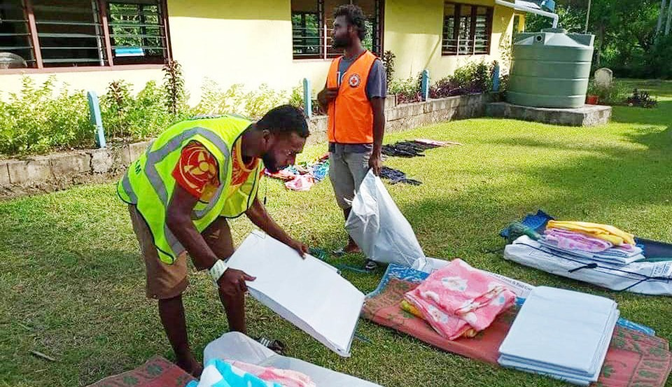
Vanuatu Red Cross volunteers from Malampa Branch assisting with relief items.
Source: Vanuatu Red Cross

Humanitarian Action in the Pacific

The survey

Introduction

The goal of the Localisation mapping survey is to identify Who is doing What in the region, document the support mechanisms in place and use this information to develop a plan to strengthen and build on the current work. As well, with the COVID-19 pandemic, the secondary objective of the survey was to map program adaptations amongst local actors to ascertain the pandemic’s impact on humanitarian activities at country level. It focuses on four thematic areas: Local country Capacity; Leadership, Partnership, and existing Funding.
11

The specific objectives of the mapping survey are to:
- Provide an overview of the strengths and existing initiatives.
- Identify areas to strengthen the implementation of the FRDP.
- Promote south-south collaboration among actors in sharing of good practices to support inclusive and accessible humanitarian action for all Pacific people.

Implications of the survey
Findings from the survey are anticipated to inform the PRP on existing strengths and strategic areas for capacity development. In the longer term, findings will also be disseminated to countries to encourage and promote collaboration, shared learnings and establish communities for sharing good practices that harness traditional knowledge and builds on local expertise. These will support strategies to mitigate longer term risks and provide, timely humanitarian responses that are locally led.

Method
- Self-administered Questionnaire: A self-administered questionnaire (Annex 2) was developed for the survey. It contained twenty-five (25) multiple choice and several open-ended questions. The mapping was conducted via the online platform Survey Monkey.
- Data analysis: A descriptive data analysis was conducted from the results and some thematic analysis is also included in the results section.
- Informed consent was sought and received from all respondents and participants to the survey.

Towards Strengthening Local Action in the Pacific

12

Findings

Section A: Participants to the mapping survey.
This section includes responses from all actors, national, regional, and international, to provide an overview of
the different scope and levels of operations provided in the Pacific region.

Figure 1: Responses (%) by types of organisation
31%
National or local organisation or network
56%
International organisation or network
13%
Regional organisation

Table 1: Participating countries (proportion of responses).

Polynesia | Micronesia | Melanesia | Greater Oceania
American Samoa (0) | Palau (12%) | Solomon Islands (16%) | Australia (10%)
Tonga (8%) | Nauru (4%) | Fiji (38%) | New Zealand (8%)
Samoa (4%) | Federated States of Micronesia (4%) | Vanuatu (16%)
Cook Islands (6%) | Republic of Marshall Islands  (12%) | New Caledonia (2%)
Tuvalu (4%) | Guam (4%) | Papua New Guinea (8%)
French Polynesia (2%) | Kiribati (10%)
Niue (2%) | Commonwealth of Northern Marianas (4%)
Majority of the responses came from Fiji and Solomon Islands as indicated in the above table (This is due to the large presence of organisations based in these countries).

Humanitarian Action in the Pacific

Current areas of work by all non-government actors in the Pacific.

Respondents were requested to outline the specific areas of work that their organisations were delivering. This was to assess alignment to the three mandates of the Framework for Resilient Development in the Pacific 1(FRDP). The FRDP goals are as follows:

- FRDP Goal 1: Strengthened integrated adaptation and risk reduction to enhance resilience to climate change and disasters.
- FRDP Goal 2: Low-carbon development.
- FRDP Goal 3: Strengthened disaster preparedness, response and recovery.

Table 2: Work aligned to the FRDP goals:

Actor | FRDP Goal 1 | FRDP Goal 2 | FRDP Goal 3
NGO | 31 | 5 | 35
RNGO | 8 | 3 | 8
INGO & UN Agencies | 24 | 5 | 21
Total | 63 | 13 | 64
The data indicates that national and international actors focused more on the FRDP goals 1 and 3.

Further, Table 3 below outlines specific areas of work currently being delivered in the Pacific by all non-
government actors.

Table 3: Specific sectors of work by organisation.

Sector | NGO | RNGO | INGO & UN Agencies | Total
Disaster Risk Reduction, preparedness and response | 32 | 8 | 22 | 62
Climate Change | 25 | 8 | 21 | 54
Advocacy and policy development | 25 | 9 | 19 | 53
Gender | 27 | 5 | 18 | 50
Health | 28 | 4 | 15 | 47
Coordination | 24 | 5 | 15 | 44
Education | 26 | 5 | 10 | 41
Food Security | 24 | 4 | 12 | 40
Disability | 21 | 3 | 15 | 39
Communication | 22 | 5 | 11 | 38
WASH | 18 | 3 | 17 | 38
Environment | 20 | 5 | 12 | 37
Child Protection | 21 | 3 | 11 | 35
Shelter | 14 | 1 | 14 | 29
Human mobility | 11 | 5 | 9 | 25

1 The Framework for Resilient Development in the Pacific (FRDP) – Forum Sec
13

Towards Strengthening Local Action in the Pacific

14

Table 4: Target beneficiaries for current work

Target groups | NGO | RNGO | INGO | Total
Rural communities | 35 | 6 | 20 | 61
Women | 35 | 6 | 17 | 58
Government agencies | 25 | 10 | 19 | 54
Youth | 33 | 6 | 12 | 51
Civil society groups | 26 | 7 | 16 | 49
Persons with disabilities | 29 | 5 | 13 | 47
Urban communities | 25 | 5 | 15 | 45
Informal settlement communities | 25 | 6 | 14 | 45
Children | 31 | 4 | 8 | 43
Elderly | 26 | 6 | 8 | 40
Peri urban communities | 22 | 5 | 11 | 38
Lesbian Gay Bisexual Transgender  Intersex Queer (LGBTIQ) | 20 | 5 | 9 | 34
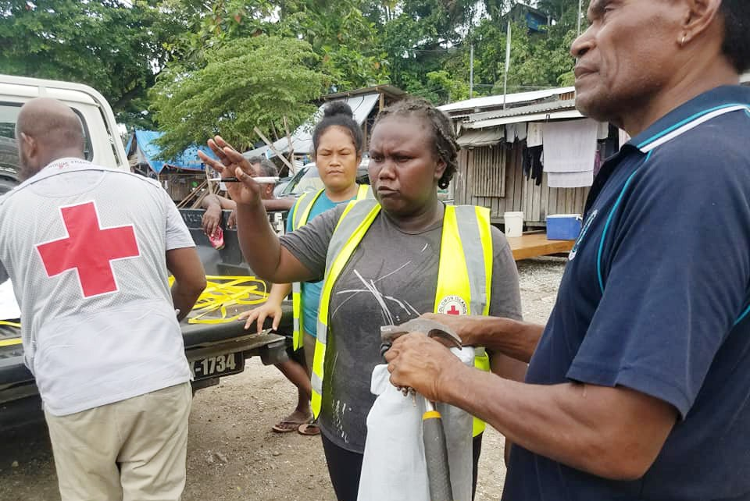
Survey findings indicate the varying degrees of engagement on the ground by organisations. For instance, five top areas of work for NGO were: rural communities, women, youth, children and working with persons with a disability. On the other end of the spectrum, whilst INGO’s & UN agencies tended to focus primarily on working with governments, there is still an even spread on other target groups. Whether this indicates active engagement or other forms of support is not clear from this data.
Solomon Island TC Harold relief workers
Source: Solomon Islands Red Cross

Humanitarian Action in the Pacific

15

Section B: Organisational Systems and Capacity
This section focuses primarily on responses from national actors only to provide in detail the scope of work, existing capacity and to highlight some areas for support. Respondents were also requested to share their perspectives on select organisational practices such as leadership characteristics to provide an indication of inclusion in decision making ownership of programs and good governance practices.
- Approximately 50 responses from national actors were analysed to inform these results.
- 74% (n-37) respondents stated their organisations had a strategic plan with a clear vision, missions
and goals to guide their work.

Figure 2: Organisational and leadership practices in national organisations.
4.5
4.4
4.3
4.2
4.1
4
3.9
3.8
3.7
Please rate the leadership characteristics in your organisation:
Organisation is inclusive
Organisation is accountable and transparent to stakeholders and beneficiaries
Organisation has shared ownership with beneficiaries
Organisation has good governance practices
Weighted Average
3.97
4.19
4.38
4.42
- 72% (n-36) responses were received for this question
- In general, majority of the responses agreed that leadership in their organisations were inclusive,accountable and transparent
and had good governance practices in place.

Community feedback.

Figure 3: Community feedback systems national actors.
Q.22: What community feedback or engagement mechanisms does your organisation use?
Suggestion boxes
Hotlines
Community meetings
Household or community National complaints
visits
or feedback mechanism
Other (please specify)
8.11%
13.51%

21.62%

27.03%

70.27%

81.08%
- 74% (n-37) respondents stated having some form of feedback mechanisms in place with more being at the community level
engagement.

Towards Strengthening Local Action in the Pacific

16

Existing capacity

Figure 4: Support received in the 12months prior to survey by national organisations.
70.00%

60.00%
Q.16: What are the main areas your organisation has received capacity support in for the last 12 months?
50.00%

40.00%

30.00%

20.00%

10.00%
0.00%
Technical support on
programming (gender, WASH, management
Project
Financial management
Training Compliance and Organisational
Other
shelter, child protection ect.)
due dilligence policy and process (please specify) development

16.67%

33.33%

36.11%

36.11%

41.67%

44.44%

61.11%
- In the previous 12 months, significant support has been received in the areas of organisational policy and process development
(61%), TA on gender, WASH, shelter and child protection (42%).

Figure 5: Capacity received was relevant and appropriate.
Support received in the last 12 months have been relevant and appropriate

2.70%
16.22%
35.14%
Not at all
Somewhat
Completely
Not applicable
45.95%
- 74% of national actors responded to this question. Of these, 46% agreed that capacity support received in the previous 12
months were completely relevant and appropriate.

Humanitarian Action in the Pacific

17

Further analysis amongst national organisations were conducted to highlight the priority areas where capacity
development support was needed. This is illustrated in the table below.

Table 5: Top priorities amongst national actors for capacity development support in the next 12 months.

Top 3 priorities for capacity support for your organisation sought (National actors only) | Percentage | Number
Project management | 49% | 18
Financial management | 54% | 20
Training* | 68% | 25
Compliance and due diligence | 65% | 24
Organisational policy and process development | 68% | 25
Technical support on programming (e.g., gender, WASH, child protection) | 57% | 21
Other (please specify) | 14% | 5
*Training non-specific.
37 responses were received to this question. Of these, training (nonspecific) and organisational policy and process development were identified as a priority at 68% each. This will need to be unpacked further. Financial and project management were also identified as important.

Familiarity with National Humanitarian, DRR and Climate Change policies. Figure 6: National actors’ familiarity with relevant policies.
Q.26: How familiar is your organisation with any of the following policies in the countries in which you work?
50.00%
45.00%
40.00%
35.00%
30.00%
25.00%
20.00%
15.00%
10.00%
5.00%
0.00%
45.45%
35.29%
36.36%
47.06%
36.36%
21.21%
18.18%
17.65%
6.06%
Humanitarian policies Disaster Risk Reduction policies Climate Change policies

36.36%
- 34 respondents answered this question.
- Responses ranged from 47% - 6% with familiarity on DRR policies being higher. Data denotes that a significant proportion of
national actors are not familiar with Humanitarian and Climate Change policies.

Towards Strengthening Local Action in the Pacific

18

Table 6: Overall non-government sector engagement with coordination mechanisms (All actors)

Engagement in Coordination mechanism | NGO | RNGO | INT.
National coordination mechanisms (e.g., Government, NDMOs, committees, clusters or working groups etc.) | 31 | 5 | 16
Regional coordination mechanisms (e.g., Pacific Humanitarian Team, PIEMA, regional  intergovernmental etc.) | 16 | 8 | 16
International coordination mechanisms or meetings (international humanitarian fora,  global summit, global meetings, global clusters etc.) | 12 | 7 | 17
Other (please specify) | 4 | 1 | 3
- The table above presents response across the 3 levels to provide a comparison of engagement at the various coordination mechanisms in the Pacific.
- Results indicate an even level of engagement across different levels by national actors.

Figure 7: National actors’ engagement in coordination mechanisms.
Q.19: Engagement of national actors in coordination mechanisms
91.18%
47.06%
35.29%
11.76%
National coordination Regional coordination mechanisms mechanisms (e.g, clusters or meetings (e.g, Pacific
or working groups) Humanitarian Team or PIEMA)
International coordination mechanisms or meetings (international humanitarian forums, global clusters ect.)
Other (please specify)
- 68% (n-34) responses were received.
- Results indicate significant engagement in national coordination mechanisms by National actors 91% (n-31).

Humanitarian Action in the Pacific

19

Access to funding support.
Respondents were requested to share sources of funding and the ease with which this support was accessed. For comparison across the different levels from national to international, is reflected on the Table 7 summary below.

Table 7: Sources of funding accessed by different organisations.

Funding sources | 0 | 1-2 sources | 3-4 sources | > 5
Actor
NGO | 1 | 17 | 7 | 11
RNGO | - | 3 | 1 | 4
INGO | - | 2 | 6 | 15
- 47% (n-17) of national actors receive 1-2 sources of funding with the same number accessing at least 3 sources or more.
- only 1 NGO denoting access to no source of funds.

Figure 8: Sources of funding.
Q.24: Which funding sources does your organisation have acess to (select all that apply)?
68.57%
57.14%
48.57%
22.86%
National funding
Regional funding
International funding
Other (please specify)
- 70% of national actors responded and shared source of funding to their programs.
- A large proportion of funding support received currently were from national and international sources.

Table 8: Ease of accessing funding by the different actors.

Ease of access to funding | Very difficult | Not easy | Somewhat easy | Very easy
NGO | 5 | 22 | 8 | 0
RNGO | 1 | 1 | 6 | 0
INTERNATIONAL | 2 | 11 | 8 | 2
- Table 8 above outlines that national actors found it challenging to access funding to support their work on the ground.

Towards Strengthening Local Action in the Pacific

20

Section C: Impact of COVID-19 on organisation operation
The survey also contained a section to ascertain information on the impact of the COVID-19 pandemic. The
results include national actors only unless indicated specifically.
- Overall, COVID-19 impacted 58% of all respondents (all actors). (71) of the one hundred and twenty-three respondents indicated on the survey that COVID-19 has impacted their organisation in one of more than one of the areas.

Figure 9: National actors only Level of impact from COVID-19.
Somewhat
44%
Significantly
56%
• 56% of national actors were significantly impacted.

Figure 10: Program adaptations to COVID-19 national actors.
Q.11: In what ways has COVID-19 impacted your organisation
Required expanding Required or adapting existing creating new
programs programs
Pushed out program timeframes
Increased funding needs
Increased human resource needs
Reduced available Other (please
funding for existing programs
specify)
15.79%

52.63%

55.26%

55.26%

68.42%

81.58%

84.21%
- 76% (n-38) responses were received from national actors. The most impact have required national actors to expand and adapt
existing programs as well as pushing out timelines.

Humanitarian Action in the Pacific

21

Figure 11: Perspectives of national actors on the impact of COVID-19 pandemic on localisation discourses.
Q.13: Please indicate the extent to which you agree or disagree with the following statements in relation to the impacts of COVID-19
Strongly disagree
Disagree
Agree Strongly agree
70.00%

60.00%

50.00%

40.00%

30.00% 60.53%
56.76%
20.00%
45.95%
28.95%
32.43%
10.00%
13.51%
0.00%
COVID-19 will strengthen locally led There is increased funding available to There is increased remote support to response and programming because of local and national actors national actors by international
less internation presence partners
- 76% responses were received. Respondents indicate to have seen an increase in funding made available to local and national actors, an increase in remote technical support by international partners and a general consensus that the overall impact of COVID-19 will stregthen locally led responses.
- Further, across all actors national to international level, 57% (n-70) respondents indicated ways they have adapted to COVID19
with a high number of organisations working remotely mostly online (79%) to conduct meetings and workshops.

Figure 12: National actors- working in a different way to adapt to COVID-19.
How has your oranisation adapted to COVID-19?
90.00%
80.00%
70.00%
78.95%
60.00%
50.00%
40.00%
30.00%
20.00%
10.00%
0.00%
63.16%
60.53%
63.16%
36.84%
15.79%
Established new Conducted more
ways of working with international partners outside of the region such
as remote technical support
work online (meeting and workshops)
Reduced your Established new programming partnerships
due to with other less funding organisations
Increased capacity in responding to a public health emergency
Other (please specify)
- 76% (n-38) responses were received for this question. 79% stated having to conduct more work virtually esp. meetings and workshops. Partnerships, new modalities of work and increased capacity around responding to public health emergencies were highlighted.

Towards Strengthening Local Action in the Pacific

22

Overview of challenges and opportunities for localisation

National actors were then requested to share of their experiences, specific challenges and opportunities for localisation of humanitarian action in the Pacific. These open responses have been categorised under four themes and are shared below. Note that these shared below are verbatim.

Table 9: Other challenges identified by respondents by themes.

Thematic areas | Challenges & Opportunities
Capacity building/  development | More targeted and event specific preparedness and planning needs to occur at  all level esp. community level
 | Strengthen support to national/local partners – finance systems & management, proposal writing, management and reporting of donor funded programs/ projects
Funding (and resource  allocation & mobilisation) | Coverage of existing work limited to easily accessible areas only e.g., urban  due to limited funding.
 | National programs and/or countries still being determined by donor (and/or) development agencies – e.g., reporting and financial procedures
 | Donor priorities restrict partner involvement and implementation
 | Donor requirements and its associated risk
 | Reluctance of donors/development partners to support local and national NGO’s
Gender & Social inclusion | SOGIESC inclusion practices LGBTIQ (international good practices) and policies  have not been adopted (and/or adapted) by national (and local) partners
 | Accessibility (structural and policies), lack of inclusion and attitudes of humanitarian workers – people living with disability
Members of vulnerable groups/communities still cannot access services being
provided – WASH,
 | SRHR services during times of emergency – women and girls are still at risk of violence during times of emergency (at EOC)
Governance & accountable  practices | Lack of accountability of development partners:
 | inclusion and support for national partners;
structures (including financial processes) undermine efforts that support and
promote localisation
 | minimal/lack of recognition of localisation by national governments
Poor/minimal support for local/national organisations by INGO’s (localisation
lens not used)
 | Istanbul Principles – how are INGO’s staying true to recommendation from WHS
 | Lack/minimal legal framework and policies on humanitarian service provision – external policies sometimes ‘overrides’ local/national policies
Synergise international practices to speak to local practices – localisation
including engagement of community-based organisations

Humanitarian Action in the Pacific

23

Section D: List of key findings:

Overall, all actors:
- Majority of the response were from Fiji and Solomon Islands
- The data indicates that national and international actors focused more on FRDP goals 1 and 3.
- Survey finding indicate the varying degrees of engagement on the ground by organisations. For instance, five top areas of work for NGO were: rural communities, women, Youth, children and working with persons with a disability. On the other end of the spectrum, whilst INGO’S tended to focus primarily on working with governments, there is still an even spread on other target groups.

National organisations only
- 50 responses were received from national organisations.
- 74% of these respondents stated their organisations had a strategic plan with a clear vision, missions, and goals to guide their work.
- Most responses agreed that organisations were inclusive, had accountable and transparent systems in place and shared ownership with beneficiaries.
- Respondents feedback mechanisms reflect higher interactive and active engagement at community level
74%).
- Respondents indicated having received significant support in organisational policy and process development and technical support in Gender, WASH, Shelter and Child protection in the 12 months prior to the survey.
- 74% agreed that capacity support received in the previous 12 months were completely relevant and appropriate.
- More support to build capacity in organisational policy and process development, financial and project management was highlighted in the response. As well, further training (non-specific) was also a need.
- Responses ranged from 47% - 6% with familiarity on DRR policies being higher. Data denotes that a significant proportion of national actors are not familiar with Humanitarian and Climate Change policies.
- Results indicate an even level of engagement across different levels (national, regional and international platforms) of coordination mechanism by national actors.
- Results indicate significant engagement in national coordination mechanisms by National actors 91%.
- 47% (n-17) of national actors receive 1-2 sources of funding with the same number accessing at least 3
sources or more with only 1 NGO denoting access to no source of funds.
- A large proportion of funding support received were from national sources followed by international and
regional sources.
- National actors shared that accessing funding was not an easy undertaking and some found it very
difficult (n-5).

Towards Strengthening Local Action in the Pacific

24

Impact of COVID-19 on organisational operations
- Overall, across all level, 58% of respondents highlighted that their organisations were impacted by the
COVID-19 pandemic.
- 56% of the national NGO’s faced significant impact to their programs during the COVID-19 pandemic such as increased funding needs to respond, drastic adaptations to programs and reprogramming or deferring planned activities.
- Respondents indicate to have seen an increase in funding made available to local and national actors during the COVID-19 pandemic, an increase in remote technical support by international partners and a general consensus that the overall impact of COVID-19 could stregthen locally led responses.
- Additionally, seventy (70) out of one hundred and twenty-three (123) respondents indicated ways they have adapted to COVID-19 with a high number of organisations working remotely mostly online to conduct meetings and workshops. Survey finding indicate an increase in virtual platforms of communications.

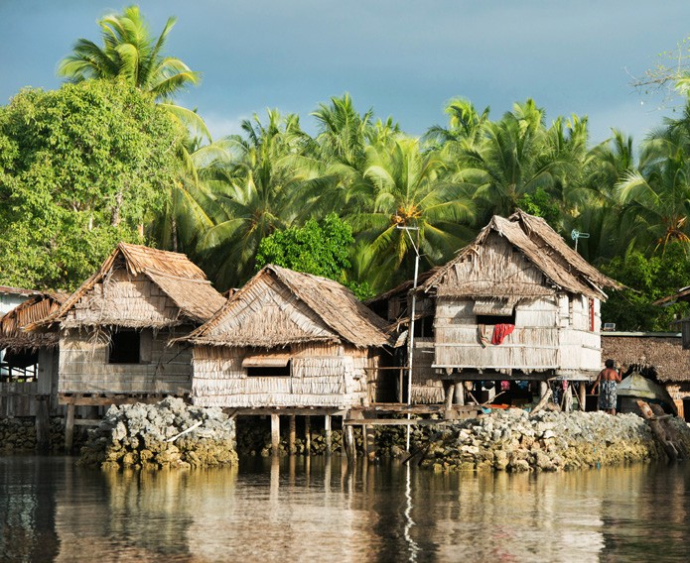
A coastal community in Solomon Islands.
Source: Pacific Island Forum Secretariat

Humanitarian Action in the Pacific

Discussions and conclusion
The mapping of local actors working in the Pacific is an initiative of the TWG on Localisation operating under the PRP umbrella. The survey set out to capture the work of NGO’s in the Pacific in particular the work of local actors. It also provided an opportunity to document, reflect upon and celebrate the ongoing work in the Pacific by NGO’s national, regional and international alike.
Nineteen pacific island countries and some territories participated in the survey. That the majority of the responses were from Fiji and Solomon Islands may be due to size and the number of NGO’s located in the two countries. These discussions will provide more emphasis to work conducted at the country level to reflect actual implementation.
Work amongst NGO’s in general focus more on strengthening resilience to climate change and disaster as well as general preparedness, response and recovery work as findings from the study reveal. DRR, Climate Change adaptations, advocacy, policy development and gender are the top four areas of work amongst NGO’s. In addition, work in the areas of gender, health, education, food security, WASH, Environment and Child Protection feature highly in the findings. The focus of work amongst NGO’s in the region correlates to donor priorities and funding availability and may therefore be donor driven as some study participants point out. At national level, these reflections are important as it links directly to shared local ownership and accountability to beneficiary communities. Subsequently, whilst participants may support the existing mandates and scope of work mentioned above, there is a prevailing sense of being excluded in shaping and influencing work priorities at country level. Local actors value and acknowledged the support of international partners and donor agencies alike. Findings from the study indicated a significant amount of technical assistance received in the year leading up to the study and local actors reflected that this support was fit for purpose. Technical support either offered remotely and or from actors present on the ground were invaluable and helped build and complement local capacity.
Active and meaningful engagement in coordination mechanisms by all actors is critical to identify synergies and enable a genuine collaborative approach to humanitarian response in the Pacific. That 91% of local actors engage across different levels of coordination is significant. Partnerships and working collaborations with government agencies, another NGO’s feature highly as well. However, translating these engagements to meaningful joint collaboration in a humanitarian response remains challenging. Linked to the above, local actors indicated their wish to further increase knowledge of related DRR policies. This will contribute to build up local actor confidence and more importantly result in increased meaningful participation that translates to tangible partnerships and collaboration during crises.
The greatest strength of local actors is that they are embedded in the rubric of local community. Study findings reflect this focus on communities strongly, as well as upon vulnerable and marginalised populations such as persons with disability. Whilst this is vital to maintain, findings also indicate that much more support is needed to expand coverage and services particularly into the remote and hard to reach communities. Resilient and prepared communities mean investing into local actors to further build upon this work, strengthen and expand coverage.
A clearly articulated mission and vision will enable local NGO’s to develop a strategic plan that is then used as a roadmap for success. Amongst national societies, 74% indicated having a strategic plan with a clear vision and mission to guide their work. Further, a majority of respondents shared of good leadership/participatory management styles, accountable and transparent governance processes in place and shared ownerships with beneficiaries. Whilst study participants have indicated the need to further strengthen capacity in institutional systems and governance structures, these findings demonstrate that local actors have the necessary structures in place to support further investment.
Despite, the above, local actors share that meeting donor criteria and accessing adequate funding remains challenging. As well, worthy to note is that a good number of actors reveal having access to more than two (2) and some more than five (5) sources of funding support at the time of the study. This is interesting and may appear contradictory to previous findings. Whether the challenge lies in access to funding per se or the inability to secure additional funding to support expansion of work in country remains unclear. Further, the majority (68%) of these funding was sourced from national level.
The COVID-19 pandemic had a dual impact on local actors in the Pacific. Although, a majority of respondents shared experiencing significant impact to their programs, there were also positive spin offs from the pandemic. Whilst local actors had to adapt existing program activities and defer workplans, there was a general consensus of strong locally led humanitarian response during this period. As well, the pandemic encouraged new modalities of work and technical collaboration such as working remotely and a general increase in the use of virtual platforms for communications. Overall, respondents unanimously shared of increased regional and international technical virtual support. How to capitalise on these moving forward will be crucial.
25

Towards Strengthening Local Action in the Pacific

26

Recommendations
According to the survey, whilst much work has been accomplished in the region, much more remains to be done. The following recommendations reflect the key priorities as identified by the respondents.

Further needs documented amongst national actors were for general capacity development support; Project Management, Financial Management, Training, Compliance, and due diligence including organisational policy and process development. As well technical support on to strengthen local expertise in select areas such as WASH, Gender was noted.

The following areas below have been highlighted by local actors for further support.

Table 10: Key priorities for further support

Training and organisational policy and process development | 68%
Compliance and due diligence | 65%
Technical support on programming selects areas; WASH, Gender, DRR | 57%
Financial Management training | 54%
Project Management training | 49%

In alignment with the focus areas of the research, the following actions are further recommended linking with
the priority areas identified above.

Capacity
To strengthen the capacity and role of local actors who are actively engaged in disaster risk reduction and climate change, low carbon development and disaster preparedness, response and recovery further support is required.

- in developing relevant organisational policies and internal processes to make local actors as strong and
effective organisation so they can continue to function and deliver their role and mandate.

- Training is required to be provided to staff, employees, and volunteers of local actors so they are equipped with the relevant knowledge and skills to be able to perform their roles and duties contributing to the mandate of their organisation.

- Orientation, training, induction, and close coordination between international, regional, and national actors in relevant international and regional regulations, rules, procedures, agreements, frameworks and conventions so local actors can comply with these standards when accessing international and regional support mechanism that will contribute to due diligence practises amongst actors.

- Ongoing technical support is required in programming related to disaster risk reduction and climate change, low carbon development, disaster preparedness, response, and recovery to ensure local actors continue to work actively to deliver programs and services including humanitarian preparedness, response and recovery during disasters.

Humanitarian Action in the Pacific

Leadership
On the organisational and leadership practises in national organisations, 4.42% (highest) indicated that their organisation is accountable and transparent to stakeholders and beneficiaries followed by 4.38% indicating that their organisation has an inclusive approach which indicates that in general, majority of the organisation agreed that leadership is their organisations were inclusive, organisation is accountable and transparent and have good governance practises. However, to build on this good leadership and practises that exists, ongoing support is required in the following areas.
- Ensuring that organisations working in the areas of disaster risk reduction, low carbon development and disaster preparedness, response and recovery have shared ownership with their beneficiaries in terms of their programs and services.

- Support organisations to develop, review and have relevant policies, rules and procedures in place that will further enhance good governance practises.

- To further support management in the organisation, further support is required in the area of project management including financial management.

Partnership
In terms of partnership, it was evident from the research that most local actors both at national and regional level are actively engage in coordination and engagement with partnership including engagement through national government mechanism and regional coordination, mechanism such as through regional intergovernmental mechanisms and UN mechanisms, particularly in the areas of humanitarian response, disaster risk reduction and climate change. To further build and strengthen this existing active engagement and coordination, the following areas is recommended to ensure that local actors at national and regional level continue to advance their partnership.

- Ensure that the local actors, particularly the NGO community, are well represented at regional and national level coordination mechanisms.

- Local actors are considered as active players in the implementation of programs and services in the areas of humanitarian action, disaster risk reduction and climate change and that their role complements the service of Governments.

- Local actors both at regional and national level continue to be meaningfully engaged and consulted on the development and review of relevant policies, frameworks, and legislation related to humanitarian action, disaster risk reduction and climate change.

Funding
According to this research, 70% of national actors shared their sources of funding related to their programs. The result of the research indicated that a large proportion of funding received by local actors were from national funding sources. While most local actors are accessing funding to support their mandate and programs in humanitarian action, disaster risk reduction and climate change, the following areas are recommended;

- More opportunity should be provided to local actors to access regional and international funding mechanism
to support their work in humanitarian action, disaster risk reduction and climate change.

- Donors are encouraged to review their funding criteria to ensure that local actors working in humanitarian
action, disaster risk reduction and climate change are eligible to access relevant funding mechanisms.
27

Towards Strengthening Local Action in the Pacific

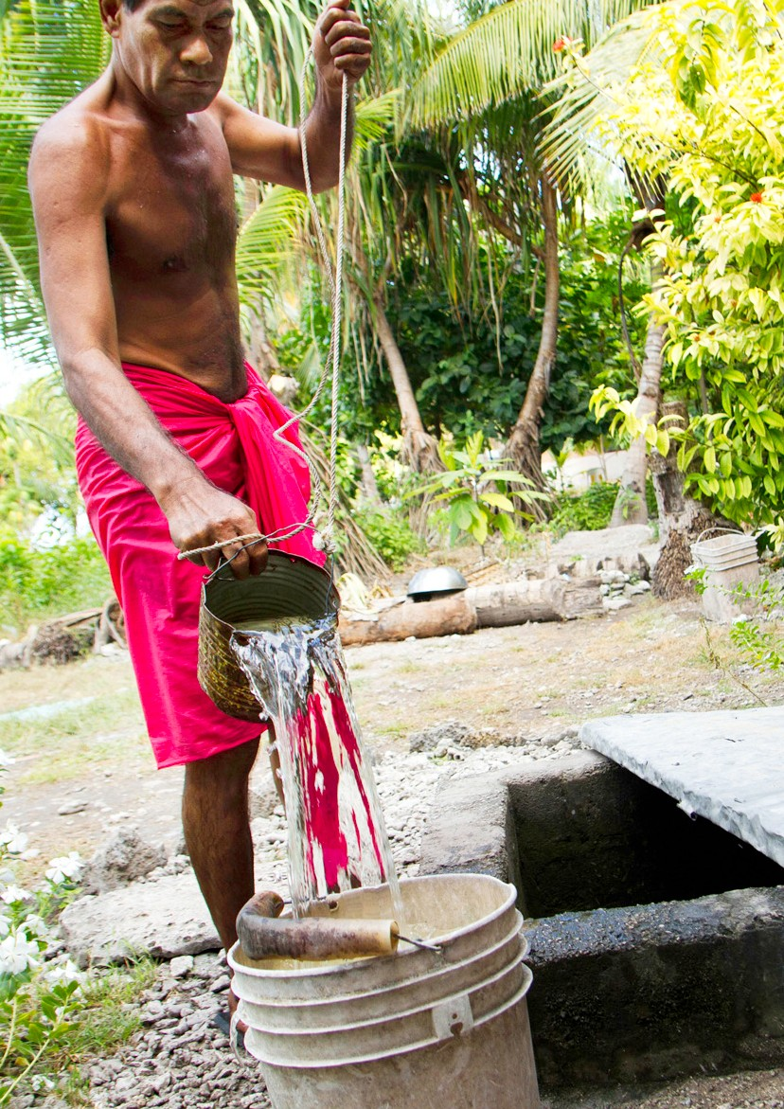

Annex One

A man collects water from a water source in Tarawa, Kiribati.
Source:

29

Four thematic areas for Localisation Mapping survey
The localisation mapping survey is framed around four key areas: Capacity, Leadership, Partnership and Funding.
The four key areas of focus are outlined below.

Capacity

The underlying premise to this is empowering and strengthening local capacity to lead humanitarian activities from preparedness to recovery. To plan this accordingly, the survey aims to first identify existing capacity in country level and document key priorities shared from the countries for future support. These sharing from participants considers the needs and voices of the vulnerable communities that they serve i.e. women, young people, children, LGBTIQ and persons with disabilities. Local actors armed with the right skills, technologies, supported by strong institutions makes sense and will bring about sustainable transformations through human, organisational, and institutional strengthening.

Leadership

Mapping leadership capacity of local actors will enable a quick temperature test to identify existing governance structures that guide and support humanitarian action in the Pacific. The fundamental principle to this is that ‘Transformative change needs leadership that is inclusive and participatory and that is supported and enabled to deliver timely and high impact humanitarian action.

Identifying these key structures and leaders within these structures will provide key entry points for various stakeholder groups such women, young people, children, LGBTIQ and persons with disabilities to engage and meaningfully participate and strengthen decision making processes that guarantee no one is left behind. It will also provide a space of sharing of traditional knowledge and expertise to strengthen humanitarian and disaster risk reduction governance and decision making. Furthermore, it will provide a platform to strengthen sustain- ability of disaster risk reduction and preparedness efforts by humanitarian actors and guarantee ownership of these initiatives by local partners and leaders.

Partnership

The survey in mapping out local actors’ scope of work in country aims to identify strategic synergies in areas of work to garner peer to peer collaboration and to establish communities of best practice. This will ensure stream- lined actions at the community level and promote collaborations and information sharing among key actors to avoid duplication, saving time and resource. Furthermore, it will provide a platform to identify sectoral need at the national and community level and provide directions on which partners to mobilise to strengthen or respond to these needs. Ensuring a coordinated approach among partners will ensure effective and efficient mobilization of technical support, resources, and initiatives.

Funding

Mapping of funding sources amongst local actors is critical to inform future strategies for program funding that include essential elements for strengthening local, regional humanitarian capacity in the Pacific region. The survey also aims to gain some information on the issues faced by local actors in accessing donor funding. While international funding is very important in advancing the localisation agenda, national government commitment is key to sustain these initiatives.

Cross cutting these four thematic areas are principals of strengthening a human rights-based approach, gender equality, child protection and disability inclusion.

Annex One

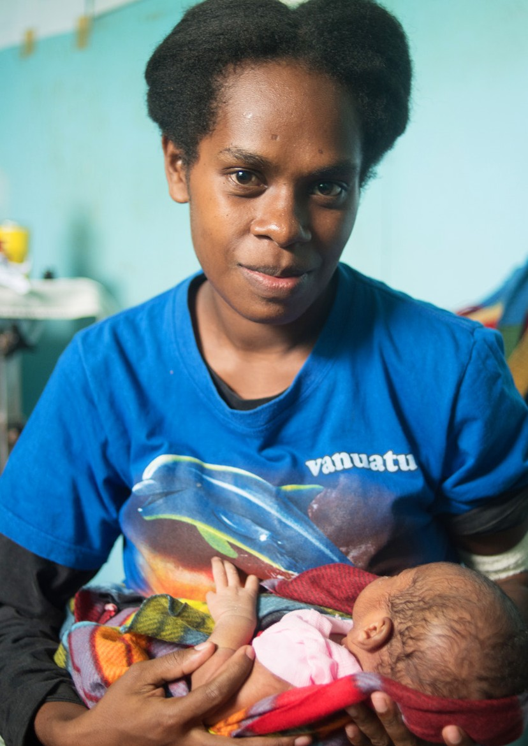
Women holds her baby at a Vanuatu health clinic.
Source: Dan McGarry

Annex Two

Women holds her baby at a Vanuatu health clinic.
Source:

Survey Questionnaire
31
“Pacific stakeholders emphasized that the process of localization has been successful when Pacific countries define how they respond to their own needs in humanitarian response and this is accepted by the international community. This includes defining the roles of different actors, the priorities for response, the relevant hu- manitarian standards and the use of traditional knowledge for disaster management. It involves international actors understanding and working with the structures, systems, process and priorities as defined by the affected country.” (Tracking Progress on Localisation report)

- Leadership
- Capacity
- Partnership
- Funding
- Participation

DEMOGRAPHIC QUESTIONS

TWG on Localisation: Mapping Questionnaire.

- Organisation Name:
- Email address
- Phone number
- Address
- Select all the countries that you or your organization work in.
  - Cook Islands
  - Federated States of Micronesia
  - Fiji
  - Kiribati
  - Nauru
  - Niue
  - Palau
  - Papua New Guinea
  - Republic of Marshall Islands
  - Samoa
  - Solomon Islands
  - Tonga
  - Tuvalu
  - Vanuatu
  - French Polynesia
  - New Caledonia
  - American Samoa
  - Guam
  - CNMI
  - Australia
  - New Zealand

Annex Two

32
- Select the Sector/Area of focus per country that you work in (Choose all that apply)
  - Health
  - Shelter
  - WASH
  - Food Security
  - Education
  - Advocacy
  - Gender
  - Disability
  - Child Protection
  - Environment
  - Communication
  - Coordination
  - Climate Change
  - Human mobility
  - Disaster Risk Reduction, Preparedness and Response
  - Others (please specify)

- Disaster Management Cycle
From the list below, select all the phases of the Disaster Management Cycle that you work in.
  - Response & Emergency relief
  - Recovery & reconstruction
  - Mitigation
  - Preparedness
  - Others (please specify)

- Please list some activities your organisation is engaged in according to the three goals of FRDP listed below;
  - Strengthened integrated adaptation and risk reduction to enhance resilience to climate change and disasters
  - Low-carbon development
  - Strengthened disaster preparedness, response and recovery
  - Others: (relevant to resilience building)

- Under the following localisation agenda, can you please answer the following questions based on the various
thematic areas

- CAPACITY
  - What type of DRM/DRR capacity building support has your organisation been able to access over the
last year?
  - What are the 5 top priority support that your organisation would like to access going forward?

- PARTNERSHIP
- From the list below, select your primary beneficiary group(s). As many as is relevant.
  - Communities Urban - Rural –
Peri urban
Informal settlement
  - Women
  - Children
  - Youth
Annex Two

33
  - Elderly
  - Persons with disabilities
  - LGBTQI+
  - Government agencies
  - Other targeted population (please specify)

- From the list below, select all the stakeholders you work with to achieve your organisation’s mission. (Please
specify the names of stakeholders)
  - Communities e.g. indigenous communities or others.
  - Women Groups and networks
  - Youth and Children’s Groups and networks
  - Disabled Peoples Organisations (DPOs) and Association
  - Government agencies
  - LGBTQI+ Groups and Association
  - Humanitarian NGOs
  - Private sector
  - Regional Organisations and Networks
  - International agencies.
  - Others (please specify)

- In terms of partnership and collaborative work within the localisation context, how does it impact the delivery?

f. Coordination
- Is your organisation engaged in any humanitarian coordination forums or meetings at the national, regional or international level? Please specify
- Is your organisation aware of any coordination systems at the national level?
- Please elaborate on the various humanitarian coordination forum or meetings that you are engaged in (i.e; it could be internal or external) Please specify

LEADERSHIP
Structure & good practices in terms of leadership – inclusive, accountability and transparency, processes

Part A: Structure:
  - Does the organisation/network have a clear structure?
  - Does the organisation/network have a strategic plan with clear vision, missions and goals?

Annex Two

34
Part B: Suggestion on a rating scale for the leadership element like so:

On a scale of 1-5 please rate the leadership characteristic in your organisation:

1-Strongly disagree, 2- Disagree, 3- Neutral, 4- Agree,5- Strongly Agree,

 | 1-Strongly disagree |  |  | 5- Strongly Agree
Organisation being
inclusive
Organisation accountable and transparent to stakeholders and beneficiaries
Organisation has shared ownership with beneficiaries
Organisation has good governance practices

PARTICIPATION
How are you engaging beneficiaries or affected communities in your programs?

FUNDING
Do you have access to funding and how long have you had that support?

On a scale of 1 to 5; how easy is it for your organisation to access donor funding? Is this for program support in general.

1 – very easy to 5 impossible (why)
If choosing 4, 5; what are some challenges faced? Why?

g. POLICY

Is your organisation engaged in policy work? (Yes or No – specify)

Does the work of your organisation influence policy at the national, regional and international level? (Yes or
No – specify)

Annex Two

35

Is your organisation aware of any of the following policies at the national level? o humanitarian,
- DRR
- climate change policies (Yes or No)

Challenges
Based on your experience, what are some of the challenges to the localisation of humanitarian action?

Opportunities
Based on the above, what opportunities do you see for localisation of humanitarian action?

LOCALISATION

- Describe your organisational/personal perspective on what ‘Localisation’ means to your
organisation?

Annex Two

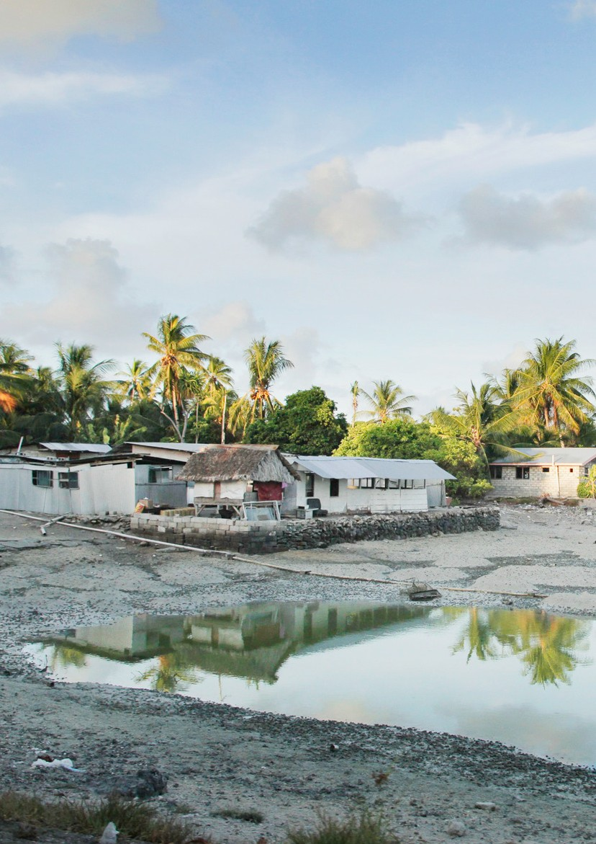

Annex Three

Homes on an atoll island - Kiribati
Source:

List of previous work and web links to reports.
37
- Tracking Progress on Localization: A Pacific Perspective https://humanitarianadvisorygroup.org/insight/tracking-progress-on-localisation-a-pacific-perspec tive/

- A window of Opportunity: Learning from COVID19 to progress locally led response and development https://humanitarianadvisorygroup.org/insight/a-window-of-opportunity/

- Localisation in Practice, a Pacific case study
https://www.care.org.au/wp-content/uploads/2016/10/Localisation-Case-Study- October-2016-13.10.pdf

- Going Local: Achieving a more appropriate and fit for purpose humanitarian ecosystem in the Pacific https://www.redcross.org.au/getmedia/fa37f8eb-51e7-4ecd-ba2f-d1587574d6d5/ARC-Localisation- report-Electronic-301017.pdf.aspx

- Localization in Fiji: Demonstrating Change https://humanitarianadvisorygroup.org/insight/localization-in-fiji-demonstrating-change

- The Grand Bargain https://interagencystandingcommittee.org/system/files/grand_bargain_final_22_may_final-2_0.pdf

- The Framework of Resilient Development in the Pacific
http://tep-a.org/wp-content/uploads/2017/05/FRDP_2016_finalResilient_Dev_pacific.pdf

Annex Three

