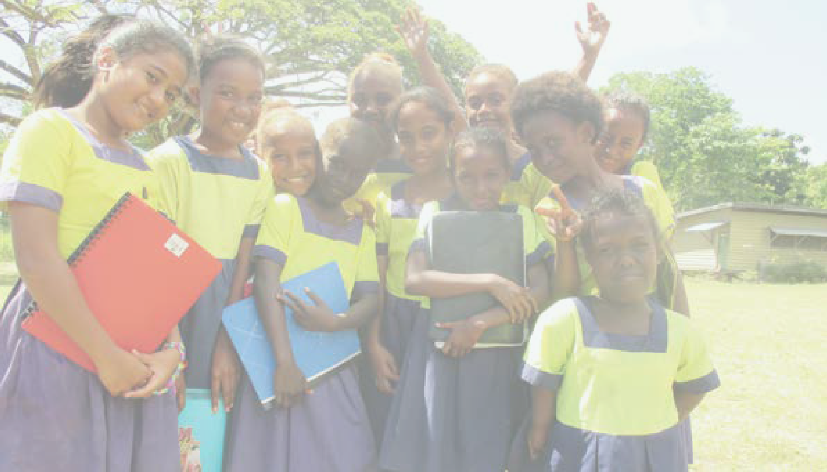Pacific Indicators for
Disability-Inclusive Education
The Guidelines Manual 2016

CBM – Nossal Institute Partnership for Disability Inclusive Development
PACIFIC DISABILITY FORUM
PACIFIC ISLANDS FORUM SECRETARIAT

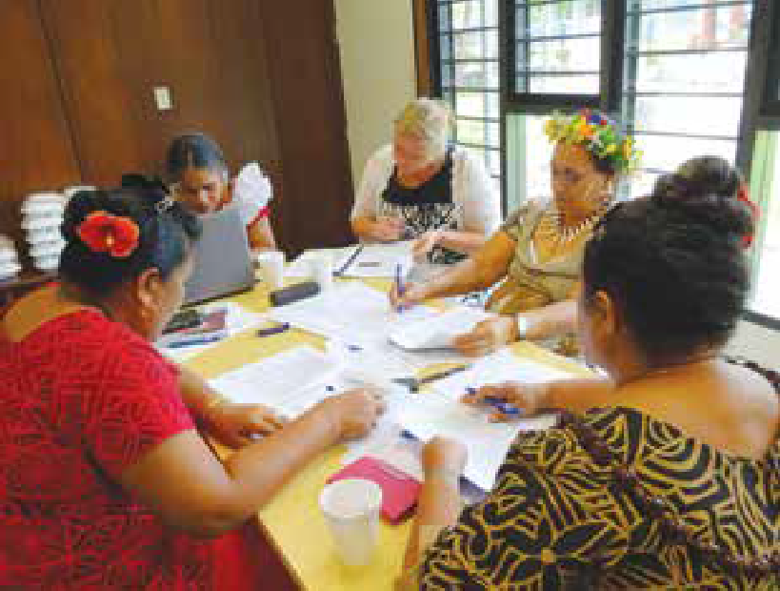Acknowledgements
Development of the Pacific Indicators for Disability-Inclusive Education (Pacific- INDIE) has been funded by the Australian Government through the Department
of Foreign Affairs and Trade’s Australian Development Research Awards Scheme number 66440 under an award titled ‘Developing and testing indicators for the education of children with disability
in the Pacific’. The views expressed herein are those of the authors and not necessarily those of the Commonwealth of Australia. The Commonwealth of Australia accepts no responsibility for any loss, damage or injury resulting from reliance on any of the information or views contained in this publication.
The Pacific-INDIE guidelines have been developed in partnership by Monash University, CBM – Nossal Institute Partnership for Disability
Inclusive Development, Nossal Institute Partnership for Disability-Inclusive Development, Pacific Disability Forum, and the Pacific Islands Forum Secretariat. We would like to acknowledge the significant contributions of Mr. Setareki Macanawai, Ms. Angeline Chand and
Mr. Shane Antonio from Pacific Disability Forum (PDF) Fiji for ongoing support and seamless co-ordination of activities in the Pacific case study countries.
We would also like to acknowledge the support provided by Mr. Laisiasa Merumeru and Mr. Michael Sivendra from Pacific Islands Forum Secretariat (PIFS) throughout the project.
We would like to acknowledge the contributions of Fiji Disabled Peoples Federation and the Ministry of Education, Fiji; Nuanua O Le Alofa (NOLA) and Ministry of Education, Samoa; Ministry

of Education and Human Resource Development, People With Disabilities Solomon Islands (PWDSI) and the Solomon Islands National University; and Disability Promotion and Advocacy Association and the Department of Education, Vanuatu.
In particular, we would like to acknowledge the contributions of our Associate Country Investigators:
- Kitione Ravulo (Corpus Christi Teachers College) and Savaira Tinaivunivalu (Fiji Disabled Peoples Federation) from Fiji;
- Faaolo Utumapu-Utailesolo (NOLA), Ailini Ioelu (Ministry of Education) and the late Mailo Pesamino (Ministry of Education) from Samoa;
- Janine Simi and James Porakari (Solomon Islands National University), George Saemane (Florence Young Christian School), Simon Dolaiano and Casper Fa’asala (People With Disabilities) from the Solomon lslands; and

- George Maeltoka, Glenden Ilaisa (Ministry of Education) and Freda Willie (Disability Promotion Advocacy and Awareness) from Vanuatu.
We would also like to thank Professor Tim Loreman, Professor Roger Slee, Professor Lani Florian, Professor Martyn Rouse, Professor Richard Rose, Dr.
Susie Miles, Professor Spencer Salend, Mr. Rick Frost, Dr. Keshari Narain Ojha, Ms. Karen Underwood, Dr. Amanda Watkins and UNICEF Pacific for their contributions and assistance in the research as expert consultants which informed these Guidelines.
A number of people from CBM-Nossal Partnership for Disability-Inclusive Development were involved in the ongoing review process including Hasheem Mannan, Tamara Jolly, Sally Baker, Matthew Allen, Amanda Benson,
Joanne Webber, Tanya Edmonds and Lisa Fitzgerald. Their support is gratefully acknowledged.

Contents

Foreword 2
List of abbreviations 4
Executive summary 5
How to use the Pacific-INDIE Guidelines 6
Part A: Introduction and background 7
Inclusive education 7
Disability-inclusive education 8
Pacific Island Country Laws and Policies for defining and determining disability 9
Defining disability-inclusive education 9
The Pacific Education Development Framework 10
Overview of the Pacific-INDIE 11
Development process of the Pacific-INDIE 12
Pacific indicator alignment with the PEDF 13
Part B: Guidance for stakeholders when implementing the Pacific-INDIE 14
A 6-Phase process for implementing the Pacific-INDIE 14
- Phase 1: Setting up the development team 15
- Phase 2: Defining disability-inclusive education 16
3 Phase 3: Selecting appropriate indicators 16
- Phase 4: Monitoring and evaluating the indicators 17
- Phase 5: Training on the indicators 17
- Phase 6: Reviewing progress and refining development 18
- Analysing Pacific-INDIE data by disaggregation 18
- Using the indicators in conjunction with the PEDF indicators 19
Part C: The Pacific-INDIE 22
Resources 75
References 76

1

Foreword
Photo by Arlene Bax courtesy of Oxfam Vanuatu

Nelly Caleb
Co-Chairperson, Pacific Disability Forum

Education for persons with disabilities in the Pacific has very much been shaped by the traditional medical and charity model paradigm. Persons with disabilities have been seen as ‘defective’ traditionally and have been cared for through charity and
social welfare systems. In line with this traditional paradigm, special schools have been established to cater for their educational needs. The adoption of the United Nations Convention on the Rights of Persons with Disabilities (CRPD) in December 2006 required a
paradigm shift to a rights-based model where persons with disabilities have the same rights as every other person. This included the right to education.
It has been emphasised that children with disabilities should be educated in mainstream schools and learn alongside their non-disabled peers.

This paradigm shift has been enforced in the Pacific through a decision by the Pacific Islands
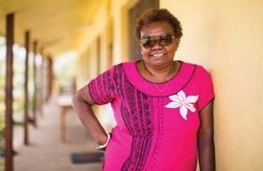
Forum Leaders in 2009 for Ministers responsible for disabilities in Forum island countries to meet and develop a Pacific Regional Strategy on
Disability (PRSD). The Forum Leaders required the PRSD to focus attention on the need to address issues facing persons with disabilities in the Pacific, to build greater awareness on the importance of allowing those with disabilities access to greater and more equitable opportunities to enhance
their quality of life and fully enjoy all inalienable human rights.
In 2009, Forum Education Ministers adopted the Pacific Education
Development Framework (PEDF). Both the PRSD and PEDF identified inclusive education as an important regional priority if Pacific nations are to meet their obligations as state
parties to the CRPD and commitment to the Dakar Education for All goals. The Forum Education Ministers met in 2014 and called for the development of a Pacific Inclusive Education Strategy for their consideration. In 2016, the PRSD will be replaced by
a new long term Pacific strategy on disability to be called the Pacific Disability Rights Framework (PDRF).

I am pleased to see this research on the development of Pacific Indicators on Disability Inclusive Education (Pacific- INDIE) through the leadership of Monash University in collaboration with the CBM-Nossal Institute Partnership for Disability Inclusive Development, the Pacific Islands Forum Secretariat and Pacific Disability Forum, which aims to develop a set of contextually specific indicators for disability- inclusive education in the Pacific and guidelines for implementation. The indicators, which are aligned to the regional frameworks on disabilities
and education, will assist countries to evaluate their efforts and develop
further plans and targets for providing quality education for children and youth with disabilities.
I am impressed with the research methodology adopted by the project. It took extensive efforts by local and international researchers to develop indicators that have potential to move the system forward in the Pacific. The project authentically involved local ministries, education officials, persons with disabilities and their national organisations, parents and their communities, regional stakeholders and organisations including tertiary institutions during the consultations. The final set of indicators in this publication can be viewed with confidence as relevant and realistic
to the Pacific context as developed by Pacific people. The Pacific-INDIE will support Pacific states in their own
3
monitoring of national efforts towards building more inclusive education systems that will allow persons
with disabilities greater access to mainstream schools without barriers.

Nelly Caleb
Co-Chairperson, Pacific Disability Forum

Authors
Umesh Sharma, Chris Forlin, Manjula Marella, Beth Sprunt, Joanne Deppeler, and Filipe Jitoko.

Availability of the Guidelines
A brief version of the Guidelines is
also available online at http://monash. edu/education/research/projects/ pacific-indie/
This is available in the following languages:
- Bislama
- English
- Fijian
- French
- Hindi
- Samoan
- Solomon Islands Pidgin.

List of abbreviations
ADRA – Australian Development Research Awards
CBM – Christian Blind Mission
CRPD – Convention on the Rights of Persons with Disabilities
DPO – Disabled Persons Organisation
EFA – Education for All
EMIS – Education Management Information System
ICF – International Classification of Functioning, Disability and Health
IEP – Individual Education Plan
MICS – Multiple Indicator Cluster Surveys
M & E – Monitoring & Evaluation
NFE – Non-formal education
NFE-MIS – Non-formal education Management Information System
NGO – Non-Governmental Organisation
Pacific-INDIE – Pacific Indicators for Disability-Inclusive Education
PDF – Pacific Development Forum
PEDF – Pacific Education Development Framework
PIFS – Pacific Island Forum Secretariat
SDGs – Sustainable Development Goals
TVET – Technical, vocational, education & training
UN – United Nations
UNESCO – United Nations Educational, Scientific and Cultural Organization
UNICEF – United Nations Children Fund.

Note: When referring to school aged children and young people with disabilities we have chosen to use the term ‘children with disabilities’.

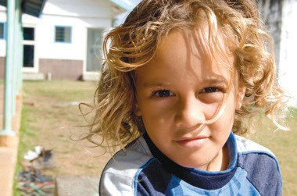Executive summary

The Pacific Indicators for Disability- Inclusive Education (Pacific-INDIE) have been designed to support the implementation of disability-inclusive education in the Pacific Islands. The final set of 48 indicators across 10 dimensions were collaboratively developed in partnership with the Pacific Islands Forum Secretariat (PIFS), the Pacific Disability Forum (PDF),
Monash University and the CBM-Nossal Institute Partnership for Disability- Inclusive Development, The University of Melbourne, as part of a research project funded by the Australian Government‘s Department of Foreign Affairs and Trade.
International principles that endorse the rights of all children including those with disabilities to access regular schools have been endorsed by Ministers in the Pacific Islands responsible for disability and those responsible for education. Pacific Island countries are now tasked with implementing disability-inclusive education and collecting appropriate statistical data to enable them to monitor and report on their progress.
One of the major challenges is a lack of existing tools that can be used to guide implementation of disability-inclusive education and monitor progress. This
is particularly true for the countries of the Pacific region. In order to guide countries to assess whether they are achieving international aims and goals it is important for them to be able to plan and map progress against contextually relevant indicators for measuring outcomes. Establishing meaningful quality indicators for measuring progress towards enabling disability-inclusive education is, therefore, critical for Pacific Island countries.

The development of the Pacific-INDIE now offers decision-makers a valuable tool for undertaking appropriate
data collection that will inform policy development work and enable them to monitor progress towards disability- inclusive education. In addition, data collected by the Pacific-INDIE can
feed back into reporting required by international Conventions such as the Convention on the Rights of Persons with Disabilities (CRPD) and the Sustainable Development Goals (SDGs).
To achieve disability-inclusive education challenges have to be addressed beyond the boundaries of the school and classroom. Disability-inclusive education specifically must be seen
as an evolving concept with issues relating to diversity and democracy as increasingly being important. This will require the integration of data from a variety of sources including those that capture the experiences of all learners

and their families in addition to data collected by the Pacific-INDIE.
Developing comprehensive data collection methods requires a long-term commitment from decision-makers. Education and other government ministries and whole communities will need to
work together to ensure equality of access for children with disabilities. Upgrading Education Management Information Systems (EMIS) by disaggregating existing data and by the inclusion of specific indicators on children with disabilities will be essential for monitoring progress through the collection of valid and
reliable information. The Pacific-INDIE further provides a structure for the development by PIFS of the proposed Pacific Inclusive Education Framework. In this way the Pacific-INDIE can act as a monitoring and evaluation framework for all Pacific countries.

How to use the
Pacific-INDIE Guidelines

The Pacific Indicators for Disability- Inclusive Education (Pacific-INDIE) are hereinafter referred to simply as
Note: It is critical that to fully understand the intent of these indicators and how they can be measured within a country context that reference must be made to the information provided in Parts B and C.

‘the indicators’. These Guidelines
have been developed to support the implementation of the indicators and they are divided into three parts:

Part A: Introduction and background provides the rationale for developing the Pacific Indicators. It addresses the reasons why disability-inclusive education is so pertinent in the Pacific and how the indicators may be used
as a way to measure progress and plan to implement effective inclusive education.
Part B: Guidance for stakeholders gives guiding principles for using the indicators for measuring disability-inclusive education in the Pacific Islands.
Part C: The Indicators presents indicators with specific information, directions and practical steps for implementing and measuring them. There are 48 indicators spread over 10 dimensions of disability-inclusive education.
The Guidelines are a resource that has been specifically developed to support Pacific Island countries in a process of developing disability- inclusive education. The Guidelines
have been prepared for administrators (e.g. Ministry or regional level), senior leaders (e.g. principals) and educators, and operational staff (such as teachers) to be used in collaboration with
other relevant professionals, parents and community stakeholders such as Disabled Persons Organisations to measure progress towards disability- inclusive education.
Not all indicators will be applicable for all Pacific Island countries. When selecting indicators to be used within
a country, some may be more relevant to different user groups than others.
It is expected that each country will have different priorities, resources, cultural perspectives and challenges in their context that will influence their specific choice of indicators to address
targets, guide implementation, identify
evaluation processes, and organise community engagement in their development work.
When selecting indicators for use within a country not all information may be required to be collated at district/provincial and national level in addition to school level. These decisions need to be made by the
Pacific-INDIE Development Team within each country.
The quotes included throughout the document highlight the feedback received from Pacific Island countries as they have participated in the development and reviewed the indicators during the development
process. The comments from participants help to capture the importance and practicality of implementing the indicators across the region and assist in conceptualising how this might occur.
We hope that all stakeholders find this document useful for guiding their work in disability-inclusive education.

6

Part A

Introduction and background

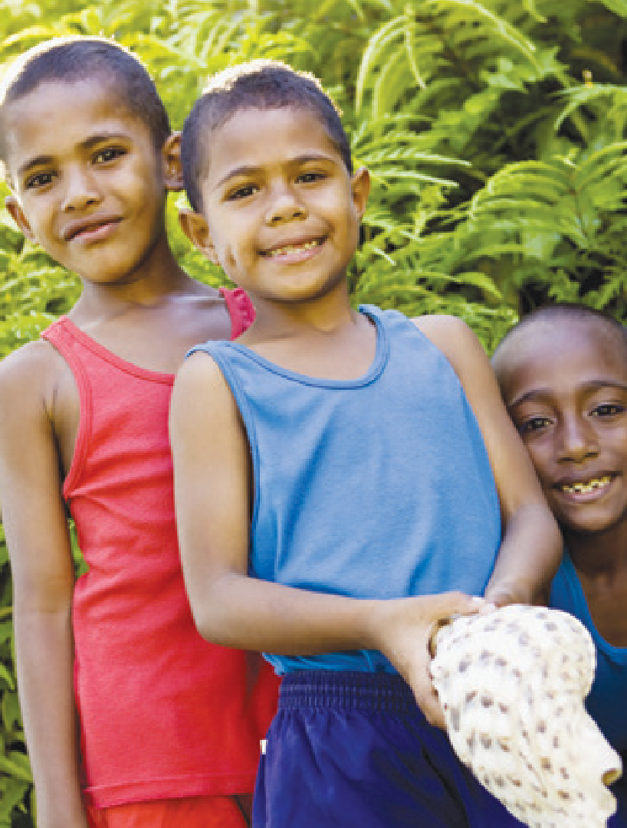Inclusive education

‘Inclusive education can be successful if we see more children with disabilities with boosted levels of confidence and self-belief and feeling like they are appreciated and gained self-confidence.’
Although the concept of inclusive education has been promoted internationally for more than two decades, multiple barriers remain to the full participation of children and young people with disability (henceforth referred to as ‘children with disabilities’ in this document) in education (WHO & World Bank, 2011, p.225). A lack of
information and discriminatory attitudes at all levels of society contribute to the continuing disregard for the rights of children with disabilities to education in many parts of the world.
The framework for understanding inclusive education is outlined in the Salamanca Statement (World Conference on Special Needs Education: Access and Quality, 1994), which states that
‘… those with special educational needs must have access to regular schools which should accommodate them within a child centred pedagogy capable of meeting these needs’
(p. viii). One of the major challenges is a lack of measurement tools that countries can use to guide their
implementation of inclusive education and monitor their progress. This is particularly true for the countries of the Pacific region. In order to guide countries and assess whether they
are achieving these aims, it is important for them to be able to plan and map progress against contextually appropriate indicators for measuring outcomes.

Parent, Samoa

The United Nations Convention on the Rights of Persons with Disabilities (CRPD), Article 24, charges States with ensuring the provision of an inclusive, quality, and
This philosophy is wholly embraced within the World Education Forum and UNESCO’s Education for All (EFA) goals (World Education Forum, 2000),
Disability is a result of an interaction between a person with impairment and attitudinal and environmental barriers.

free primary and secondary education
to people with disability on an equal basis with others in the communities in which they live (United Nations, 2006). Further, Article 31 outlines the
the CRPD (2006) and in the new SDGs, (United Nations, 2015). In particular SDG
4 aims to ensure inclusive and equitable quality education and promote lifelong
learning opportunities for all with the

responsibilities of State Parties with respect to statistics and data collection, by stating that States Parties are required to ‘… undertake to collect appropriate information, including statistical and research data, to enable them to formulate and implement policies to give effect to the present Convention’ (United Nations, 2006). Article 31 expands this further with:

The information collected in accordance with this Article shall be disaggregated, as appropriate, and used to help assess the implementation of States Parties’ obligations under the present Convention and to identify
and address the barriers faced by persons with disabilities in exercising their rights… States
Parties shall assume responsibility for the dissemination of these statistics and ensure their accessibility to persons with disabilities and others.’

United Nations, 2006, p. 23

In addition, Article 33 requires States Parties to establish national/regional monitoring points and independent monitoring mechanisms.
In realising the right to education, persons with disabilities are not to be excluded from the general education system on the basis of disability, and children with disabilities are not to be excluded from Early Childhood Education, from free and compulsory
primary education, or from secondary education, on the basis of disability.
specific target that by 2013 countries will ‘… eliminate gender disparities in education and ensure equal access to all levels of education and vocational training for the vulnerable, including persons with disabilities, indigenous peoples and children in vulnerable situations.’ These principles have been endorsed by Ministers in the Pacific responsible for disability and those
responsible for education (Pacific Islands Forum Secretariat, 2009). As signatories to these Conventions countries are required to monitor progress towards achieving the set goals. Each of these could potentially be informed by data collection linked to the Pacific-INDIE.

Disability-inclusive education
Disability is a result of an interaction between a person with impairment and attitudinal and environmental barriers. Disability should not only be measured by a diagnosis of the underlying health, learning, psychological, neurological,
or emotional condition, but should also consider environmental factors that might impact on access and participation. The International Classification of Functioning, Disability and Health (ICF) (WHO, 2001) is the globally accepted way of defining and measuring disability. The World Report on Disability provides a clear description of the various constructs which make up the ICF. Disability arises from the interaction of health,
learning, psychological, neurological or emotional conditions with contextual factors – environmental and personal, and is considered as being difficulties
encountered in any or all three areas of
human functioning:
- Impairments are problems in body function or alterations in body structure e.g. paralysis or blindness
- Activity limitations are difficulties in executing activities
e.g. walking or eating
- Participation restrictions are problems with involvement in any area of life e.g. facing discrimination in employment or transportation
(World Health Organisation, 2011, p.5)
Most recently UNICEF and the Washington Group on Disability Statistics have developed modules on Child Functioning and Disability for children aged 2-4 years and 5-17 years. These provide a series of questions to identify the sub population of children that
are at greater risk than children of the same age of experiencing limited social participation due to functional limitations. The rationale behind these is to provide a way of defining disability by avoiding a medical approach to diagnosis and by using the ICF
bio-psycho-social model instead which is consistent with the CRPD.
The questions focus on activity limitations including several functional domains and reflect the continuum of disability. These new modules when finalised will provide a standardised methodology/guidelines for follow-up assessments, based on existing best practice approaches for the evaluation of disability in children in developing countries. They can be downloaded from data.unicef.org or http://www. cdc.gov/nchs/washington_group.htm

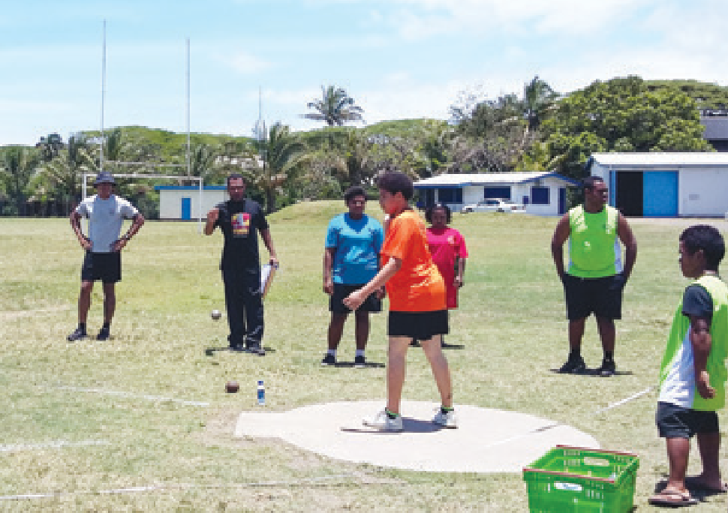‘What would it take to enable a child with disability to access education?’

DPO group, Samoa

Pacific Island Country Laws and Policies for defining and determining disability
Approaches to determining disability amongst children with disabilities vary tremendously across the Pacific, as they do around the world. It is an important process for each Pacific Island government, in collaboration with Disabled Persons Organisations
(DPOs) and other disability stakeholders, to review existing laws, policies and practices that have relevance for how disability is defined. In many cases, laws and policies in Pacific Island countries are not absolutely clear on measurement of disability amongst children with disabilities. Laws may be outdated
and have been drafted using largely a medical approach, which is inadequate in the context of contemporary approaches to understanding and identifying disability. Updating the laws and regulations to foster inclusive education and to move away from
the medical model are important for enabling disability-inclusive education. In addition, providing guidance and information on available resources related to local regulations and policies

that will help nurture disability-inclusive education would be important.
In some places, children with disabilities are counted as having a disability simply by whether they are enrolled in a special school. As countries increasingly implement disability-inclusive education, the methods of determining students’ strengths, challenges and disability often need to be more formalised as many more children with disabilities will access schools across the country. However, it is critical that the process does not lead to over identification of children as having a disability. A better approach might be to
identify students who are at risk of having a disability rather than identifying those having a confirmed diagnosis. In order to measure progress in disability-inclusive education using the Pacific-INDIE a clear and agreed upon country definition
of disability is essential. Countries that do not have any system of defining disability might find it helpful to use questions from the Washington Group to identify children at risk of having a disability. Other countries that have an existing system to define disability may benefit by revising the existing system in line with the recommendations of the Washington Group.

Defining disability- inclusive education
Whilst the term ‘inclusive education’ was originally focussed on including students with special educational needs, it has more recently come to refer to education systems, processes and practices that focus on the inclusion of a range of commonly excluded groups, such as girls, indigenous, rural and remote children, child workers, street children, Roma/ nomadic children, or ethnic minorities, among other potentially marginalised groups. The term ‘disability-inclusive education’ is used here to distinguish
the population sub group for whom the indicators in these Guidelines have been designed. Nonetheless, these indicators also have implications for implementing and evaluating inclusive education for all students.
Drawing heavily on the rights outlined in the UN CRPD Article 24, we define disability-inclusive education in these Guidelines as:
Disability-inclusive education is the means by which the rights of
children and youth with disabilities to education are upheld at all levels within the general education system, on an equal basis with others in the communities in which they live. It involves identifying and overcoming barriers to quality education in the general education
system; reasonable accommodation of the individual’s requirements; and provision of support measures to facilitate access to and participation in effective quality education.

The Pacific Education
The 14 member countries of the Pacific Island Forum have agreed

Development Framework to work towards disability-inclusive education.
The Pacific Regional Strategy on Disability (Pacific Islands Forum Secretariat, 2009) highlights that less than 10% of children with disability in the Pacific have access to any form of education. Thus, 90%
of children with disabilities are out of

school. Consistent with endeavours globally to achieve EFA goals, and recognising that millions of children and young people with disabilities remain excluded from education (UNESCO, 2010), efforts towards disability-inclusive education in the Pacific Island countries are increasing in strength and scale.
Through the Pacific Education Development Framework (PEDF) approved by all Pacific Island Education Ministers in 2009, special and inclusive education are seen as a priority thereby endorsing a rights based
and inclusive approach to disability and education for all learners (PEDF, 2009). The 14 member countries of the Pacific Island Forum have adopted this Framework and agreed to work
towards disability-inclusive education at a regional level (Pacific Disability Forum and Pacific Islands Forum Secretariat, 2012). A number of processes require governments in Pacific Island countries to report against disability-inclusive education indicators, including country educational policies, the monitoring and evaluation of the PEDF, EFA, the SDGs, and the CRPD.
Pacific Island countries are, therefore, progressively drafting and implementing policies to promote disability-inclusive education. Disability-inclusive education programs are, nonetheless, at various stages of implementation across
the Pacific, often with bilateral and multilateral support from donors.
In the development of the monitoring and evaluation framework for the PEDF,
finalised in July 2013, for each of the six education subsectors.¹ The indicators for the cross cutting themes, which includes special needs and inclusive education, have been treated as disaggregated data across all the education subsectors. Various processes have been identified at both national and regional levels to
support the collection of relevant data to meet the needs of national, regional and international reports such as the PEDF, EFA and SDGs.
As much of this work is in the early stages, strong and useable indicators for measuring the quality and impact of disability-inclusive education do not yet exist. Governments, funding agencies, DPOs and other civil society stakeholders agree that they need to be able to implement high quality and
effective inclusive education programs, and measure progress toward a quality education for children with disabilities in the Pacific Island countries. Data systems need to provide information that establishes baselines, guides planning and implementation, identifies areas for improvement, and facilitates evaluation of efforts. These data can be used to validate effective models, approaches, policies and practices and identify
the factors that contributed to their efficacy, and determine strategies to enhance areas in need of improvement. This would enable evidence-based decisions to be made regarding a range of strategies for promoting disability- inclusive education, for example, capacity development of in-service teachers, provision of teacher assistants,
for technologies, and comparison of benefits of different inclusion approaches and models.
To record data across the Pacific region, Directors of Education from all 14 Pacific countries agreed in October 2011 to work towards an EMIS that would include significant questions and data regarding children with disability (Pacific Islands Forum Secretariat, 2011). The Pacific Islands Forum Education Ministers’ Meeting in May 2012, further endorsed upgrading the EMIS and the inclusion of indicators on children with disability (PDF and PIFS, 2012).
Collaborative efforts are being developed between the UNESCO Institute of Statistics, Secretariat of the Pacific Community and PIFS in terms of supporting data collection from countries and at the same time,
enhancing the capacity of national EMIS staff to better manage their national systems. The involvement of the Pacific Heads of Education Systems is a key aspect in the process to ensure the support and commitment to these efforts from the highest hierarchy of national education systems and to ensure sustainability of the process.
Technical guidelines for the EMIS to monitor the PEDF Indicators are also currently being developed.

The involvement of the Pacific Heads of Education Systems is a key aspect in the process.

indicators have been developed and cost estimates on investment required

1 Early childhood, care & education, formal schooling (primary & secondary), technical, vocational, education & training (TVET), non formal education (NFE), teacher development, and Systems, governance & administration.

Overview of the Pacific-INDIE
Disability-inclusive education is premised on systems accommodating the diverse strengths and needs of learners and their families.

What is an indicator?
Indicators can provide important information which can be used to improve decision making and program planning and implementation. It is important, however, to remember that indicators only indicate; they do not explain. They may provide important information about whether a particular phenomenon exists or not, and even the extent of that phenomenon, but indicators do not provide explanations for the existence of the phenomenon.
In education, indicators may be direct, for example, the numbers and percentage of children attending (or not attending) school regularly. Indicators also may be indirect, using so-called proxy indicators. For example, the number of children completing primary school may be seen as a proxy indicator of effective teaching and learning. However, indicators have to be used with caution. Although indicators may provide useful information about many elements of education, other important aspects of schools and schooling are not easily measured or readily converted into indicators.
The Pacific-INDIE is designed to assist countries in setting targets to promote the inclusion of children and youth
with disabilities. It could also be used by participating countries in determining how best the set priorities could be achieved. The Pacific-INDIE allows
for collaboration amongst a range of stakeholders in identifying strategies that might work within their contexts to implement disability-inclusive education.

The Pacific-INDIE is designed to assist countries in setting targets to promote the inclusion of children and youth with disabilities.

The indicators presented in the Guidelines are, therefore, designed to support Pacific Island countries in the measurement and reporting of the progress of their targeted development efforts in disability-inclusive education. The indicators have been developed to align with country educational policies and other Pacific regional processes outlined in the PEDF and the priorities of disability and education stakeholders in the Pacific.
While the indicators have been developed for all Pacific Island countries, it is acknowledged that each Pacific context is unique and that each country will select indicators that are appropriate to the country specific development priorities. In particular, notice will need to be taken of contemporary versus traditional approaches such as chiefly systems when seeking to develop appropriate methods for designing
and implementing effective disability- inclusive education programs and measuring their impact.

Principles underpinning the development of the Pacific-INDIE
Previous work has established indicators suitable for use in other regions such
as the European Agency for Special Needs and Inclusive Education (EASNIE) (EADSNE, 2011, 2011a; Kyriazopoulou & Weber, 2009). These indicators are well conceptualised but not contextualised for the Pacific Island countries.
These tools along with UNESCO’s

undertaken in Phase 1 of the indicators research2 provided a basis for the development of this set of Pacific-INDIE.
Three key principles provided the foundation to developing the Pacific Island indicators:

Collaboration
A collaborative and rigorous approach to developing indicators which measure what Pacific Islanders value as authentic
and relevant disability-inclusive education is essential. The project was undertaken in partnership with two regional bodies: PIFS and PDF. Both regional bodies were involved in the conception, design and implementation of the research to develop the indicators.
- A need for system change Disability-inclusive education is premised on systems accommodating the diverse
strengths and needs of learners and their families; rather than expecting the child or youth to ‘fit in.’ This project is about measurement and disability. We were aware of the danger of identifying disability as a problem residing within an individual. We, therefore, made every attempt possible to move away from the medical model of disability towards using social and human rights models of disability. This approach allowed us to identify indicators that addressed environmental barriers
to providing quality education to

work (UNESCO, 2005, 2011) and work children with disabilities.

2 Forlin, Sharma, Loreman, & Sprunt, 2015; Loreman, Forlin, Chambers, Sharma & Deppeler, 2014; Loreman, Forlin, & Sharma, 2014; Sharma, Forlin, Sprunt, & Merumeru, submitted; Sharma, Loreman, & Macanawai, 2015; Sharma & Ng, 2014.)

Nothing about us without us: The leadership role of Pacific Islanders
‘It’s not the culture that is a barrier, at the heart of it we have an inclusive society, but we don’t have the systems to support it. We need to embed the indicators into all systems.’

One of the significant limitations

of previous research on disability- inclusive education in developing countries is that much of it has been conducted by outsiders (in terms of people who do not have a disability). Involvement of people with disability and their families in research that has direct impact on their life is vital.
People with disability and their organisations from the Pacific were involved in this project as partners and Associate Investigators in each of the four case countries (Fiji, Samoa, Vanuatu, and Solomon Islands).

Development Process of the Pacific-INDIE
In order to develop the indicators, a four- part process was employed:
- Systematic literature reviews.
- Survey of key stakeholders from 14 Pacific Island countries.
- Focus group and key informant interviews in four Pacific countries.
- Document analysis of reporting frameworks.
Three literature reviews were undertaken to determine international perspectives on indicators for measuring disability- inclusive education (Loreman, Forlin, & Sharma, 2014); previous work undertaken in Pacific Island countries (Forlin, Sharma, Loreman & Sprunt, 2015); and to identify what strategies have worked to include out-of-school children with disabilities in education in developing countries (Sharma & Ng, 2014).
To gain an understanding of indicators and systems already being used to monitor and evaluate education
in the 14 Pacific Island countries a
DPO, Samoa

questionnaire was developed. The key focus of the survey was to determine what data countries were already collecting in relation to disability- inclusive education. It also provided an opportunity for stakeholders to recommend indicators that would
be most appropriate for individual country contexts (Sharma, Forlin, Sprunt & Merumeru, submitted). The key stakeholders consisted of government officials who had a portfolio of working in disability and/or the education sector.
A series of key informant and focus group interviews were also conducted in four countries of the Pacific (Fiji, Samoa, Solomon Islands and Vanuatu). The participants consisted of members representing DPOs, parents of
children with disability, primary and early childhood teachers, secondary teachers, disability service providers, and representatives from Ministries of education, health, community
development, social welfare, and other key education or disability stakeholders.
The information provided great depth and breadth in understanding what Pacific Islanders valued in terms of approaches to the education of children with disabilities.
The document analysis identified the implications of various monitoring and evaluation frameworks, performance assessment frameworks, UN Conventions, regional and country strategies, and frameworks and agreements that
relate to the reporting requirements of the Pacific Island countries in terms of disability-inclusive education.

Information from these four activities provided the initial draft list of indicators. These were further refined in a series of collaborative meetings held in Melbourne and Fiji with key stakeholders over an eight month period. Members of the Fiji meetings
included representatives from Ministries in four case study countries, parents of children with disability, DPOs, non- government education providers, senior staff from the PIFS and PDF, and the research team. An international expert review team also provided feedback
on the indicators throughout the development phase.
Final review of the draft indicators by the international experts rated each indicator against five criteria: Relevance (is the indicator relevant for disability-inclusive education; will it be applicable for learners with all types of disability and is it germane to disability-inclusive education in the Pacific Islands?); Measurability
(is the indicator measurable using quantitative or qualitative data? Will it be possible to collect data that will
allow for each indicator to be measured in the Pacific Islands?); Specificity (is
the indicator specific enough? Does it relate to disability-inclusive education in the Pacific Islands?); Attainability
(is the indicator attainable/realistic for disability-inclusive education in the Pacific Islands?); Timeliness (can the information on the indicator be
obtained within a reasonable timeframe that is manageable by stakeholders given the Pacific Island context?).

12

Pacific indicator alignment with the PEDF
- To achieve efficient and effective utilisation of resources ensuring balanced and sustained
The final resulting 10 dimensions containing 48 indicators form the Pacific-INDIE.

The final resulting 10 dimensions
containing 48 indicators form the
Pacific-INDIE. These indicators have been developed to supplement, align and assist with the implementation of the PEDF vision of quality education for all
in Pacific Island countries; their mission: to enable each Pacific learner to develop all his/her talents and creativities to the full and thereby enabling each person to take responsibility for his/her own life and make a meaningful contribution
to the social, cultural and economic development of Pacific society; and the PEDF three strategic goals of:
  - To achieve universal and equitable participation and access to Pacific education and training (Access & Equity);
  - To improve quality and outcomes (Quality);
development of Pacific education systems (Efficiency & Effectiveness).
PEDF (2009-2015)
Members of PIFS reviewed these indicators and mapped them according to the three key themes Access,
Quality, or Efficiency and Effectiveness used within PEDF framework. It is possible that in future PEDF might adopt the Pacific-INDIE to monitor
the implementation of disability inclusive education across the Pacific. The indicators are presented in Table 1 under the 10 identified dimensions
that emerged during the development process. Of the 48 indicators, 12 are highly recommended by PIFS and PDF as regional indicators for reporting on disability-inclusive education within the Pacific Islands.

Table 1

Dimensions Classified According to the PEDF Strategic Objectives of Access (A), Quality (Q), Efficiency and Effectiveness (E)

 | N of Indicators | N of Recommended Indicators | PEDF Strategic Objectives*
Dimension
 |  |  | A | Q | E
1. Policy and Legislation | 5 | 2 | - | - | 5
2. Awareness | 3 | 1 | 1 | - | 2
3. Education, Training and Professional Development | 4 | 1 | - | 3 | 1
4. Presence and Achievement | 12 | 2 | 9 | 3 | -
5. Physical Environment and Transport | 2 | 1 | 1 | 1 | -
6. Identification | 4 | 1 | - | 1 | 3
7. Early Intervention and Services | 5 | 1 | 1 | 2 | 2
8. Collaboration and Shared Responsibility | 7 | 1 | 1 | 2 | 4
9. Curriculum and Assessment Practices | 2 | 1 | - | 2 | -
10. Transition Pathways | 4 | 1 | 4 | - | -
TOTALS | 48 | 12 | 17 | 14 | 17
Note: * A = Access; Q = Quality; E = Effectiveness and Efficiency

Part B

Guidance for stakeholders when implementing the Pacific-INDIE

The process of using the indicators to support the development of disability- inclusive education in the Pacific
surveys may provide data to supplement the measurement of the indicators
e.g. household or labour force surveys,
Different indicators record data at three different levels: systems, school and community levels.

Island countries draws on the views and the engagement of a number of
population censuses, and any other large-scale surveys. In addition, new data

stakeholders. These perspectives may include but are not limited to: Ministry staff, school leaders, parents, teachers, DPOs, students, and other advocates and members of communities.
It is important to note that different indicators record data at three different levels: systems, school and community levels. Additionally, there are some indicators that record data at more than one level (e.g. school and community). The indicators are assigned to provide as much as possible a standard reporting format across the Pacific Islands to measure progress towards disability- inclusive education.
To respond to the indicators it may be necessary to improve data collection beyond the standard use of existing school surveys. Access to other regular
collection methods may be required to respond to specific indicators. It would seem appropriate that the EMIS monitoring systems could be adapted to incorporate data in response to these indicators to enable district, provincial or national data collection and analysis of information.
It is recommended that governments include pertinent indicators from the Pacific-INDIE in their national EMIS to assist with planning, monitoring and evaluation.

A 6-Phase process for implementing the Pacific-INDIE
The proposed method for adopting the Pacific-INDIE involves a 6-Phase process that considers the full cycle of education planning, implementation,
data collection or evaluation and
reflection (Figure 1). The process commences with establishing a national development team that includes people with disabilities and their family members to oversee the implementation of the indicators across the country. This is followed by defining disability-inclusive education for each country and selecting appropriate indicators to measure progress towards this. The establishment of a process for monitoring, collecting data, and evaluating the indicators and planning for community engagement follows. The final stage is reviewing the process and refining development to ensure a country’s capacity to continue to collect data to measure progress against the indicators. Figure 1 outlines development steps for implementing the indicators as a 6-Phase process.

Figure 1. The 6-Phase process for using the indicators

3
Selecting appropriate indicators

4
Monitoring and evaluating the indicators

1
Setting up the Development Team
2
Defining disability-inclusive
education

6
Reviewing progress and refining development

5
Training on indicators

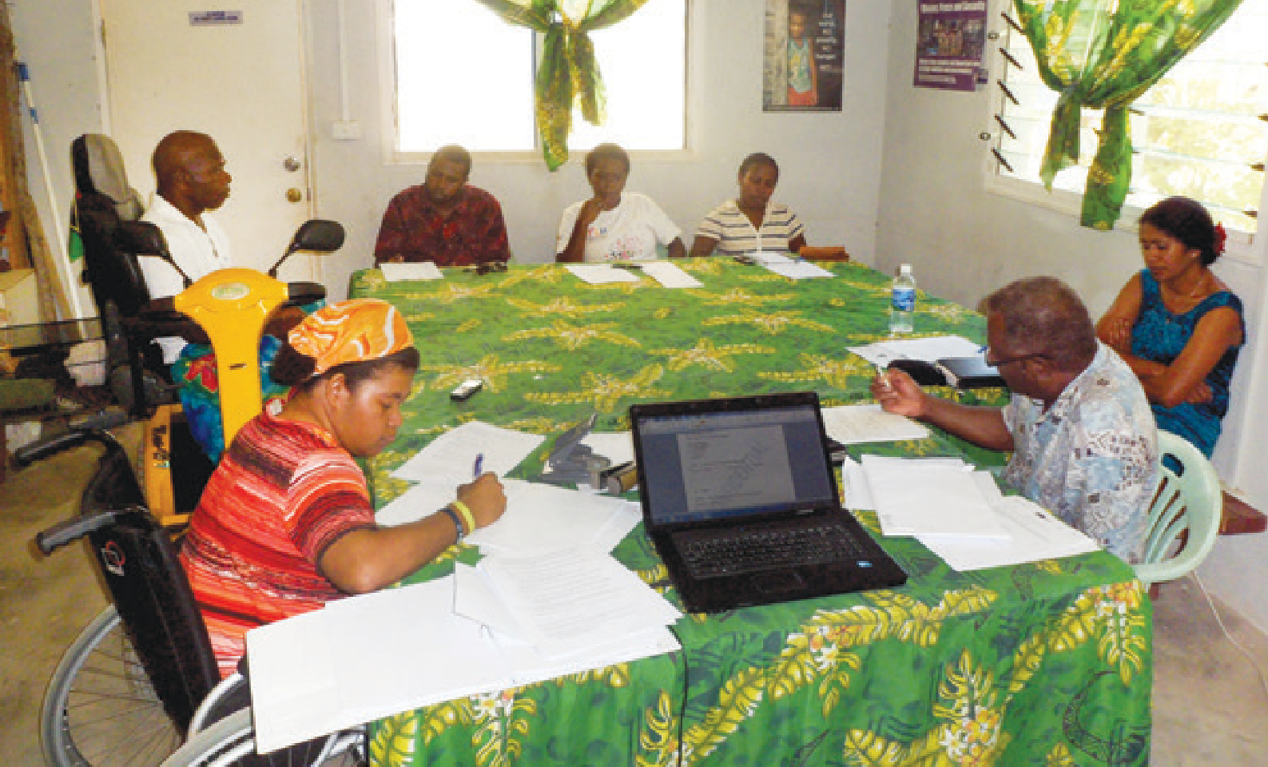The EMIS form/website could include questions related to whether a school has formal processes for involving parents of children with disabilities in educational programs. Many of the indicators could be tracked by using existing EMIS
data procedures by either adding new indicators or updating existing ones to be disaggregated according to disability. It will be critical to ensure
that EMIS personnel are included in

Phase 1: Setting up the Development Team
Any government staff responsible for reporting against the following frameworks should be informed of the Development Team and invited to join where relevant. This may include individuals responsible for reporting on the Pacific Regional Strategy on Disability, UN CRPD, EFA,
‘In the Solomon Islands, all schools within the country are mandated
to have school boards – this is a requirement. Now in my opinion, within these school boards, I would like to see that a representation of people with disabilities must be included, so that this person can advocate for those children with special needs/disabilities in school.’

Incheon Strategy, SDGs, and national

any Ministry-level development team for disability-inclusive education.
Engaging key staff in the complex issues of disability-inclusive education will help improve understanding of the importance of these data and encourage the inclusion of relevant indicators as early as possible into the EMIS system.
disability policies and legislation/Acts of Parliament. In addition, the relevant person from the Central/National Statistical Office should be informed of the Development Team and involved in decisions related to national surveys, censuses and measurement of the
prevalence of disability. The team should also include representatives from DPOs.
Key informant, Solomon Islands

The development team must ensure that everyone is kept informed about the progress of implementation of disability-inclusive education.

Teacher, Samoa

Choose the right team

‘Inclusive education is very important for us.’
The first step in the process starts with setting up a ministry level Development Team. This work needs to be embedded within existing structures to establish a team
that reflects the main areas of the educational system, including the full educational spectrum, from Early Childhood to post-secondary, plus
representatives from special/disability- inclusive education, assessment, school assets and infrastructure, policy, EMIS/data management units, as well as DPOs and non-government education providers.

Develop a mutual understanding of the role of the team
  - Become familiar with the indicators
  - Commitment/consultation with relevant key stakeholders
Raise awareness and strategic networking to measure improvements in disability-inclusive education through the use of the indicators Involvement of DPO members is vital in this initial phase. It is often the perspectives of persons with disabilities or those closest to them that provide new insights into exclusionary processes and inclusionary possibilities within a community.
Prioritising collaboration and stakeholder engagement throughout the development process will ensure that the perspectives of the community are reflected in decisions regarding the gathering and evaluation of evidence pertinent to development.

‘Make it everybody’s responsibility.’

Principal, Samoa

Phase 2: Defining disability-inclusive education
The Development Team should refer to Section 2 in these Guidelines to identify an agreed definition of disability and disability–inclusive education that is appropriate for their context and they can adopt for use in conjunction with the indicators. It is important to ensure that the definition refers to providing equitable access to education for
all students with different types of disability. The definition should also guide the development of policies and practices within each country.

Phase 3: Selecting appropriate indicators
While the indicators have been developed for all Pacific Island countries it is important to recognise that selecting appropriate indicators requires a focus on country development priorities (United Nations Development Programme (UNDP), 2009). Each Pacific context is unique and countries will have a number of priorities identified for development that should guide
selection of relevant indicators to design high quality programs addressing and measure progress towards national disability-inclusive education goals.
There is variation between Pacific Island countries regarding the stage of disability-inclusive education they have
achieved. There are likely to be significant differences within countries between
the ways in which urban, rural and outer island communities are addressing disability-inclusive education. Countries should select indicators that are:
- Consistent with local guiding principles of country ownership, capacity and human development.
- Meet the assessment needs of a country, considering the applicability of the indicators for all types of locations.
- Relevant for local contexts.
It is not expected that countries would want to use all indicators. These Guidelines provide information for the identified 48 indicators that form the
Pacific-INDIE. These indicators are listed in Table 2 under the 10 dimensions.

  - Highly recommended indicators and country specific indicators
There are 12 core regional disability- inclusive indicators that have been identified as being critical for all Pacific Island countries that align closely with PEDF indicators on disability inclusive education (see italicised indicators in Table 2). These core regional indicators provide a standard measuring benchmark for all countries and are highly recommended to be adopted.
Beyond the 12 recommended indicators, there are 36 additional indicators, which countries may select based on relevance to a country’s context, policy and priorities. Country-specific indicators offer greater scope to guide the planning and implementation of policies and practices that support effective disability-inclusive education and monitor and evaluate processes at national and school levels, which provide important feedback
on a country or school’s progress. It is envisaged that countries would not want to utilise all of the indicators but they should select ones which are appropriate to their specific context and current needs.

  - Selecting indicators
It is recommended that the Development Team undertake the following process to select indicators:
- Be familiar with the information already collected through a Ministry’s EMIS or at the school level (e.g. records, log books, processes for recording enrolment information, attendance, and dropout) that may be relevant to the Indicators.
- Collate and review national education and disability policies and relevant national reporting commitments such as the Ministry of Education Annual Report, district or provincial reporting requirements, and other reports that are required.
- Collate and review relevant international reporting commitments UN CRPD, SDGs, EFA and the Incheon Strategy targets.
- Make a list of the indicators (or information) required for reporting in 1 and 2.
- Select a reasonable number of indicators (country specific and regional), prioritised to enable monitoring and evaluating goals, objectives and service delivery areas issues within policies and programs. Maintain a balance between indicators that can be monitored routinely and those which require periodic data collection for evaluation.
- Develop a monitoring and evaluation framework (described in detail in the next section) as a tool to review whether adequate systems are in place to collect and report high-quality data for all indicators included.

A clear monitoring and evaluation framework, agreed among the key stakeholders is essential.

Phase 4: Monitoring and evaluating the indicators
Monitoring involves using data that are collected and reviewed on a regular or ongoing basis, and provides information to enable program adjustments in a timely way; evaluations occur only periodically and provide more in-depth assessment. Evaluation draws heavily
on data generated through monitoring, including baseline data, information
on the implementation process, and measurement of progress towards the planned results through indicators.
A clear Monitoring and Evaluation Framework, agreed among the key stakeholders is essential in order to carry out monitoring and evaluation systematically (The Global Fund, 2011).
To prepare for collecting data, Development Teams should prepare a Monitoring and Evaluation (M&E)
Framework. This should include a definition of how disability is classified within the country, a list of relevant policies and legislation related to disability-inclusive education and a list of reporting requirements. The team should also set targets for each indicator selected for their context. The target can be set for achievement in 3 to 5 years
or to align with existing M&E reporting cycles for each indicator.
In planning the data collection process it is important to consider how to make best use of existing information and to identify what further information needs to be collected and how this can be done most efficiently.

  - Selecting appropriate means of verification: How do we know we are collecting the right information?
Data for each indicator would need to be collected or may already be available in some countries. The development team needs to make a decision if the existing data can be used or if new
The guidelines include suggested ideas for reporting data against the indicators.

indicators. It is recommended that countries use the existing data in the first instance to report against the indicators rather than collecting new data for each indicator. Over time countries may plan to collect new data. The kind of data that can be collected for each indicator is detailed in Part B.
On-site data verifications or data quality audits may also need to be conducted at regular intervals. These will ensure that data describing achievements towards disability-inclusive education is validated by evidence-based decisions and is dependable across different schools, communities and regions.
The guidelines include suggested ideas for reporting data against the indicators. Many of the indicators require a response by ‘number.’ While percentages may provide stronger comparable information, as the countries of the Pacific may not have reliable data on total populations it would be difficult to calculate accurate proportions. Some indicators will allow for percentages to be calculated and
these are included where relevant in the guidelines, whereas others might move in this direction in the future.

Phase 5: Training on the indicators
If data are to be used to report progress nationally, standard reporting frameworks will be needed. Collecting good quality data is essential for Pacific-INDIE. These data will require
national validation to ensure a consistent interpretation of the indicators at all levels. As detailed in Part B, data for each indicator are collected and reported
by different stakeholders working at

data needs to be collected for specific regional, national, district/province,

school and community levels. Training for key stakeholders working at these different levels will be necessary to ensure a common understanding and interpretation of the intent of each indicator. Training of Ministry leaders and other Ministry personnel, school principals and other leaders (e.g., teacher trainers, key NGOs, DPOs), is particularly important for an effective disability- inclusive education system. Effective training will assure understanding of disability-inclusive education and the practical provisions required to deliver
a meaningful approach
A training manual that comprises series of presentations, examples and exercises for understanding Pacific-INDIE, methodology for data collection for a sample of indicators, how to compile data from reliable sources, ethics of data collection, data analysis and reporting has been developed. This is available from http://monash.edu/education/ research/projects/pacific-indie/

Phase 6: Reviewing progress and refining development
The commitment of all those involved has to be maintained throughout
the evaluation and subsequent implementation phases. Sustaining general commitment will be essential in providing the motivation for continuing disability-inclusive education work. Using the indicators entails critical examination of existing practices, beliefs and values in the community. It is expected that some
administrators, staff, parents, teachers, people with disability and other leaders may not agree with particular processes or developments. The Development team will have to encourage staff and others to discuss their differences of view and use reflective criticism as a way of refining developments so that they may become relevant to as many members of the school community as possible. The development team must ensure that everyone is kept informed
of disability-inclusive education, for example, through media, newsletters, and professional development and community information sessions.
Reporting the results of national assessments in relation to progress towards disability-inclusive education can be useful in building public awareness and support. A reporting strategy should be seen as an important part of the development cycle. To ensure that the data collected to inform outcomes for the indicators are useful, it will be important to develop a process for managing and reporting on the data on an annual basis. Technology-based management systems will need to be developed to import and collate the data to enable easy access to the information.
Procedures will need to be in place as to how the data are to be reported at different levels, e.g. school and community, regionally and nationally using accessible formats. When
implementing the indicators, issues of resourcing to support data collection, management, analysis, and reporting will also need to be addressed.
The development team will need to identify relevant stakeholders who might contribute in the various phases of the development process. Different stakeholders may be responsible for collecting data to respond to selected indicators. It is recommended that a process is developed for identifying who will collect and report on data at all levels.
On completion of the 6-phase process a further step maybe to re-define disability-inclusive education based on reviewing progress.

It is recommended that data are disaggregated into district/province, urban or rural, gender, age, disability type, and year group.

Analysing Pacific-
INDIE data by disaggregation
It is recommended that data should be disaggregated by separating into categories. Disaggregation is commonly done by gender, grade,
age, and sometimes by ethnic group. Although not all countries will currently be collecting data and disaggregating this, to allow for a more comprehensive analysis of progress towards disability- inclusive education it may be relevant for data about children with disabilities to be disaggregated into a number of categories. It is recommended that data are disaggregated into district/province,
urban or rural, gender, age, disability type, and year group. In addition, data may
be disaggregated for other categories according to country need. The data from schools can then be used to identify areas where disability-inclusive education is progressing effectively, where additional support may be necessary and to ensure that achievements of children with disabilities are proportionate with other students.
Disaggregation into disability types is important and recommended by
the United Nations for disaggregating surveys. Nevertheless, a major challenge for governments is to ensure that
they avoid classifying, categorising and labelling learners in order to provide information on the provision the children require. If regions are currently not collecting data related to any indicators, they may need to be supported in establishing a system of compiling this information by the relevant Ministries.

about the progress of implementation

Using the indicators in conjunction with the PEDF Indicators
Following closely the same stringent process of development and in collaboration and consultation with
‘A student (with disability) is a student of the school and the school includes those with special needs.’

all stakeholders, the Pacific-INDIE has

The PEDF has identified eight educational cross cutting themes for strategic educational planning across the Pacific Islands. To monitor the progress and achievements of countries towards these, the PEDF has developed a set of indicators through the combined efforts of Pacific Island country officials. The PEDF Indicators will be used to assess how each country has progressed in terms of achieving the three strategic objectives of access, quality, and effectiveness and efficiency. While these indicators are for general education, where practical, PIFS has proposed that indicators should be disaggregated according to disability.
been produced to align with the PEDF indicators but to focus specifically on providing a means to measure the theme of disability-inclusive education. The Pacific-INDIE provides a structure for the development by PIFS of the proposed Pacific Inclusive Education Framework. In this way the Pacific- INDIE can act as a monitoring and evaluation framework for all Pacific countries. Of the 48 Pacific-INDIE, we have identified 12 core indicators that are representative of the 10 dimensions and these are strongly recommended for use by all countries. These are italicised in Table 2.
Principal of an inclusive secondary school, Fiji

Table 2

Indicators for Measuring Disability-Inclusive Education in the Pacific Island Countries (Pacific-INDIE)

Note: The indicators written in italics are highly recommended for obtaining an overview of disability-inclusive education within each country.

No | Indicator | Mapping of the indicators across the three key themes of PEDF
1. | POLICY AND LEGISLATION
Outcome Children’s right to disability-inclusive education is supported by legislation and/or policy
1.1 | Existence of legislation and/or policy that clearly articulates right to appropriate education for all children with disabilities. |  | E
1.2 | Percentage of education budget spent on implementation of disability-inclusive education plan at the local level. |  | E
1.3 | A national disability-inclusive education implementation plan is developed and aligned with relevant legislation and/or policy. |  | E
1.4 | A national disability-inclusive education implementation plan is approved by the relevant Ministry. |  | E
1.5 | Percentage of schools that have implemented a national/provincial disability-inclusive education plan. |  | E
2. | AWARENESS OF THE RIGHTS OF CHILDREN WITH DISABILITIES
Outcome Communities are responsive to the rights of children with disabilities and their families, and the benefits of disability-inclusive education to the society
2.1 | Number of community awareness programs focused on out of school children with disabilities. |  | E
2.2 | Number of disability awareness programs designed and implemented in partnership with DPOs. |  | E
2.3 | Number of parent/family education programs for supporting their children with disabilities. |  | A

Note: Pacific Education Development Framework (PEDF) Strategic Objectives: A = Access; Q = Quality; E = Efficiency and Effectiveness; Children with disabilities = Children and Youth with Disabilities.

.
No | Indicator | Mapping of the indicators across the three key themes of PEDF
3. | EDUCATION, TRAINING AND PROFESSIONAL DEVELOPMENT
Outcome The workforce is competent and committed to implement disability-inclusive education
3.1 | Teacher training curriculum includes a mandatory course on disability-inclusive education. |  | Q
3.2 | Teacher education programs include disability-inclusive education practicum experiences. |  | Q
3.3 | Percentage of teachers in service who have received training in the last 12 months to teach students with disabilities. |  | Q
3.4 | Number of teacher assistants who have completed accredited programs in disability-inclusive education. |  | E
4. | PRESENCE AND ACHIEVEMENT
Outcome Increased enrolment and attendance of children with disabilities in education facilities
4.1 | Number of regular schools enrolling children with disabilities. |  | A
4.2 | Number of children with disabilities completing primary school. |  | A
4.3 | Number of children with disabilities completing secondary school. |  | A
4.4 | Number of children with disabilities enrolled in regular primary and secondary schools. |  | A
4.5 | Percentage of new enrolments of children with disabilities as a proportion of new entrants in regular schools. |  | A
4.6 | Percentage of children with disability attending school regularly. |  | A
4.7 | Number of students with disability meeting grade appropriate literacy standards in national/school-based/district wide tests. |  | Q
4.8 | Number of students with disability meeting grade appropriate numeracy standards in national/school-based tests. |  | Q
4.9 | Number of children with disabilities dropping out of school. |  | A
4.10 | Number of dropped out children with disabilities who have re-enrolled. |  | A
4.11 | Number of children with disabilities enrolled in Non-Formal Education (NFE) programs. |  | A
4.12 | Number of children with disabilities accessing incentive programs for education. |  | Q
5. | PHYSICAL ENVIRONMENT AND TRANSPORT
Outcome Education facilities are accessible to children with disabilities
5.1 | Percentage of schools (primary, lower and upper secondary) with adapted infrastructure and materials for students with disabilities. |  | Q
5.2 | Number of school transport vehicles that are accessible for children with disabilities. |  | A
6. | IDENTIFICATION
Outcome children with disabilities are identified through referral or screening processes
6.1 | Education Management Information System (EMIS) records data on children with disabilities |  | E
6.2 | Number of schools reporting on the number of children with disabilities to the Ministry. |  | E
6.3 | Number of parent information sessions on referral processes. |  | E
6.4 | Number of schools conducting a disability screening program. |  | Q

Note: Pacific Education Development Framework (PEDF) Strategic Objectives: A = Access; Q = Quality; E = Efficiency and Effectiveness; Children with disabilities = Children and Youth with Disabilities.

Pacific-INDIE – The Guidelines Manual

No | Indicator | Mapping of the indicators across the three key themes of PEDF
7. | EARLY INTERVENTION AND SERVICES
Outcome children with disabilities receive timely access to appropriate disability services including early intervention
7.1 | Number of children with disabilities who are provided with relevant assistive devices and technologies. |  | Q
7.2 | Number of schools that have used a referral system to access early intervention services. |  | A
7.3 | Number of schools that have made referrals to health and rehabilitation services. |  | E
7.4 | Number of schools with access to specialists to support inclusion of children with disabilities. |  | Q
7.5 | Number of specialist staff available to support disability-inclusive education. |  | E
8. | COLLABORATION, SHARED RESPONSIBILITY AND SELF-ADVOCACY
Outcome Collaborative efforts are made between Ministry, schools, special schools, service providers, DPOs, community organisations and families to enhance disability-inclusive education for children with disabilities
8.1 | Formal processes are established to systematically involve parents of children with disabilities in educational programs. |  | E
8.2 | Number of meetings involving parents of children with disabilities. |  | Q
8.3 | Number of schools with a collaborative inclusive education committee/team. |  | E
8.4 | Number of regular schools collaborating with stakeholders to facilitate disability-inclusive education. |  | E
8.5 | Number of children with disabilities and families who have received self-advocacy training. |  | E
8.6 | Advocacy mechanisms are in place to support children with severe intellectual disability or psychological disorders which prevent self-advocacy. |  | Q
8.7 | Number of children with disabilities accessing training specific to their needs. |  | A
9. | CURRICULUM AND ASSESSMENT PRACTICES
Outcome School curriculum and assessment processes are inclusive and acknowledge the diverse learning needs of children with disabilities
9.1 | Number of children with disabilities being assessed against the national curriculum. |  | Q
9.2 | Number of children with disabilities who sit exams with reasonable accommodations |  | Q
10. | TRANSITION PATHWAYS
Outcome Children with disabilities transition through the various educational settings from early childhood to post-secondary options
10.1 | Number of children with disabilities graduating at an age-appropriate level and transitioning from primary to secondary school. |  | A
10.2 | Number of children with disabilities transitioning from special schools to regular schools. |  | A
10.3 | Number of children with disabilities graduating at an age-appropriate level and transitioning from secondary to higher education and/or employment. |  | A
10.4 | Number of students with disabilities accessing post-school options. |  | A

Note: Pacific Education Development Framework (PEDF) Strategic Objectives: A = Access; Q = Quality; E = Efficiency and Effectiveness; Children with disabilities = Children and Youth with Disabilities.

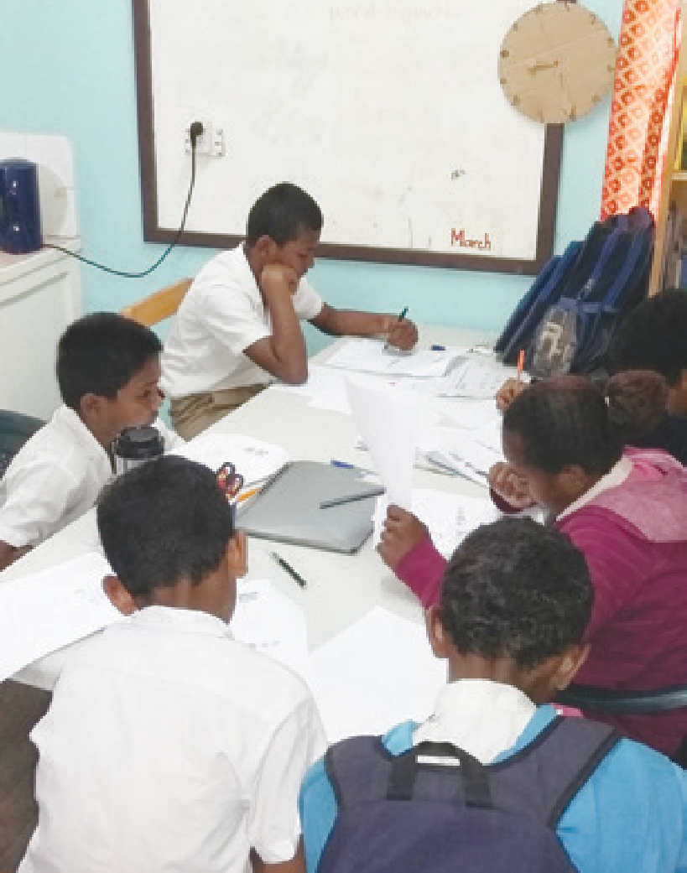Part C

The Pacific-INDIE

Part C presents the 48 indicators developed specifically to measure progress towards disability-inclusive education in the Pacific Island countries. They are presented within 10 dimensions related to different aspects of education (Table 2). For each dimension there
is one identified outcome with 1-12 recommended indicators to measure achievement of the outcome.
Information for each dimension initially provides the outcome and overall purpose. We strongly advise that information about each indicator be read in its entirety as leaving out some sections pertaining to an indicator is unlikely to provide true intent of the indicator. It may also have adverse effect on what information is collected and how it is interpreted.
For each indicator within the dimension information is provided on:
- outcome and purpose of the indicator;
- definition;
- data type and source;
- method for compiling and reporting data;
- who collects the data;
- frequency;
- interpretation of data; and
- limitations.
It is recommended that it might be appropriate for countries to consider disaggregating data by geographical region, city and urban, gender, age, disability type, type of school and year group for some indicators to gain more specific information if required.
In addition, systems may also wish to record data as percentages as well as numbers where appropriate.
A list of resources to support the indicators is included in the Appendix.

‘It seems that you are standing alone, but with input from everyone we can go on and make a difference.’

Ministry of Education workshop participant, Fiji

Dimension 1:

Policy and legislation

Outcome
Children’s right to disability-inclusive education is supported by legislation and/or policy.

Purpose
In order to enact education-related commitments to human rights treaties, including the United Nations Convention on the Rights of the Child, and the United Nations Convention on the Rights of Persons with Disabilities, governments must have laws that support fulfilment of these rights. The implementation of these laws relies on policies, often developed by relevant government Ministry, to provide details for schools and other agencies to clarify how to uphold the law.
Following the passage of legislation or policy, an important step is
the development of a national implementation plan or strategy and the allocation of an adequate budget to support implementation of these. The implementation plan for disability- inclusive education needs to be aligned with existing legislation and/or policy and approved by relevant government Ministry. Information on the percentage of schools that have implemented the plan is also important.

Indicator 1.1
Existence of legislation and/or national policy that clearly articulates the right to appropriate education for all children with disabilities.

‘We have been driving the cart without the horse but now we will have an inclusive policy.’

Principal, Solomon Islands

Definition
Legislation is law passed by parliament, which states the right for all children with disabilities to access appropriate and quality education. A policy is created at the national level and details how the government, schools, and other relevant agencies provide relevant supports to enable children with disabilities to access education.

Data type and source
The most important policy to monitor is likely to be developed and implemented by the relevant Ministry. Some schools may also have policies on education
of children with disabilities. There are other important types of legislation or government decrees that may
contain the relevant rights, such as the Education Act, Disability Discrimination Act, the Constitution, or Social Welfare Acts. Relevant policy documents may exist in various government Ministries.

Method for compiling and reporting the data
The data for this indicator needs to be collected as existence of legislation/ policy and should be recorded as:
- No.
- Yes.
If recorded as ‘yes’ then a list should be developed nationally and updated periodically, containing reference to all relevant legislation and policy. The list should include: Name of Legislation
or Policy, Date of enactment, Date of the last review (if undertaken), and References to relevant clauses.

Who collects the data?
Relevant Ministry responsible for compiling data. Analysis of who currently collects this
information and who will be best placed to continue collecting this data will be an important first step. This is dependent on the history of responsibilities of organisations in each Pacific Island country. Disabled Persons Organisations sometimes monitor legislation and policies so it may be appropriate to provide further support to formalise this role. Government officers responsible for reporting against policies and laws may already be undertaking reviews and updates.

Frequency
Every two years.

Interpretation
If no legislation/policy exists and then a government passes legislation or approves a policy, it is an important
indication of progress. A law that simply states access to education for all, without specifying children with disabilities,
may indicate less intention for specific action. However some governments use legislation more broadly and support this with strong and clear policies. The legislation and/or policy needs to be revised periodically in line with Pacific and international policy frameworks.

Limitations
This indicator merely asks for monitoring of the existence of legislation; it does not seek monitoring of their implementation. The presence of legislation is an important step in the process, but means that
the interpretation is limited. Some governments are strong on developing legislation but are not as good at ensuring implementation. Monitoring a variety
of indicators linked to the laws and policies (such as other indicators in these Guidelines) is important to determine whether they are being enacted.

Indicator 1.2
Percentage of education budget spent on implementation of disability- inclusive education policy and plan
at national and school levels.

Definition
National level: Total amount of the annual national education budget spent on costs related to the education of children with disabilities, as a proportion of the total education budget.
School level: Total amount of education budget spent in the 12 month reporting period on extra costs related to education of children with disabilities, as a proportion of total school expenditure.

Data type and source
National level: Relevant Ministry annual financial report.
School level: Annual financial report. A question should be included in the Education Management Information System (EMIS) form/website, linked to the school budget section.
Data collection on this indicator requires careful planning as this information may not be easily available. Specific budget lines may need to be developed to collate this information from different sources such as finance reports from infrastructure, education and others.

Method for compiling and reporting the data
The data for this indicator needs to be collected in numbers and reported in percentages based on budget spent on different disability-inclusive education activities in the previous year. Data should be recorded as follows:
Percentage of disability-inclusive education budget =
Budget allocated to disability inclusive education
× 100%
Total education budget
National level: Costs related to the education of children with disabilities are expenditure related to salaries of teacher assistants and other specialist staff, training programs, modifications to physical infrastructure, modified assessment processes, etc.
School level: Expenditure should be recorded for assistive devices, technologies, furniture (e.g. Braille machines, screen reading software, special seats or desks), teacher assistants, adaptations to physical environment, printing enlarged-font papers and assessments, specialist professional services, etc.

Who collects the data?
Education officer(s) responsible for the inclusive/special education budgets and policies at the National level. Head teacher/Principal (or delegate) and/or School Management Committees.

Frequency
Annual.

Interpretation
Information from this indicator will be useful to understand the commitment and progress made to address specific disability-inclusive education needs. This information may also be used for future budget allocation. The total amount spent on disability-inclusive education may be difficult to interpret unless these figures are cross-matched with the total number and proportion of children with disabilities enrolled and attending school figures.
In some countries Ministries other than Education may be involved in supporting disability-inclusive
education. This data could be recorded separately for in-country use.
More detail through individual budget lines will provide important
information, e.g. training costs, assistive technology, built environment, teacher assistants, etc. Sub-sectors that may
be collecting data on this indicator are Early Childhood Education, Primary and Secondary schools supporting children with disabilities.

Limitations
Costs spent on disability-inclusive education require detailed descriptions and discussions to accompany the total figures.

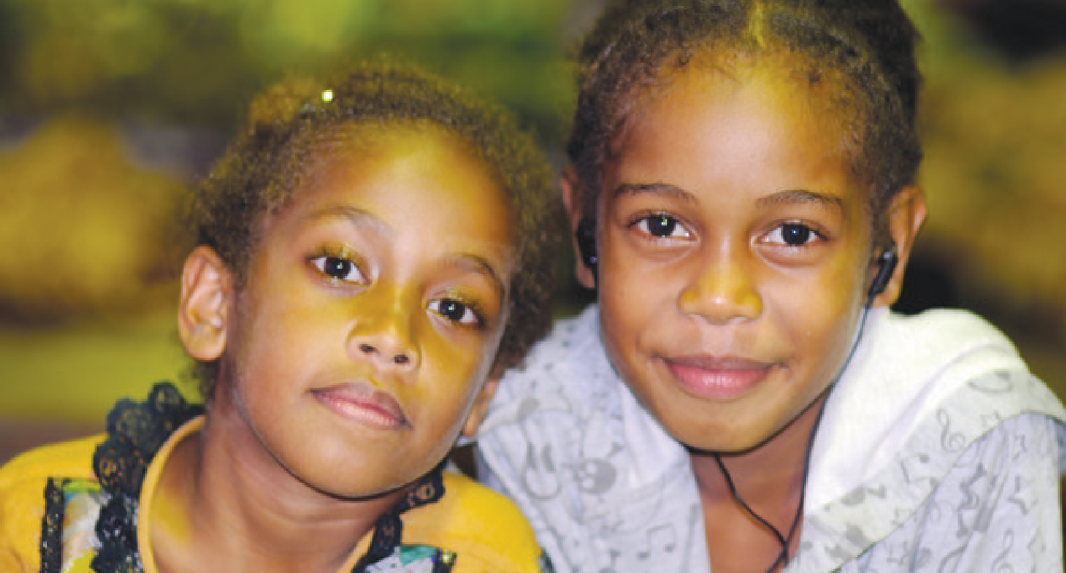Indicator 1.3
A national disability-inclusive education implementation plan is developed and aligned with relevant legislation and/or policy.

Definition
A national disability-inclusive education implementation plan includes objectives, actions, roles, responsibilities, monitoring and evaluation mechanisms, timelines and budget estimates, and
is aligned/consistent with relevant legislation and/or policy and the indicators. Alternatively, disability- inclusive education should be embedded within a national education plan rather than a separate plan.

Data type and source
A copy of the national disability-inclusive education implementation plan.

Method for compiling and reporting the data
Data should be recorded using the following categories:
- There is no plan.
- There is a plan but it is not aligned to relevant legislation/policy.
- There is a plan which is aligned to relevant legislation/policy.

Who collects the data
Relevant Ministry policy or legal officer.

Frequency
Four years or according to the national implementation plan timeline(s).

Interpretation
Where the disability-inclusive education implementation plan is not complete
or aligned to legislation or policies
there may be challenges that arise with implementation. For example, in relation to eligibility for services, numbers of teachers or teacher assistants allocated to schools, training or qualifications required, or support for transport.
In the Pacific context Churches and Village Councils play important role in community activities. Therefore,
they should be actively involved in the process of enacting relevant policies.

Limitations
The indicator provides no information on the quality of the implementation plan, or on the legislation or policies. If implementation plans are developed in line with legislation or policies that are
outdated or contradictory to contemporary understandings of rights to education,
it is advisable that these laws or policies be reviewed. This can be challenging as processes to adjust legislation and even policies can be very lengthy.

Indicator 1.4
A national disability-inclusive education implementation plan is approved by the relevant Ministry.

Definition
A national disability-inclusive education action plan, which includes objectives, actions, roles, responsibilities, monitoring and evaluation mechanisms, timelines (and preferably budget estimates), and which is approved by the relevant government/Ministry.

Data type and source
A separate national disability-inclusive education action plan. Alternatively, disability-inclusive education may be
embedded within a national education plan rather than a specific plan.

Method for compiling and reporting the data
Data should be recorded using the following categories:
- There is no approval.
- Approval is complete.

Who collects the data
Relevant education officer responsible for disability-inclusive education.

Frequency
Four years or according to the national implementation plan timeline(s).

Interpretation
The approval of a national action plan is a strong indication of progress towards disability-inclusive education. If there is an action plan, it should be included in the relevant Ministry’s M&E framework, so that there is accountability and
ownership of disability-inclusive activities. If progress against the national action plan is reported regularly, this is also an indication of government commitment.

Limitations
This indicator does not measure progress against the national action plan, so once the plan is approved by the relevant Ministry, a country may choose to refine this indicator to monitor implementation of the national action plan.

Indicator 1.5
Percentage of schools that have implemented a national/provincial disability-inclusive education plan.

Definition
The number of primary and secondary schools that have implemented the relevant responsibilities for schools, listed within the national disability- inclusive education implementation plan, as a proportion of the total number of primary and secondary schools.

Data type and source
The relevant Ministry may assign a dedicated officer to collect this information from all schools that i s then fed into the Education Management Information System (EMIS) form/website.

Method for compiling and reporting the data
Data should be collected in two stages. First the schools report whether they have implemented the disability- inclusive education plan or not. This data will then be collated by the relevant Ministry to calculate percentage as indicated below:
Percentage of schools =
Number of schools implemented the plan
× 100%
Total number of schools

Who collects the data
Education officer responsible for the inclusive/special education budgets and policies at the National level.

Frequency
Annual.

Interpretation
A growing proportion of schools implementing the national disability- inclusive education plan is a proxy indication of the country’s preparedness for fulfilment of the right to education for children with disabilities.
In some countries a plan for disability- inclusive education may be within other national/provincial plans.

Limitations
Until a country has developed its national disability-inclusive education plan and responsibilities of schools are defined and means of measuring fulfilment of those are determined, it is impossible to define what a school would have to undertake to have met this indicator.

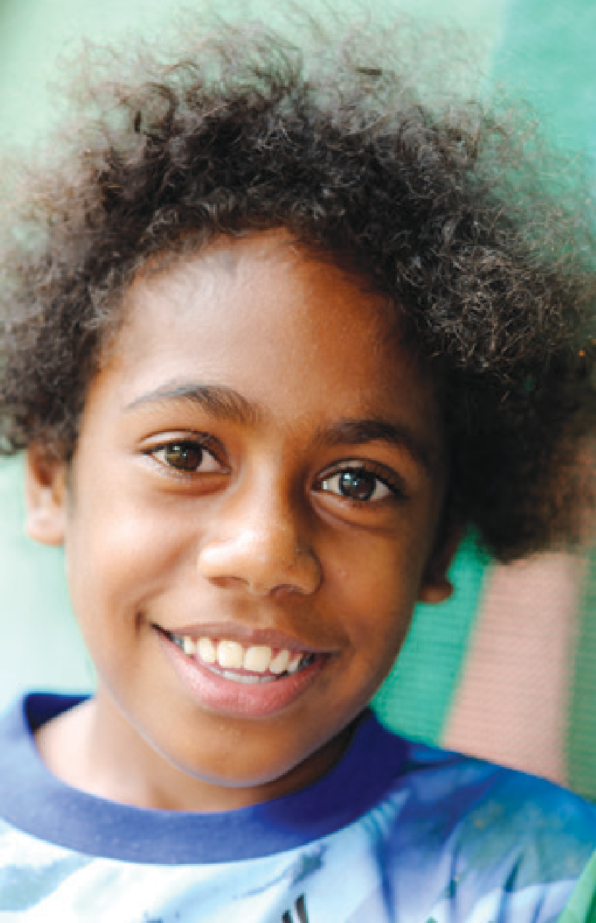Dimension 2:

Awareness of the rights of children with disabilities

Outcome
Communities are responsive to the rights of children with disabilities and their families, and the benefits of disability-inclusive education to the society.

Purpose
Community attitudes towards the education of children with disabilities have been shown to be one of the greatest barriers to accessing education. These can be attitudes that assume a lack of the potential for the children with disabilities to be educated, shame, over-protectiveness, or stigma and fear about the health condition leading
to the disability. Community-based programs frequently have multiple positive benefits, in terms of changing attitudes, increasing awareness of
the opportunities available through programs and services, linking people with disabilities and their families to community networks, and identifying children with disabilities who may be at home and not attending school.
Identifying the number of community awareness programs that focus on out of school children; those that
are designed and implemented in partnership with DPOs; and the number of parent education programs enabling them to support their children with disabilities will all assist in monitoring progress towards improving awareness of the educational needs of children with disabilities.

‘Use people with disabilities as champions of inclusive education to share on inclusive education during awareness programs.’

DPO Focus Group, Samoa

Indicator 2.1
Number of community awareness programs focused on out-of-school children with disabilities.

Definition
This indicator focuses specifically on community awareness programs such as community meetings, house-to- house campaigns, events at religious, social or sports gatherings, or media events, which focus on out-of-school children with disabilities as one of their objectives. Objectives may include actions to identify out-of-school children with disabilities, communicate or connect with children with disabilities and their families, inform them about opportunities for education, learn about their experiences in accessing or trying to access education, identify plans to overcome any barriers to education, link them with relevant services or supports. Out-of-school children with disabilities include those who have never attended formal education or have enrolled and then dropped out at some point during compulsory school years. It may also
be relevant to report measures taken to encourage advocacy for children with intellectual and social disabilities.

Data type and source
- Number of community awareness programs as per the definition.
- School records.
- Disability Persons’ Organisation (DPO) activity reports.
- Non-government organisation (NGO) records/activity reports.
- Religious organisations records/ activity reports.

Method for compiling and reporting the data
A record of activities could include Date, Activity, Location, Organisations
involved in undertaking the activity, purpose/objectives of the activity, description of the community targeted, estimated number of community members reached, names and details of out-of-school children with disabilities identified (including follow up actions required) and the planning committee’s reflections on notable results and actions arising from the event and notes for future events. A joint record of the activities with a copy each for the school and the DPO would be appropriate.
If the district or provincial offices or the relevant Ministry requires reporting on this indicator, an annual summary of this record could include number of activities, number of locations covered, and number of children with disabilities or their families reached.

Who collects the data
  - Head teacher/Principal (or delegate).
  - DPOs.
  - NGOs working in the community.
  - District or provincial offices or the relevant Ministry.
  - Community leaders or religious leaders.

Frequency
Annual.
The record should be updated each time there is a community awareness program with an objective of focusing on out-of-school children with disabilities. Individual child records should be updated regularly to record progress
in overcoming barriers to education.

Interpretation
Across the Pacific, a large number of children with disabilities remain out of school. Disability awareness programs targeting families and communities
of children with disabilities could be highly successful in enhancing access to education for/by this population. The results of this indicator are most useful
at a local level and at the level of the individual child. By recording progress against this indicator, schools, DPOs and NGOs are reminded to focus not only on children with disabilities in the school system, but to continue to reach out to those outside of the system. The records kept with individual details of
the children with disabilities can be used by an Inclusive Education Committee
(or nominated staff person from the school or the DPO) to follow up and remain connected with the children with disabilities and family and to record outcomes of the ongoing interactions.
Interpretation of the annual summary of this record can show trends in both the outreach activities undertaken, as well as the situation of out-of-school children with disabilities. By cross-matching
out-of-school children with disabilities identified in the community awareness activities, with enrolments, attendance and drop-out figures, the school
can keep track of progress in efforts towards disability-inclusive education. If children with disabilities enrol following an outreach campaign, it could be interpreted that the campaign has been successful. If, however, those children with disabilities drop out of school after some months, there is work required to address factors which support children to remain at school. Interpreting figures from this indicator is difficult at a national level, but local-level monitoring will be very important in tracking the issues faced by individual children
with disabilities.

Limitations
By simply monitoring the number of community awareness programs undertaken, there is little that can be understood in terms of results of the outreach. Undertaking the more detailed processes described in the method and interpretation sections
above will greatly enhance the ability for the school and community to monitor progress.

Indicator 2.2
Number of disability awareness programs designed and implemented in partnership with Disabled Persons Organisations (DPOs).

Definition
DPOs are local or national representative groups of people with disabilities
who are organised and skilled in communicating within communities to address negative attitudes about
disability, promote the rights inherent in the United Nations Convention on the Rights of Persons with Disabilities, provide role-models of people with disabilities as empowered and active citizens, and to facilitate links to services, networks and programs. Disability awareness programs can include a variety of activities with the purpose of increasing community awareness about disability and the right of people with disability to education, such as community meetings, house-
to-house campaigns, events at church or sports gatherings, or media events. This indicator is specifically measuring awareness programs that have been designed and conducted in partnership with DPOs.

Data type and source
    - Number of disability awareness programs as per the definition.
    - School records.
29

  - Disabled Persons Organisation activity reports.
  - NGO records and activity reports.

Method for compiling and reporting the data
Many DPOs (or any other organisations that conduct community awareness programs) record their activities for a variety of reporting purposes. Schools may also keep records on community activities. A record of activities could include: Date, Activity, Location, Organisations involved in undertaking the activity, purpose/objectives of the activity, description of the community targeted, estimated number of community members reached, and planning committee’s reflections on notable results and actions arising from the event, and notes for future events. A joint record of the activities with a copy each for the school and the DPO would be appropriate. If the district or
provincial offices or the relevant Ministry requires reporting on this indicator, an annual summary of this record would include number of activities, number
of locations covered, and number of community members reached.

Who collects the data
  - DPOs, NGOs, or any organisation that offers such programs.
  - Head teacher/Principal (or delegate).

  - District, provincial or national offices responsible for compiling data.

Frequency
Annual.
The list should be updated each time there is a community awareness program.

Interpretation
An increasing number of community awareness programs may indicate a greater emphasis on disability-inclusive education for children with disabilities. Tracking the geographic location of the programs, and cross-matching this with enrolments and attendance can provide a more qualitative sense of whether
the activities are resulting in greater access to education for children with disabilities. At a school level, an annual review of the record of activities may be useful in helping an Inclusive Education Committee (made up of school staff, community and service representatives) to plan actions for subsequent years.

Limitations
At a national level, the interpretation of this indicator may be limited because it only shows trends in the number of awareness programs, organisations involved and estimates on community
reached; it does not measure the results of the programs, for example positive changes in community attitudes.

Pacific-INDIE – The Guidelines Manual

Indicator 2.3
Number of parent/family education programs for supporting their children with disabilities.

Definition
Parent education programs can be organised by school staff, specialist staff or organisations, DPOs or relevant Ministry. They may cover a range
of issues including things such as: information on the specific health condition, impairment or disability the children with disabilities has and its impact on learning; approaches and methods to support access to education and to achieve maximum participation; information on services, networks and resources available; skills in supporting children with disabilities to utilise any relevant assistive technology; methods of supporting homework practices, assessment preparation, accessing information, and skills in alternative communication approaches.

Data type and source
    - Number of parent education programs as per the definition.
    - School records.
  - Records from other organisations district or provincial offices or the relevant Ministry.

Method for compiling and reporting the data
A list of the parent education programs could be compiled from record logs.
The data could include information on number, type and number of children with disabilities or their families who have accessed the program. Care should be taken how the information is collected and compiled
  - Total number of education programs provided for parents (e.g. if a disability rights session were provided to two different families at different times, this would be counted as 2).
  - Number and description of the different types of education programs undertaken (e.g. the same disability rights session provided to two different families at two different times would be counted only as 1 type of program).
  - The number of children with disabilities whose parents/family have participated in education programs.
  - The number of other sessions where disability has been included.

Who collects the data
  - Head teacher/Principal (or delegate).
  - District, provincial or national offices responsible for compiling data.

Frequency
Annual.

Interpretation
An increase in the number of parent education programs can be seen as a growing recognition by the school of the importance of involving parents and families in the children with disabilities’ education. In addition programs may be organised by local community groups or organisations.
Relevant Ministry could consider adding this indicator to the periodic inspection routine undertaken by district/provincial education officer (e.g. External School Review Inspection).

Limitations
The indicator does not seek
qualitative and quantitative information on the outcomes of the parent education programs.

Dimension 3:

Education, training and professional development

Outcome
The workforce is knowledgeable, competent and committed to implement disability-inclusive education.

Purpose
Implementation of disability-inclusive education requires that the workforce is adequately prepared, understands the philosophy behind disability-inclusive education and has the skills to implement effective practice. It is important for countries to collect information about this aspect of workforce preparation to ensure successful implementation of disability-inclusive education policies, including the number of trained educators and the types of training
that is available and completed.
Collecting information about a country’s training program for teachers will identify whether this includes
a mandatory course and practicum experiences on disability-inclusive education. Information on the number of accredited teacher assistants, together with data on the availability of continuing professional learning
about disability-inclusive education will detect the potential learning needs of the workforce to ensure they are able to provide disability-inclusive education.

‘Teachers need training on inclusive education so that they can become inclusive teachers in their classrooms... Also they need training on how to detect a child with special need in the class,
so that they can be able to better respond to that child’s need.’

Indicator 3.1
Teacher training curriculum includes a mandatory program on disability- inclusive education.

Definition
This indicator refers to a compulsory course on disability-inclusive education in a pre-service teacher education program.

Data type and source
All university/teacher education program teacher- training curricula as per the definition.

Method for compiling and reporting the data
Data on this indicator could be recorded using a four- point scale.
- No information covered.
- Some information covered
(if information about disability- inclusive education is covered in one or two lectures).
- Substantial information is covered (if a stand-alone subject covers the information on disability- inclusive education).
- Extensive information is covered (if information about disability-
inclusive education is covered in both a stand-alone subject and infused in other teacher education subjects).
Copies of the teacher education curriculum should be provided to the relevant Ministry and content should be highlighted that covers disability-inclusive education. Certification of teachers as

Who collects the data
  - Universities/Teacher education program providers.
  - District, provincial or national offices responsible for compiling data on teacher education, training and professional development. The information should also be made available to the relevant Ministry responsible for accreditation of teacher education programs.

Frequency
Annual and at the time of revising teacher education programs.

Interpretation
Data on teacher education curriculum including a compulsory course on disability-inclusive education provides an indication that new graduates are
prepared to implement disability-inclusive practices. The curriculum of teacher education programs should be reviewed carefully to determine if the information on disability-inclusive education is covered comprehensively in the program.

Limitations
A compulsory course on disability- inclusive education in the teacher- training curriculum itself does not ensure an effective, good quality rights based training for pre-service teachers on disability-inclusive education. In some university courses, information about disability-inclusive education could be covered at a very rudimentary level and would be unlikely to prepare teachers to work in inclusive classrooms. Universities may collect data about teacher trainees’

sufficiently educated to work with children attitude, knowledge and skills to teach

Key informant, Ministry of Health, Solomon Islands
with disabilities in inclusive classrooms would provide confirmation of training.
in inclusive classrooms to determine the efficacy of the program.

Pacific-INDIE – The Guidelines Manual

Indicator 3.2
Teacher education programs
include disability-inclusive education practicum experiences.

Definition
This indicator refers to the practice teaching experience in disability- inclusive educational settings during the teacher education program. Teacher
education programs include those run by universities or teacher training colleges (both government and private). Disability- inclusive practicum experiences must be in classrooms where children with disabilities are enrolled and in a disability- inclusive education setting for the indicator to be met.

Data type and source
Practicum records of universities and/ or other teacher education program providers as per the definition.

Method for compiling and reporting the data
Data can be recorded about placement in disability-inclusive classrooms as:
- No.
- Yes.
If yes then record number of hours.
Schools which place teachers for their practice teaching can provide data on the number of hours each trainee
has spent in inclusive classrooms to the universities. Universities or teacher
education colleges then can submit this data to relevant Ministry responsible for monitoring programs.

Who collects the data
Student practicum placement
co-ordinators of teacher education programs report to the relevant Ministry responsible for compiling data on teacher education, training and professional development.

Frequency
Annual.

Interpretation
The data on the disability-inclusive education practicum experiences during teacher education programs provide information regarding how the teacher education programs are
supporting teachers to become trained in a disability-inclusive educational setting. To strengthen the value of the information related to this indicator, different types of inclusive practices experienced by teacher trainees could also be recorded. Countries may consider making a requirement of a minimum number of hours to
be completed.
It is recommended that teacher education programs consider including a minimum required period within
disability-inclusive educational settings during the practice placements of
pre-service teachers. If the teacher education program does not include practice placements of teachers in disability-inclusive educational settings, it is recommended to consider revising/ amending the curriculum accordingly.
Accreditation of teacher education programs could take into consideration if relevant practicum in inclusive classrooms is integrated in the teacher education curriculum.

Limitations
The number of schools implementing disability-inclusive practices in regular classroom teaching may be limited. All teachers may, therefore, not be placed for a sufficiently long enough time in such a setting. Moreover, the way in which disability-inclusive practices
are defined and/or implemented at individual schools might be different, thus making accurate and comparable measurement of this indicator difficult. It may be useful for teacher education programs to identify schools that could be categorised as disability-inclusive schools. In some countries, there are demonstration schools that can be identified as ‘disability-inclusive schools.’ A record of the different disability- inclusive practices implemented would ensure a more accurate interpretation of the data and enable student teachers to reflect on practice with lecturers/tutors.

Indicator 3.3
Percentage of teachers in service who have received training in the last 12 months to teach students with disabilities.

Definition
Total number of in-service teachers who have attended at least one professional development program on disability-inclusive education as a percentage of the total number of
teachers in the school. The professional development program must be accredited by the relevant Ministry, or other relevant council on professional education for teachers.

Data type and source
    - Percentage of teachers, as per the definition.
    - School records or relevant Ministry database on teacher professional development,

Method for compiling and reporting the data
Data need to record total number of teachers undertaking professional development on disability-inclusive education at the school, district/ province, and national level as a percentage of the total number of teachers. It is recommended that
schools and Ministry also collect data on content covered during the training.

Who collects the data
  - Head teacher/Principal (or delegate).
  - District, provincial or national offices responsible for compiling data on teacher training and professional development.

Frequency
Annual.

Interpretation
The data on this indicator provides information about how much effort is put in to ensure that the workforce is constantly supported to learn necessary skills to implement disability-inclusive education.
Total numbers presented as percentages of whole school staff when compared over time provide a useful indication of how much the system is progressing.
To make effective use of data on this indicator (1) schools (or systems) could collect data on number of teachers who have completed programs with respect to the total number of teachers in the school (or district/province or the nation), and (2) they should collect the data over time.
See the formula below:
Percentage of teachers who have completed PD in disability- inclusive education =
Number of teachers who have completed PD
× 100%
Total number of teachers
If schools are currently not collecting data related to this indicator, then they may be supported in establishing a system of compiling this information by the relevant Ministry.
In addition similar data may wish to be collected on training for administrators (Ministry) and school principals.

Limitations
Data on this indicator will have limited usefulness if it is not clear to collection authorities what classifies as professional development on disability-inclusive education, There is a possibility that schools may report data on any type of professional development undertaken by their staff as being relevant to disability- inclusive education. Like teacher education courses, there is no guarantee that the activities will be of high quality. This limitation can be addressed by establishing a system where the relevant Ministry or other recognised body within the country accredits a professional development program. This will also be a useful step to ensure that the training is of high standard.

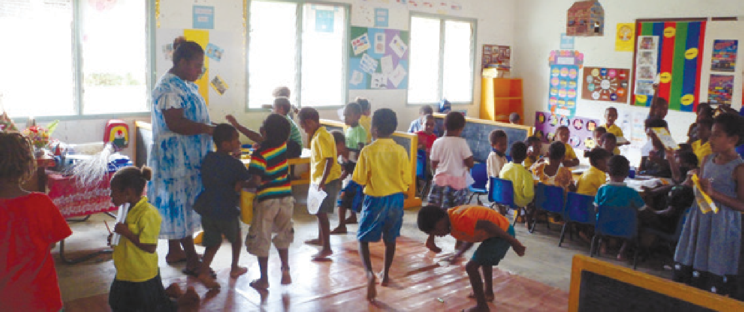Indicator 3.4
Number of teacher assistants who have completed accredited programs in disability-inclusive education.

Definition
Teacher assistants are adults hired to help teachers in the classroom with disability-inclusive education related activities. The number of teacher assistants, who have completed accredited programs, which are formally recognised by the relevant Ministry responsible for the relevant qualifications framework.

Data type and source
    - Number of teacher assistants as per the definition.
    - School records or relevant Ministry database.

Method for compiling a nd reporting the data
Data to be recorded of total numbers at the school, district, province and national level.

Who collects the data
  - Schools.
  - District, provincial or national offices responsible for compiling data on education workforce.

Frequency
Annual.

Interpretation
The data on this indicator provide information regarding the number of teacher assistants who have
undertaken accredited training in order to assist teachers in the classrooms. To provide effective support to teachers, training in disability-inclusive education is a strong advantage. Information about the type of training received (if any) allows for the better identification of the type of support that could be provided to upskill teacher assistants.
Increasing numbers of trained teacher assistants may indicate that the workforce is available and better
prepared to support schools to provide education for children with disabilities.
To make a more accurate interpretation of the data, schools can report the percentage of teacher assistants who have completed accredited teacher aide education program, using the following formula:
Percentage of teacher assistants who have completed accredited teacher aide education programs =
Number of teacher assistants completed accredited programmes
× 100%
Total number of teacher assistants

Limitations
The indicator does not specify whether the teacher assistants are working at schools, or whether the indicator is based simply on teacher aide trainees graduating. Certification of assistants as sufficiently educated to work with children with disabilities in inclusive
classrooms would provide confirmation of training.

Dimension 4:

Presence and achievement

Outcome
Increased enrolment, attendance and achievement of children with disabilities in education facilities.

Purpose
Implementation of disability-inclusive education requires that children with disabilities have a presence in schools by being enrolled in, attending, participating and achieving. To ensure that all
children are participating in schooling it is important to identify the specific number of children with disabilities enrolled at all levels of schooling.
Monitoring continued enrolment and participation is also important as
many children with disabilities tend to find staying engaged in school more challenging and experience greater drop- out rates than their peers. Regular data collection on the numbers of children with disabilities enrolled in and attending school allows for improving access to schooling to ensure that it meets their needs. In this way the drop-out rate can be minimised and enrolment maximised.
There are 12 specific indicators that are designed to capture information about enrolment, attendance and
achievement of children with disabilities.
Two indicators record information on the number of regular schools
enrolling children with disabilities and the percentage as a proportion of new entrants. Three indicators focus on the number of students enrolled in and successfully completing regular primary
in non-formal education programs. Two indicators report the number of children with disabilities meeting grade appropriate literacy and numeracy standards in national or school-based tests. The final indicator reviews the number of children with disabilities accessing post-school options.

Indicator 4.1
Number of regular schools enrolling children with disabilities.

Definition
The indicator refers to the number of Early Childhood Education (ECE) Centres, and regular primary and secondary schools who have enrolled children with disabilities.

Data type and source
- Number of schools as per the definition.
- Schools records.
- EMIS or similar database if schools report data on whether they enrol children with disabilities.

Method for compiling and reporting the data
Data could be collected in two stages. First the schools report whether they are enrolling children with disabilities.
This data can then be collated by the relevant Ministry to report on the number of schools that are enrolling children with disabilities within a district/province and at
a national level. At the national level, data on this indicator may also be reported as a percentage of the total number of children enrolled and disaggregated according to geographical region.

Who collects the data
- School level: Head Teacher/Principal.
- National level: Relevant Ministry responsible for compiling the data.

Frequency
Annual.

Interpretation
The data on this indicator provides information about the inclusion of children with disabilities in their local schools. This is essential to ensure that children with disabilities from all district/ provinces and school districts are being given access to education.

Limitations
A clear definition of what ‘enrolment’ means is important to ensure data are accurate. Enrolment should not simply be the placing of names on a register. It may need to relate to a minimum number of school days that children with disabilities participate in schooling per year.
To ensure accuracy of data there should be a clear definition and understanding of what is meant by ‘enrolment.’ It may be necessary to adopt external monitoring of data to quality assure its accuracy.

and secondary schools. Two more consider the number of children with disabilities who drop-out of school and of those the number that re-enrol.
Data are also collected on the number of children with disabilities who are enrolled
‘We have invited parents (of children with disabilities) to come to our school and when they see other children with disabilities engrossed in learning activities, their mind set is changed, next thing we see them bringing in their child for enrolment.’

Primary teacher, Fiji

Indicator 4.2
Number of children with disabilities completing primary school.

Definition
The indicator refers to the number of children with disabilities who complete primary school.

Data type and source
  - Number of children with disabilities as per the definition.
  - Primary schools’ records.
  - EMIS or similar database if primary schools report data on the children with disabilities.

Method for compiling and reporting the data
Data should be collected on the number of children with disabilities completing the final year of primary school at school, district, provincial or national levels. Data could also be recorded as a percentage of all children completing primary school and disaggregated by disability type, severity and gender.

Who collects the data
  - Head teacher, principal or delegate.
  - District/provincial or national offices responsible for compiling data on monitoring student completions.

Frequency
Annual.

Interpretation
The data on this indicator provides information about the completion rates of primary schooling for children with disabilities enrolled in regular primary schools. This will enable monitoring
of completions of primary schooling over a period of time. The data from schools can be used to identify districts/provinces where children with disabilities are completing primary schooling. It will also identify areas of concern that might require additional support to ensure that children with disabilities are able to complete primary school.
In some Pacific countries education is not just provided by schools but other organisations such as religious bodies. Information could be collected from those organisations as well.

Limitations
A clear definition of what ‘completion’ means is important to ensure data are accurate. Completion may need to
be related to achieving a minimum attendance across the primary school years and/or to obtaining identified outcomes depending on the specific country context. It may be necessary to adopt external monitoring of data to quality assure its accuracy.
Provided that there is a comparable understanding of the meaning of completion and all schools are required to submit this information, accurate data collection should be possible.

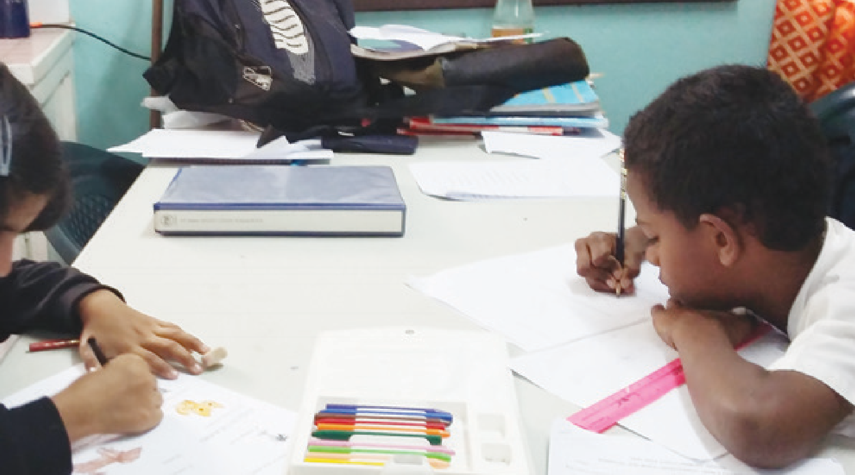Indicator 4.3
Number of children with disabilities completing secondary school.

Definition
The indicator refers to the number of children with disabilities who complete secondary school.

Data type and source
- Number of children with disabilities as per the definition.
- Secondary school records.
- EMIS if secondary schools report data on children with disabilities.

Method for compiling and reporting the data
Data should be collected on the number of children with disabilities completing secondary school at school, district,
provincial or national levels. This may be further disaggregated according to type of school. Data could also be recorded as a percentage of all children completing secondary school and disaggregated by disability type, severity and gender.

Who collects the data
- Head teacher, principal or delegate.
- District, provincial or national offices responsible for compiling data on monitoring student completions.

Frequency
Annual.

Interpretation
The data on this indicator provides information about the completion rates of secondary schooling for children with disabilities enrolled in regular secondary schools. This will enable monitoring of completions of secondary schooling
over a period of time. The data from schools can be used to identify schools where children with disabilities are completing secondary schooling. It will also identify areas of concern that might require additional support to
ensure that children with disabilities are able to complete compulsory years of secondary school.

Limitations
A clear definition of what ‘completion’ means is important to ensure data are accurate. Completion may need to be related to achieving a minimum attendance across the secondary school years or to obtaining identified outcomes. It may be necessary to adopt external monitoring of data to quality assure its accuracy.
Provided that there is a comparable understanding of the meaning of completion and all schools are required to submit this information, accurate data collection should be possible.

Indicator 4.4
Number of children with disabilities enrolled in regular primary and secondary schools.

Definition
The indicator refers to the number of children with disabilities who are enrolled in regular primary and secondary schools.

Data type and source
  - Number of children with disabilities as per the definition.
  - School records.
  - EMIS if schools report data on children with disabilities.

Method for compiling and reporting the data
Data should be collected on the number of children with disabilities enrolled at school, district, provincial or national levels.

Who collects the data
- Head teacher, principal or delegate.
- District or provincial offices or the relevant Ministry responsible for compiling data on monitoring student enrolments.

Frequency
Annual.

Interpretation
The data on this indicator provides information about the inclusion of children with disabilities in regular primary or secondary schools. It could further identify the year levels that children with disabilities are enrolled in. This would enable longitudinal monitoring of enrolments throughout
compulsory schooling and identify areas of concern that might require additional support to enrol children with disabilities.
Schools may also wish to collect information about the number of children with disabilities who are included in all aspects of the school and community life (e.g. clubs, teams, leadership positions, cultural activities) as an indication of the breadth of opportunities available to them
once enrolled.
Further data from this indicator could inform the proportion of children with disabilities accessing schooling at district, provincial or national level. Percentage can be calculated as follows:
Percentage of children with disabilities enrolled =
Number of children with disabilities enrolled
× 100%
Estimated total number of
children with disabilities in the district/province or in the country

Limitations
A clear definition of what ‘enrolment’ means is important to ensure data are accurate. Enrolment should not simply be the placing of names on a register. It may need to relate to a minimum number of school days that children
with disabilities participate in schooling per year. It may be necessary to adopt external monitoring of data to quality assure its accuracy.
Provided that there is a comparable understanding of the meaning of enrolment and all schools are required to submit this information, accurate data collection should be possible.

Indicator 4.5
Percentage of new enrolments of children with disabilities as a proportion of new entrants in regular schools.

Definition
The indicator refers to the number of new enrolments of children with
disabilities as a percentage of the total number of new enrolments in primary and secondary schools.

Data type and source
  - The percentage of children with disabilities as per the definition.
  - School reports or records and data- bases at district, provincial or national levels.

Method for compiling and reporting the data
At a school level data should be collected on the number of children with disabilities newly enrolled as a percentage of all newly enrolled students. Data could also be disaggregated by disability type, severity and gender.
At a district/provincial level data should be collected on the percentage of children with disabilities newly enrolled at all schools in the district/province compared to all enrolments.
At a national level data should be collected on the total percentage of children with disabilities newly enrolled in regular primary or secondary schools compared to all enrolments.
Percentage of children with disabilities newly enrolled =
Number of newly enrolled children with disabilities
× 100%
Number of all new student enrolments
This will also identify areas of concern that might require additional support to enrol children with disabilities.

Who collects the data
- Head teacher, principal or delegate.
- District, provincial or national offices responsible for compiling data on enrolment of children with disabilities.

Frequency
Annual.

Interpretation
The data on this indicator provides information about the percentage of newly enrolled children with disabilities enrolled in their local schools compared to all new enrolments. This helps to measure progress of increasing inclusion of children with disability over time. This is essential to ensure that children with disabilities from all districts/provinces are being given
access to education. It will also allow for long term monitoring demonstrating an increase in enrolments for children with disabilities.

Limitations
A clear definition of what ‘enrolment’ means is important to ensure data are accurate. Enrolment should not simply be the placing of names on a register. It may need to relate to a minimum number of school days that children
with disabilities participate in schooling per year.
Provided that there is a comparable understanding of the meaning of enrolment and all schools are required to submit this information, accurate data collection should be possible. To ensure accuracy of data there should be a clear definition and understanding of what is meant by ‘enrolment.’ It
may be necessary to adopt external monitoring of data to quality assure its accuracy.

Indicator 4.6
Percentage of children with disabilities attending school regularly.

Definition
The indicator refers to the number of enrolled children with disabilities who attend school regularly as a percentage of the total number of enrolled children with disabilities.

Data type and source
Method for compiling and reporting the data
The data for this indicator needs to be collected in numbers and reported
as percentages. Data could also be disaggregated by disability type, severity and gender. Data should be recorded as:
Percentage of children with disabilities attending regularly =
Number of enrolled children with disabilities attending regularly

Frequency
Annual.

Interpretation
Successful inclusive education requires more than just enrolment in school.
It is important to also measure the attendance rates of enrolled children with disabilities to ensure that they are participating sufficiently to access a quality education and to achieve appropriate outcomes.
It is essential that clear information

  - The percentage of children with × 100%
is provided at a national level about

disabilities as per the definition.
  - School records.
Number of enrolled children with disabilities

Who collects the data
- Head teacher, principal or delegate.
- District, provincial or national offices responsible for compiling data on enrolment of children with disabilities.
the expected attendance of children with disabilities. Monitoring of attendance is critical to ensure
that children with disabilities are consistently accessing education.

Limitations
It is important to have clarification as to what is meant by ‘attending regularly’ in local schools in order to collect comparable data at a national level.
40

Indicator 4.7
Number of children with disabilities meeting grade appropriate
literacy standards in national/ school-based tests.

Definition
The indicator refers to the number of children with disabilities who have participated in school-based, district, provincial or national literacy tests and have achieved grade appropriate standards. It is expected that where
necessary children with disabilities will have been able to access reasonable accommodations when taking these tests commensurate with what they normally require to complete their work in class e.g. additional time, alternative formats, and sign language interpreter.

Data type and source
  - Number of children with disabilities per the definition.
  - Data could include the type of literacy test and whether this is normed at school, district/province or national level. Data could be collected for
all aspects of literacy (e.g. reading, writing, spelling, and grammar and punctuation). Data could also be recorded as a percentage of all
children meeting grade appropriate standards and disaggregated by disability type, severity and gender.
  - School records and/or databases at District/provincial/national level.

Method for compiling and reporting the data
Data should be collected in numbers of children with disabilities achieving
grade appropriate literacy standards in all national/school-based/district wide tests.
School records.
EMIS if schools record this information on children with disabilities.

Who collects the data
- Head teacher, principal or delegate.
- District or provincial offices or the relevant Ministry responsible for compiling data on achievement standards for students in national/ school-based/district wide tests.

Frequency
Annual.

Interpretation
Successful inclusive education requires more than just attendance in school, it is important to also measure the progress of students to ensure they are achieving/ accessing a quality education. One way to do this is measure regular performance by pparticipation in high stake tests. This can lead to increased rates of participation in education, improved performance on district or provincial assessment measures, higher expectations and improved instruction. Yet children with disabilities are seen as being under-represented
in national and district or provincial testing and accountability measures in most countries. The reporting of
educational outcomes varies and does not necessarily reflect the ‘value’ that children with disabilities may have gained from their schooling.
The data on this indicator provides information about the achievement rates of children with disabilities in school-based, district, provincial or national exams. It will further identify
the areas of literacy that are most problematic for children with disabilities, which can guide curriculum planning to support them.
It is essential that the relevant Ministry provides clear information about when children with disabilities should be included in general testing to ensure the appropriateness of measures
for assessing achievement. The development of policy at a national level regarding participation in general testing by children with disabilities should provide clarity for schools.

Limitations
Internationally it is accepted that children with disabilities should be included in general district-wide assessment programs, with appropriate accommodations where necessary, with schools reporting annually on their participation rates, performance, and
progress. When children with disabilities cannot participate in testing, even
with accommodations, children with disabilities should be assessed using alternate assessments.
While recording information about children with disabilities who achieve grade appropriate literacy standards this should not exclude the enrolment of students who will be unable to achieve these due to their disability. Students with different abilities such as intellectual disabilities may need to be assessed using different approaches and, therefore, will not be included in national/school- based/district wide tests.
Access to exams alongside peers is a critical outcome for children
with disabilities to measure literacy achievement and to provide admission to opportunities for further study or work. See Dimension 9: Curriculum
& Assessment Practices for further information about what reasonable accommodations may be required to enable children with disabilities to participate in these exams.

Indicator 4.8
Number of children with disabilities meeting grade appropriate numeracy standards in national/school-
based tests.

Definition
The indicator refers to the number
of children with disabilities who have achieved grade appropriate numeracy standards in district, provincial or national tests. It is expected that where necessary children with disabilities will have been able to access reasonable accommodations when taking these tests commensurate with what they normally require to complete their work in class e.g. additional time, alternative formats, sign language interpreter.

Data type and source
The number of children with disabilities as per the definition.
Data should include the type of numeracy test and whether this is a school, region or national level test. Data should be collected on all aspects of numeracy (e.g. number, measurement, etc. Data could also be recorded as
a percentage of all children meeting grade standards and disaggregated by disability type, severity and gender.
School records and/or databases at district, provincial or national level.

Method for compiling and reporting the data
Data should be collected in numbers of children with disabilities achieving grade appropriate numeracy standards in all district, provincial or national wide tests.
School records.
EMIS if schools record this information on children with disabilities.

Who collects the data
- Head teacher, principal or delegate.
- District or provincial offices or the relevant Ministry responsible for compiling data on achievement standards for students in district, provincial or national wide tests.

Frequency
Annual.

Interpretation
Participation in high stake tests for children with disabilities has led to increased rates of participation in education, improved performance on district or provincial assessment measures, higher expectations and
improved instruction. Yet children with disabilities are seen as being under- represented in national and district or provincial testing and accountability measures in most countries. The reporting of educational outcomes varies and does not necessarily reflect the ‘value’ that children with disabilities may have gained from their schooling.
The data on this indicator provides information about the achievement rates of children with disabilities in school-based, district, provincial or national numeracy exams. It will further identify the areas of numeracy that
are most problematic for children with disabilities, which can guide curriculum planning to support them.
It is essential that Ministry provide clear information about when children with disabilities should be included in general testing to ensure the appropriateness
of measures for assessing achievement. The development of policy at a national level regarding participation in general testing by children with disabilities should provide clarity for schools.

Limitations
Internationally it is accepted that children with disabilities should be included in general district-wide assessment programs, with appropriate accommodations where necessary, with schools reporting annually on their participation rates, performance, and
progress. When children with disabilities cannot participate in testing, even
with accommodations, children with disabilities should be assessed using alternate assessments.
While recording information about children with disabilities who achieve grade appropriate numeracy standards this should not exclude the enrolment of students who will be unable to achieve these due to their disability.
Students with different abilities such as intellectual disabilities may need to
be assessed using different approaches and, therefore, will not be included in national/school-based/district wide tests. Estimates of the prevalence indicate that only 1-2% of all students will need to take alternate assessments.
Access to exams alongside peers is a significant outcome for children
with disabilities to measure numeracy achievement and to provide admission to opportunities for further study or work. See Dimension 9: Curriculum
& Assessment Practices for further information about what reasonable accommodations may be required to enable children with disabilities to participate in these exams.

Indicator 4.9
Number of children with disabilities dropping out of school.

Definition
The indicator refers to children with disabilities who having enrolled in a regular school then drop-out each year.

Data type and source
  - Number of children with disabilities as per the definition.
  - School records and/or databases at district, provincial or national level.

Method for compiling and reporting the data
Data should be collected on the number of children with disabilities who drop-out in each school year at school, district, provincial or national levels. Data could also be recorded as a percentage of all children dropping out of school and disaggregated by disability type, severity and gender.

Who collects the data
  - Head teacher, principal or delegate.
  - District or provincial offices or the relevant Ministry responsible for compiling data on monitoring student drop-outs.

Frequency
Annual.

Interpretation
To drop-out of school means leaving for practical reasons, necessity, or disillusionment with the system.
Many students will quit school before graduating to avoid failing in exams, bullying, or to go to work. Children with disabilities have higher rates of drop-out than their peers.
The data on this indicator provides information about the drop-out rates of children with disabilities enrolled in either regular primary or secondary
schools. The data from schools can be used to identify areas where children with disabilities are dropping out of schooling. It will also identify areas of concern that might require additional support to ensure that children with disabilities are able to complete
43

primary or secondary schooling. This will enable monitoring of drop-outs across the school years over a period of time. In contrast to most other indicators, reduction in the number on this indicator is a sign of the school/or system making progress in achieving disability-inclusive education.

Limitations
A clear definition of what ‘drop-out’ means is important to ensure data are accurate. This may need to be related to being absent for a specified time frame (e.g. half a year or four consecutive weeks) or to receiving notification that children with disabilities will no longer be attending school.
Provided that there are national guidelines as to the meaning of drop- out and all schools are required to submit this information, accurate data collection should be possible.

Indicator 4.10
Number of dropped out children
with disabilities who have re-enrolled.

Definition
The indicator refers to the number of children with disabilities who were previously enrolled in school, dropped out of schooling and then subsequently re-enrolled in either
primary or secondary schooling. It does not include children with disabilities who are enrolling in a school for the first time.

Data type and source
    - Number of children with disabilities as per the definition.
    - School records and/or databases at district, provincial or national level. Relevant Ministries collate this data from schools.

Method for compiling and reporting the data
Data should be collected on the number of children with disabilities re-enrolling in school after a period of drop-out at school, district, provincial or national levels. Data could also be recorded as a percentage
of all children dropping out of school and re-enrolled and disaggregated by disability type, severity and gender.

Who collects the data
District, provincial or national offices responsible for compiling data on monitoring student re-enrolments.

Frequency
Annual.

Interpretation
Data on this indicator would be easier if each student had a unique identification number to record data on EMIS.
The data from schools can be used to identify areas where children with
disabilities are re-enrolling in schooling after a period of absence. It will also identify areas of concern that might require additional support to ensure that children with disabilities are able to complete primary or secondary schooling. This will enable longitudinal monitoring of re-enrolments across the school years.

Limitations
This may need to be related to being absent for a specified time frame (e.g. half a year) after dropping out of school.
To ensure accuracy of data there should be a clear national definition and understanding of what is meant by
‘re-enrolment.’ It may be necessary to adopt external monitoring of data to quality assure its accuracy.

Indicator 4.11
Number of children with disabilities enrolled in Non-Formal Education (NFE) programs.

Definition
Non-formal education (NFE) is any organised and sustained educational activities that are not within the formal education system of schools, colleges and universities. NFE is an effective way to reach out of school children with disabilities. NFE may take place within and outside educational institutions and cater to persons of all ages. Depending on country contexts, it may cover educational programs to impart basic education for out-of-school children or work skills. In some countries this may include traditional approaches such as weaving fine mats and planting taro/ bananas and serving (tautua).
This indicator includes children with disabilities who have been or are currently enrolled in NFE programs during the 12 months leading up to data collection.

Data type and source
- National surveys such as Multiple Indicator Cluster Surveys (MICS), Demographic Health Surveys and disability surveys or NFE-MIS.
- Reports from organisations conducting NFE programs.

Method for compiling and reporting the data
Data should be collected in numbers and may be obtained from a variety of national level surveys. Data could also be recorded as a percentage of all children enrolling in NFE and disaggregated by disability type, severity and gender. A question on enrolment in NFE programs needs to be included on a national survey and the survey must have means of disaggregating by disability. Countries may use different surveys and there are a range of these which may be relevant for including a question that could gather data to answer this indicator.
For example, the UNICEF 5-yearly Multiple Indicator Cluster Survey, or a national Demographic Health Survey, or a national Living Standards Survey. Consultation with the Central Statistics Office will inform the decision of which survey process is relevant.

Who collects the data
District, provincial or national offices responsible for compiling data.

Frequency
Linked to the timing of national surveys,
e.g. MICS surveys are 5-yearly.
NFE-MIS will have more regular options for data collection.

Interpretation
A high participation rate of children with disabilities in NFE may indicate a national context where lifelong learning is available and accessible to children with disabilities. However, interpretation of the number of children with disabilities enrolled is difficult without additional information to understand whether NFE is replacing formal education. Enrolment of children with disabilities in NFE within the age-bracket of primary or secondary school may indicate that the formal education system within a specific location needs to become proactive in educating children with disabilities.

Limitations
The indicator does not describe the quality of the program and it does not provide information on the outcomes of the NFE. Collection of additional
information such as the content covered and outcomes would add more value.

Indicator 4.12
Number of children with disabilities accessing incentive programs
for education.

Definition
Number of children with disabilities who receive incentives with the conditionality of enrolling and/or attending primary or secondary school, within the year of reporting.
Incentive programs can be government or non-government. Incentives program may consist of any of the following: scholarships, fee waiver
or cash incentives, free meals, free uniform, free stationery items, and free transport facilities.

Data type and source
- Number of children with disabilities as per the definition.
- School records and/or district, provincial or national level databases.

Method for compiling and reporting the data
Data should be collected from individual student files on the number of incentive programs received. Data could also be recorded as a percentage of all children accessing programs and disaggregated by disability type, severity and gender.
A question could be included in the Education Management Information System (EMIS) annual census form, or EMIS student record the EMIS if accessed through a website.

Who collects the data
- Head teacher, principal or delegate.
- District, provincial or national
offices responsible for compiling data from EMIS.

Frequency
Annual.

Interpretation
Data on access to incentive programs can be cross-matched with data
on enrolments and attendance to investigate correlation between the data.

Limitations
Children with disabilities who receive incentive programs but do not enrol or attend will not be captured by this analysis. Data is
unlikely to be available on this indicator unless school level student files are adapted, and the annual EMIS census includes a new question.
46

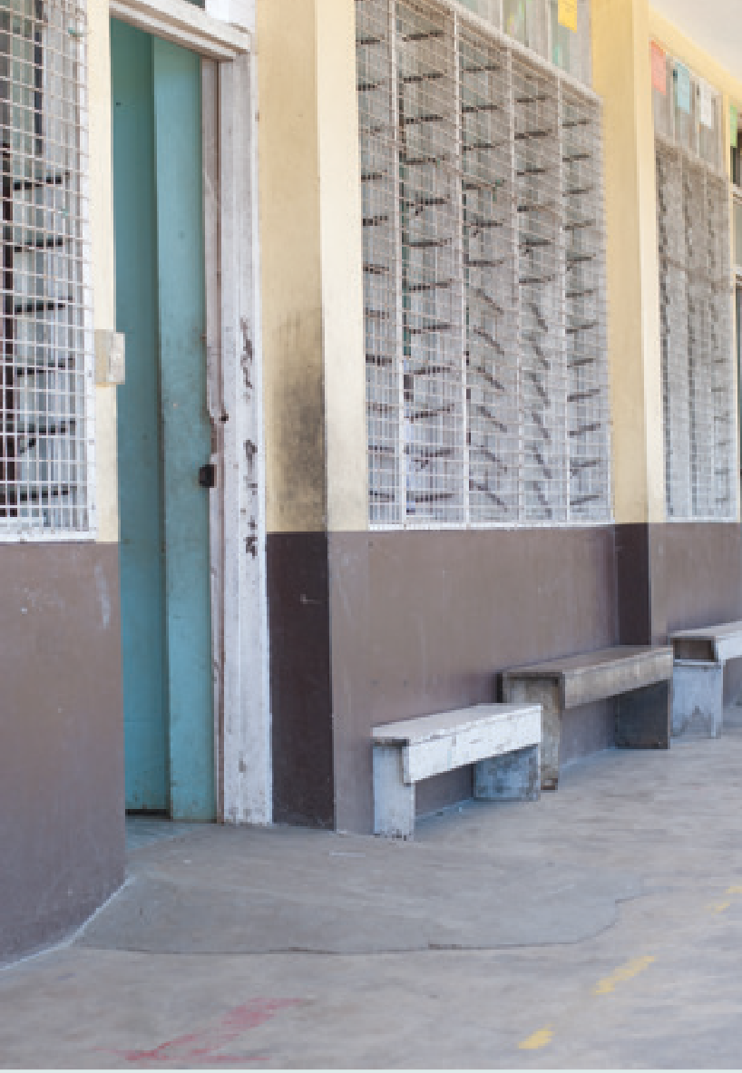Dimension 5:
and transport

Physical environment

Outcome
Education facilities are accessible to children with disabilities.

Purpose
Implementation of disability-inclusive education requires that children with disabilities are able to physically access education facilities.
There are two specific indicators that are designed to capture information about access to education facilities. These relate to transport and physical access of the buildings.
Transport to education facilities maybe essential for some people with physical disabilities. Vehicles need to provide easy and safe physical access and accommodate wheelchairs where required. All buildings need to be enabled for access by children with disabilities. This includes but is not limited to those who use wheelchairs, crutches or other walking devices, physically frail, visually impaired, or height restricted.

‘If all the Form 4 strands are upstairs, may be the one which has the student in a wheelchair should move down to the ground floor. All you need is to enlarge the toilets to fit the wheelchair and buy a bag of cement to build up the ramp for the wheelchair to come into the basement of the bottom floor classroom.’

Primary school head teacher, Fiji

Indicator 5.1
Percentage of schools (primary, lower and upper secondary) with adapted infrastructure and materials for students with disabilities.

Definition
The indicator refers to schools that provide adaptations according to local building requirements to infrastructure and materials to allow students with disabilities to attend. This should be calculated as a percentage of all schools within the country.

Data type and source
  - The percentage of schools as per the definition.
  - School records and government audits on building design.

Method for compiling and reporting the data
The data for this indicator needs to
be collected in numbers and reported in percentages.
A process needs to be developed to identify whether schools are providing appropriate adaptations and materials.
The relevant Ministry should compile this data from the schools in the district/ province to calculate the percentage
as below:
Percentage of schools =
Number of schools meeting requirements
To obtain this information, schools could collect data on the way in which they provide physical access for children with disabilities to their facilities.

Who collects the data
- Head teacher, principal or delegate in support with a trained officer.
- A DPO representative could be trained to undertake the assessment and assist schools in data collection.
- District/provincial or national offices responsible for compiling data auditing on school access and/or monitoring implementation of the Code.

Frequency
Annual.

Interpretation
The data on this indicator provides critical information about physical access for children with disabilities to school facilities. The data from schools can be used to identify access issues that need to be addressed nationally, district/province, or locally. The data at district/provincial level could provide an overview of schools available to accommodate the needs of children with disabilities. The data from all district/provinces in a country could be compiled to calculate the data at national level to identify support that needs to
be provided to ensure requirements for access are met at all levels.

Limitations
The development of a standard checklist in collaboration with the local DPO to be used by all schools for identifying physical access options would provide a consistent way of collecting and collating data. Information could be sought on the availability of access devices such as ramps or lifts; use of handrails or other supports; heights of control buttons,
or alternative mechanisms for reading instructions e.g. braille.
Consideration could also be given to access within classrooms for the use of appropriate desks, augmentative
devices, or visual supports etc. Physical access to appropriate toilet facilities and to all sections of the school building including doors, raised areas e.g. a stage, and recreational areas, are also important aspects to consider.

× 100%
Total number of schools

Indicator 5.2
Number of school transport vehicles that are accessible for children
with disabilities.

Definition
The indicator refers to the number of any vehicles that are currently being used for access to the school or for transport to other facilities provided by the school as part of the school day.
Only vehicles that are owned or rented by the schools or educational authority are to be counted to obtain data for this indicator.

Data type and source
  - Number of school transport vehicles as per the definition.
  - Information on whether the vehicles can accommodate wheelchairs and/ or provide easy physical access may be recorded.
  - School records and/or district, provincial or national level office records.

Method for compiling and reporting the data
The data for this indicator need to be collected in numbers. The data can be recorded at the school level
asking schools to record any transport facilities that it provides to children with disabilities. At a school level data should be collected on the number and type of vehicles provided that can accommodate children with disabilities and the frequency that these are used. Information on any modifications made to vehicles
to provide physical access should be recorded. At district/province and national levels data should be collected on the number of schools
that provide accessible vehicles for children with disabilities.

Who collects the data
- Head teacher, principal or delegate.
- District, provincial or national offices responsible for compiling data on the provision of vehicles for school access.

Frequency
Annual.

Interpretation
The data on this indicator provides information about how children with disabilities can access school and participate in school related outings.
The data from schools can be used to identify access issues that need to be addressed locally. The data at
district/province level could provide an overview of schools with appropriate transport available to accommodate the needs of children with disabilities. The data in a country could be compiled
to calculate the data at national level to identify system support that needs to be provided to ensure children with disabilities are able to access schools.
If children with disabilities are unable to reach a school due to distance or a lack of transport then they will be unable
to participate in disability-inclusive education. If a parent or carer and/or the school are experiencing challenges in managing transport for children with disabilities and funding is not available to assist them, then they may be unable to support their attendance.
Children with disabilities living in remote areas may experience greater disadvantage if accessible transport to school is unavailable.
In all instances it is essential to consider alternative ways to enable children with disabilities to reach school.
Consideration could be given to the use of public transport or a roster system
to support children with disabilities to reach school. To fund this it may be necessary to establish a transport
assistance program that could provide financial support where necessary to arrange public transport, provide travel passes, or for contracting specialised taxi or minibus services where available.
The provision of accommodation for children with disabilities living in remote areas to attend a local school by residing close by during the week may also provide a viable option. Ministries may wish to establish disability standards for accessible public transport and use this to map data against.
The relevant Ministry may also wish to consider establishing a transport assistance program where funding could be made available on a needs basis to cover the costs of transport to and from schools for children with
disabilities. Data could then be collected on the number of schools and amount of funding allocated to support this
see e.g. Queensland school transport assistance for students with disabilities program at: http://education.qld.gov. au/students/transport/parents.html

Limitations
Information on the use of vehicles may not be available to schools if parents organise their own transport. It may be necessary to undertake regular surveys of children to identify how they access the school.
Data reported are for school-based transport. It is acknowledged that local community transport arrangements may be in place.

Dimension 6:

Identification

Outcome
Children with disabilities are identified through referral or screening processes.

Purpose
Implementation of disability-inclusive education requires that children with disabilities are identified and provided with necessary services.
There are four specific indicators in this category. A key purpose of these indicators is for systems to be able to identify children with disabilities as soon as possible so that necessary services can be provided by targeting
schools or communities that need such services. Information on schools that report on the number of children with disabilities, those that carry out disability screening programs and also provide parent information sessions on referral processes, provides an indication of how schools are working towards disability- inclusive education.

Indicator 6.1
Education Management Information System (EMIS) records data on children with disabilities.

Definition
A number of countries across the Pacific either have an EMIS system or they are in the process of setting one up. It is recommended that any existing EMIS or a similar database be modified to collect data on children with disabilities.

Data type and source
Information collected in EMIS on children with disabilities.

Method for compiling and reporting the data
The data for this indicator needs to be collected in three categories:
- There is no EMIS.
- There is an EMIS but no data are collected on children with disabilities.
- There is an EMIS and data are collected on children with disabilities.

Who collects the data
District, provincial or national offices responsible for compiling data.

Frequency
Annual.

Interpretation
The data on this indicator provides information about the recording procedures for the number of children with disabilities by the relevant Ministry for monitoring progress with regard to access to education.
A number of countries across the Pacific already have or are in the process of setting up an EMIS. It may be useful to collaborate with such countries and work in partnership with Pacific Islands Forum Secretariat to set up EMIS system that is suitable for the local and district/ provincial needs.

Limitations
If countries only report on whether the EMIS collects data on children and young people with disabilities, it will be difficult to interpret the quality and
validity of the data from the system. It is important that countries are reporting all three categories of response to this question and also the type of data that is collected. Ideally countries would be able to demonstrate the process used by head teachers to report on disability in the EMIS.

‘It is very important for children with disabilities enrolled at pre-school level to have the continuous support of the parents. Parents need training, the same as the training given to the teachers about how to support the children with disability. In Fiji we need to conduct a lot of awareness telling the parents about the rights of children with disabilities to be educated.’

Primary teacher, Fiji

Indicator 6.2
Number of schools reporting on the number of children with disabilities to the relevant Ministry.

Definition
The indicator refers to the number of schools that report on numbers of children with disabilities enrolled.

Data type and source
Number of schools as per the definition.
The relevant Ministry can obtain information on the number of schools that report data on children with disabilities. The relevant Ministry can collate this information either from within the EMIS or by other means.

Method for compiling and reporting the data
- Data should be collected in numbers. It is suggested that systems may also wish to record data as a percentage of all schools.
- Relevant Ministry.
51

Who collects the data
District, provincial or national offices responsible for compiling data on the number of students enrolled.

Frequency
Annual.

Interpretation
The primary purpose of this indicator is to record the number of schools that are proactive in reporting on the inclusion of children with disabilities. The data on this indicator provides information about how many schools are identifying children with
disabilities in their schools. Unless this information is available to the relevant regional offices or Ministry, provision of the necessary resources could be difficult to target. Information from this indicator needs to be interpreted in combination with other specific indicators within this category for effective planning.

In addition to recording numbers the district/provincial office or the relevant Ministry may also want to calculate percentages from this data. The number can be converted into percentages as follows:
Percentage of schools reporting on children with disabilities =
Number of schools reporting on children with disabilities
× 100%
Total number of schools
Washington Group on Disability Statistics has developed a set of questions to identify children and young people at risk of functional limitations and disability. These questions focus on functional aspects of disability rather than medical aspects of disability.
They are included in Appendix.

Limitations
There should be clear national guidelines in defining and identifying children with disabilities to ensure consistency of reporting from schools.

Indicator 6.3
Number of parent information sessions on referral processes.

Definition
The indicator refers to the number of parent information sessions conducted by schools supported by relevant Ministries and DPOS’s on the services available within the community to provide support for children with disabilities.

Data type and source
  - Number of parent information sessions as per the definition.
  - School records.
  - The organisations providing the information sessions and the relevant district or provincial office and/or to the Ministry.

Method for compiling and reporting the data
The data for this indicator needs to be collected in numbers. Authorities conducting such sessions may report the number of sessions to their
regional office. The district or provincial office can then compile the data and provide it to the relevant Ministry. It is suggested that systems may also wish to record data as a frequency of all schools and disaggregate according to geographical region.

Who collects the data
  - Head teacher, principal or delegate.
  - District, provincial or national offices responsible for compiling data.

Frequency
Annual.

Interpretation
The data on this indicator provides information about what the different educational authorities are doing to ensure that parents/carers are able to access support for children with
disabilities. Data on this indicator would indicate which district/province (and schools) is proactive in supporting parents to seek outside support. Countries may like to make this a priority and identify providing such sessions as an important task for educational authorities.

Limitations
If appropriate information is not covered during the information session, and, if the sessions are not attended by parents whose children with disabilities require additional support or diagnosis then the indicator will have limited use. It may be useful to develop the parent sessions in consultation with local DPO members and teacher education institutes with inputs from the relevant Ministry.
Parents of children with disabilities who are already enrolled in schools and accessing community support options could be involved in the delivery of information sessions.

Indicator 6.4
Number of schools conducting a disability screening program.

Definition
The indicator refers to the number of schools that carry out a disability screening program(s) to identify children with disabilities. Countries should define what a screening
program consists of based on resources and context. Most screening programs would be designed to identify learners with special educational needs so that appropriate intervention and support may be provided to enable them to engage in learning.

Data type and source
    - Number of schools as per the definition.
    - School records.
    - Records of service providers.

Method for compiling and reporting the data
The relevant Ministry should obtain information on the number of schools conducting a disability -screening program. The relevant Ministry should collate this information either from within the EMIS or by other means.
It is suggested that systems may also wish to record data as a percentage of all schools and disaggregate according to geographical region.

Who collects the data
District, provincial or national offices responsible for compiling data on the number of schools conducting disability screening programs.

Frequency
Annual.

Interpretation
The data on this indicator provides information about how many schools are proactive in identifying children with disabilities by conducting disability
-screening programs. Unless this

information is available to the relevant regional offices or Ministry, provision of the necessary resources could be difficult to target. Information from this indicator needs to be interpreted in combination with other specific indicators within this category for effective planning.
The district or provincial office or the relevant Ministry can then calculate the total number from this data. The number can also be converted into percentages as follows:
Percentage of schools with
a disability screening program =
Number of schools carrying out disability screening programme
× 100%
Total number of schools

Limitations
There should be clear national guidelines in defining and identifying children with disabilities to ensure consistency of identification at all schools. It is also important to ensure that the quality of any screening program is adequate to identify all children.

Dimension 7:

Early intervention and services
‘Health plays a vital part in identifying children with disabilities and referring them to appropriate providers of services who can then support schools.’

Samoa

Outcome
Children with disabilities receive timely access to appropriate disability services including early intervention.

Purpose
Implementation of disability-inclusive education requires that children with disabilities have appropriate access
to relevant disability services. These services include early intervention programs, use of referral systems to seek support, rehabilitation, medical interventions, and provision of assistive devices and technologies to assist them with participating in education fully.
There are five specific indicators designed to identify if children with disabilities get timely access to appropriate disability services including early intervention services. Indicators collect data on the number of schools using a referral system for early intervention services, referring children with disabilities for health and rehabilitation services and the number of children provided with relevant assistive devices and technologies. The number of schools with access to specialists and the number of specialists available to support the inclusion of children with disabilities is also collected.

Indicator 7.1
Number of children with disabilities who are provided with relevant assistive devices and technologies.

Definition
This indicator refers to the number of children with disabilities who are
provided with the assistive devices and technologies to support them to access quality education. ‘Assistive devices and technologies’ includes items such
as: wheelchairs/crutches/white canes, glasses, screen-reading software, magnifying glass, Braille machines, hearing aids and gripping devices.

Data type and source
  - Number of children with disabilities as per the definition.
  - This indicator should be disaggregated by the type of device or technology provided.
  - School records and district, provincial or national level databases/records.
  - In some countries a resource centre could be providing all assistive devices. If this is the case then the data about assistive devices could be collected from such centres.

Method for compiling and reporting the data
The data for this indicator should be collected in numbers. It is suggested that systems may wish to record data as a percentage of all children with disabilities and disaggregate data by disability type, severity and gender.
Schools could record the number of children with disabilities who are provided with assistive services or
technologies. It is important that schools need to classify/categorise the type of assistive services children with disabilities are provided with to make the data more explanatory. The data can be compiled at district, provincial or national level.

Who collects the data
  - Head teacher, principal or delegate.
  - District, provincial or national offices responsible for compiling data on the availability of assistive devices and technologies for children with disabilities.

Frequency
Annual.

Interpretation
Data on this indicator provides information on the number of children with disabilities who are provided with assistive devices and technologies
to ensure that they are supported effectively to meet the demands of everyday learning at schools. Along with the number, it would be useful to record the type of disability and the type of assistive device each person receives.
Countries may need to establish a system of providing assistive devices to children with disabilities who need it if they currently do not have one.
The indicator could be enhanced by schools collecting information on the total number of children with disabilities who have and use assistive devices or technology, irrespective of whether the child received the device within that year. This would assist an understanding of how many children are using devices/ technologies. In many places in the Pacific, DPOs are in a good position to support networking and referrals to assistive devices/technologies where they exist.

Limitations
Provision of assistive devices itself does not imply the use of these devices. The data on the number of children with disabilities provided with the assistive devices may not represent the number of children with disabilities who would be using these. It may be useful to gather information about the usefulness of assistive devices from the students themselves, teachers, or their parents. Training in the use of assistive devices is also critical.

Indicator 7.2
Number of schools that have used a referral system to access early intervention services.

Definition
This indicator refers to the number of schools that have used a district or provincial referral system (if any), or a local referral systems (possibly maintained
by health and rehabilitation centres or early intervention offices) consisting of a formal process developed to refer children to access early intervention
services for children with disabilities. Early intervention services may include access to specialist treatment, diagnosis, special programs, resources or technology.

Data type and source
    - Number of schools as per the definition.
    - School records, service providers, or other records.

Method for compiling and reporting the data
The relevant Ministry records the number of schools that have used a referral system to access early intervention services for children with disabilities.
It is suggested that systems may also wish to record data as a percentage of all schools and disaggregate according to geographical region.

Who collects the data
  - Head teacher, principal or delegate.
  - District, provincial or national offices responsible for compiling data on availability of early intervention services to children with disabilities. Providers that offer early intervention services can also record the number of schools that are using their services.

Frequency
Annual.

Interpretation
Data on this indicator provide information regarding schools accessing referral systems for children with disabilities enrolled in schools.
Schools may also wish to record the number of children with disabilities who have accessed different early intervention programs through these services. It is recommended to collect data on the different types
of intervention programs received together with the number of children with disabilities accessing them.

If information about the number of schools that use referral services is available then it may also be converted into percentages as follows:
Percentage of schools that have used referral systems to access early intervention services -
Number ofschools that have used referral systems
× 100%
Total number of schools
It is recommended that each country maintain a referral system (either at the district, provinces or national level) to identify, locate, and evaluate children with disabilities who are eligible for early intervention services.

Limitations
If the country does not maintain a national, district, or provincial referral system it will not be possible to collect data on this indicator. Similarly, if the referral system is maintained by the local health care services, it could delimit
the range of referral services available, especially in remote areas.
Countries may first need to set up early intervention services or support existing NGOs to provide such services for children with disabilities enrolled
in schools. Once such services are established then a system of monitoring the referral system can be established.

Pacific-INDIE – The Guidelines Manual

Indicator 7.3
Number of schools that have made referrals to health and rehabilitation services.

Definition
This indicator refers to information on whether children who are at risk or have a disabling and/or health condition are identified and referred to health and rehabilitation services.

Data type and source
    - Number of schools as per the definition.
    - School records, service providers, or other records.

Method for compiling and reporting the data
The relevant Ministry records the number of schools that have made referrals to the health and
rehabilitation services. It is suggested that systems may also wish to record data as a percentage of all schools and disaggregate according to geographical region.

Who collects the data
    - Head teacher, principal or delegate.
    - Health, Rehabilitation and Early Intervention service providers.
    - District, provincial or national offices responsible for compiling data.

Frequency
Annual.

Interpretation
Information on this indicator provides an indication of how proactive schools are in identifying and referring children for the services. Processes for collecting this information need to be determined by each country. It is possible to include a question in the EMIS.
While compiling the data at the district, provincial or national level, it is recommended that in addition to
recording the number of schools it may be useful to record the percentages of schools that have made referrals. This can be calculated by using the formula:
Number of schools that have made referrals
× 100%
Total number of schools
If the referral system is maintained by the local health care services, it could limit the range of referral services, especially in remote areas.
The lack of clear policy/guidelines on referral services, outlining who can make referrals, when to make referrals, where to make referrals or how to make referrals may also have hampering effect on the use of referral systems.
It is also important to note that schools or referral agencies need to understand when a child should be referred.
Over-identification and referrals should be monitored and avoided. This may
require that the person who has the responsibility of referring a child has basic training in identifying students who may benefit from the services. It is important to note that referring a child to an outside agency does not mean that schools do not have any responsibility for that child any more. The children with disabilities, and his or her education, should remain the primary responsibility of the school rather than of an outside agency.
It is recommended that each country inserts information about any existing referral directories in this section.

Limitations
The indicator does not distinguish between a school that has made one referral and a school, which is referring all children where relevant and to multiple services. Nor does it require information on the outcomes of the referrals to evaluate whether the referrals were appropriate and/or useful. More detailed information could be collected on which children are referred for which services from which organisations.
In countries where there are no places to refer a child with a health and/or disabling condition, this indicator will have limited use.

Indicator 7.4
Number of schools with access to specialists to support the inclusion of children with disabilities.

Definition
This indicator refers to the number of schools with qualified and trained
specialist staff available to support the inclusion of children with disabilities. Specialists are defined in a range of ways and each country would need to approve the definition, however, some of the common categories of specialists are: special education teacher, Braille and orientation and mobility instructor, sign language interpreter/instructor, therapist, audiologist or audiometrist.

Data type and source
- Number of schools as per the definition.
- It is recommended that a detailed report (which could be in form
of a template) should include the qualification/specialism of the specialist staff whether they are employed on
a casual, contract, or permanent basis (e.g., frequency, duration), and whether they are working full-time or part-time and type of support offered.
- School records.
- Service providers.

Method for compiling and reporting the data
Data regarding this indicator can be collected in numbers. While reporting the data it is important that the number of specialists is reported along with their specialization.
Data on the number of specialist staff may not be sufficient to identify whether the schools have enough support
staff available to effectively implement disability-inclusive educational practices. It is, thus, recommended to report the ratio of the number of FTE specialist staff to the number of children with disabilities, e.g. 1( specialist staff):
14 (children with disabilities).

Who collects data
- Head teacher, principal or delegate.
- District, provincial or national offices responsible for compiling data on access to specialists for children with disabilities. District/provincial offices and/or Ministry need to maintain the record of the specialist staff available at schools.

Frequency
Annual.

Interpretation
Data regarding this indicator provide information regarding the number of schools with access to specialist staff to support disability-inclusive
educational practices. Schools can use the data to identify whether they have sufficient number of specialist staff to meet the demands of inclusion and also whether the qualification and training of the specialist staff match with the requirements of children with
disabilities; that learning activities can be effectively adapted to meet their needs.
The data can be compiled at district, provincial or national level. While compiling the data, it may be useful to also report in terms of percentages for an accurate interpretation of the data.
Percentage of schools with access to specialists =
Number of inclusive schools with access to specialists
× 100%
Total number of
inclusive schools

Limitations
Data on the number of schools with access to specialists may not indicate whether the schools have sufficient number of specialist staff for the effective implementation of disability- inclusive educational practices. Similarly, a general agreement over the definition of specialist staff is also recommended to ensure consistency of data reporting.

Indicator 7.5
Number of specialist staff available to support disability-inclusive education.

Definition
This indicator refers to the number of specialist staff available to assist
teachers with implementing disability- inclusive educational practices.
Specialist staff are defined in a range of ways and each country would need to approve the definition, however, some of the common categories of specialist staff are: special education teacher, Braille and orientation and mobility instructor, sign language interpreter/ instructor, therapist, audiologist or audiometrist. An assistant in the classroom who assists teachers with the regular classroom teaching should not be considered as specialist staff.
The term ‘available’ means that the specialist is able to provide services in the school setting as required.

Data type and source
  - Number of specialist staff as per the definition. This should include: name, role (specialist skill) s/he is employed for, average number of days per term each specialist is employed for. Each individual specialist staff should be counted only once.
  - School records and district, provincial or national level databases.

Method for compiling and reporting the data
The data for this indicator needs to be collected in numbers. The data could include the total number of specialist staff at a school, district/ province and national level and the type of expertise provided.

Who collects the data
- Head teacher, principal or delegate.
- District, provincial or national offices responsible for compiling data on specialist staff.

Frequency
Annual.

Interpretation
Specialist staff may be provided through partnerships with other service providers.
When cross-checking with data on numbers of children with disabilities and types of disabilities in the school/ district/country, the indicator provides an indication if sufficient numbers of specialist staff are available to cater
to the diverse needs of children with different disabilities. Useful additional information would be on the qualifications of the specialist staff to track the training levels of specialist staff.
Also recording specialist teacher-student with disability ratio will indicate the amount of support available. This can
be recorded as the number of teacher assistants to the number of children with disabilities, e.g. 1 (teacher assistant):
14 (children with disabilities).

Limitations
By measuring only the number of specialist staff available, this does not enable analysis of availability versus needs of the children with disabilities. The cross-checking suggested in interpretation would assist with this, however, at a school level it would be possible to undertake a more detailed analysis of the needs of the individual children and compare those with the specialist staff available to help with planning and overcoming any gaps. It is possible that some countries may not have any specialist staff or if they are available then information about them is not available at a central location.
Some places in the Pacific have found a referral directory useful, including names and roles of specialists who are available for supporting children with disabilities in schools.

Dimension 8:

Collaboration, shared responsibility and self-advocacy

Outcome
Collaborative efforts are made between Ministries, schools, special schools, service providers, DPOs, community organisations, people with disabilities and families to enhance disability-inclusive education for children with disabilities.

Purpose

‘Health and education should work together in building the capacity of health profession to be able to identify children with disabilities, from early age, but have other health professionals in place to help on an individual or community basis to provide information on that disability to their families.’

Key informant, Ministry of Health, Samoa

The nature of community and systems in the Pacific means that efforts to ensure access to quality education for all children with disabilities rely on multiple stakeholders working collaboratively together. Every country has a different set of strengths and challenges and the following examples serve to illustrate the
‘These are very good strong
indicators to measure inclusion. We can easily capture this information from school reports’

Fiji workshop
variety of roles different stakeholders may play. Special schools may offer support
to regular schools to educate children with disabilities by training teachers and providing itinerant/outreach based services. DPOs and NGOs can provide ongoing linkages to services and support structures both for children with disabilities and the family. Community organisations and clubs can help overcome access challenges such as transport or physical adaptations to the school or home.
To maximise participation in education, it is important that children with disabilities can manage a range of activities for themselves and can communicate their learning support needs to school staff, other students and family members. As children with disabilities transition to a new grade, teachers will benefit from them being able to communicate their particular needs. It is always important to have the maximum involvement of the children with disabilities in communicating his/her preferences especially during transitions to post-secondary education and into the workplace.
There are seven indicators that relate to different collaborative aspects.
Two consider information about the involvement of parents of children with disabilities in educational programs and participation in meetings. Two request information about whether a school has a collaborative inclusive education committee and whether they work with stakeholders to provide an appropriate education. Three relate to issues of
self-advocacy. Two are to ensure that children with disabilities and their parents have received training in self- advocacy and that mechanisms are in place to support those who are unable to self-advocate due to their disability. The final one is to ensure that children with disabilities have been able to access training specific to their needs.

Indicator 8.1
Formal processes are established to systematically involve parents of children with disabilities in educational programs.

Definition
Parents or guardians of children with disabilities are involved in educational programs through regular meetings with the school to discuss learning goals for their child and activities and processes to work towards the goals. In some Pacific Island countries, Individualised Education Plans (IEPs) are used as the tool for documenting this process. This indicator is aimed at understanding if schools have established formal processes to involve parents. It does not gather information about the outcomes of the meetings as that information is collected through a different indicator.

Data type and source
- Existence of formal processes as per the definition.
- School records of the meeting protocol. If IEPs are used, these are suitable as the record of parent involvement. Minutes of meetings should be kept at school and used to provide evidence of the existence and types of formal processes for involving parents of children with disabilities in educational programs. Schools could also record the percentage of family members who attend IEP meetings.

Method for compiling and reporting the data
Data can be recorded on whether formal processes are established to systematically involve parents of children with disabilities in education programs.
- No.
- Yes .
At the district/provincial/Ministry level data can be collated to indicate number of schools that have formal processes.

Who collects the data
  - Head teacher, principal or delegate.
  - District, provincial or national offices responsible for compiling data.

Frequency
Annual.

Interpretation
Families who are informed, supported and involved are fundamental in supporting their children to participate fully in education, especially in the Pacific context. Data from this indicator suggest whether schools are proactive in establishing the mechanism to involve parents and care givers.

Limitations
The indicators only allow capturing information if the processes exist to formally involve parents and caregivers. It does not inform about the robustness of the process to systematically involve parents and care givers. The next indicator would allow collecting that information.

Indicator 8.2
Number of meetings involving parents of children with disabilities.

Definition
Meetings that can be counted as part of this indicator include only formal meetings that systematically involve
parents of CWYD in education programs (IEP) meetings, or inclusive education committee/team meetings.

Data type and source
    - Number of meetings as per the definition.
    - School records – individual student files (meetings) or meeting record books.

Method for compiling and reporting the data
The number of meetings is recorded based on the meeting records.
At the district, provincial or national level data can be collated to indicate number of schools that have conduct meetings involving parents of children with disabilities.

Who collects the data
  - Head teacher, principal or delegate.
  - District, provincial or national offices responsible for compiling data.
  - Ministry could consider adding this indicator to the periodic inspection routine undertaken by a district/ provincial education officer (e.g. External School Review Inspection).

Frequency
School level – once a term.
Ministry – annually or to
match the timing of the existing inspection schedule.

Interpretation
An increasing number of meetings in which parents of children with disabilities are involved can be
interpreted as beneficial for educational outcomes. By involving parents of children with disabilities in meetings, they have a voice in decision-making opportunities and they are informed
of activities underway in the school. In addition to providing information about how best their children with disabilities could be supported by families, these meetings are a mean for parents to find out other information about services, opportunities and networks in the wider community for children with disabilities.

Limitations
This indicator does not provide information on the quality or outcomes of the meetings. It is important to record the number of meetings per children with disabilities rather than the total number of parent meetings. Schools
are encouraged to reflect on whether meetings are attended by parents of all children with disabilities rather than the same parent of the same child attending numerous meetings.
It may therefore be necessary to collect additional information about the meetings. For example, key outcomes of the meetings may be recorded in the minutes/notes/files.

Indicator 8.3
Number of schools with a collaborative inclusive education committee/team.

Definition
Each school should establish an inclusive education committee/team made up of relevant stakeholders. In some countries committees might exist that could
take additional responsibilities related to disability-inclusive education as described below.
The committee could include members selected from the Head Teacher/ Principal and nominated inclusive education focal point teachers, the district education officer, local health workers, community-based rehabilitation workers, representative from the DPOs, village leaders, church leaders, women’s group leaders, parents association, youth association, and older or former children with disabilities and others. The aim is that the ownership of the process of disability-inclusive education developed by the team will result in broader community support for the education of children with disabilities, solutions to overcome local barriers, and a greater awareness of the issue and the work being done by the school.

Data type and source
  - Number of schools as per the definition.
  - School policy document or a copy of the inclusive education team members and roles with identified.

Method for compiling and reporting the data
Data should be recorded in numbers. It is suggested that systems may wish to
record data as a percentage of all schools. A question should be included in the EMIS form/website regarding whether schools have an inclusive committee that meets regularly to support the inclusion of children with disabilities.

Who collects the data
  - Head teacher, principal or delegate.
  - Ministry of education could consider adding this indicator to the periodic inspection routine undertaken by a district/provincial education officer (e.g. External School Review Inspection).

Frequency
Annual.

Interpretation
A growing number of schools that have a functioning inclusive education committee or team indicate a greater chance of overcoming barriers to education for children with disabilities in a greater proportion of the country.
Information on the location of schools with an inclusive education committee/ team could be cross-matched with data on enrolment, attendance or learning outcomes of children with disabilities
to see whether the presence of these is a positive factor in other indications of improved access to education for children with disabilities.

Limitations
The indicator does not measure the function or outcomes of the inclusive education committee/team unless the above-mentioned cross-matching is undertaken.

Indicator 8.4
Number of regular schools collaborating with stakeholders to facilitate disability-inclusive education.

Definition
Stakeholders may be different in each location. Collaboration is the active cooperation between the school
and two or more of the following stakeholders at least once each in the previous 12 months on an area of work related to disability-inclusive education: DPOs, churches and other faith-based organisations, rehabilitation and
health providers, families, people with disabilities, community groups, clubs, village leaders, police, private companies, nearby special schools, or government Ministry of health, social welfare, youth, rural development and others.

Data type and source
  - Number of schools as per the definition.
  - School records – individual student files or meeting record books.
  - NGO records.

Method for compiling and reporting the data
Data should be recorded in numbers.
A question could be included in the EMIS form/website in relation to this indicator.
Or information could be collected directly from school records/reports.

Who collects the data
  - Head teacher, principal or delegate.
  - District, provincial or national offices responsible for compiling data.

Frequency
Annual.

Interpretation
District, provincial or national level: a greater number and proportion of
schools collaborating with stakeholders may indicate a greater commitment to overcoming barriers to disability-inclusive education. Cross-matching data from
this indicator with attendance and learning outcomes data on children with disabilities may provide insight into the value of collaboration. Qualitative inquiry into the types, objectives and outcomes of collaborations would provide useful information to further inform the interpretation of this indicator.
School level: Schools can record the stakeholders they meet with, purpose and outcomes of collaborative activities. This is useful for reflecting on the strengths and support available in
the community to support disability- inclusive education.

Limitations
Without use of cross-matching the indicator with data from other indicators, as described above in interpretation, the data from this indicator can be limited
as it does not indicate the quality or outcomes of the collaborations.

Pacific-INDIE – The Guidelines Manual

Indicator 8.5
Number of children with disabilities and families who have received
self-advocacy training.

Definition
Self-advocacy training includes a range of methods to build capacity of the children with disabilities or their family in information, skills and confidence to communicate to relevant stakeholders regarding any number of a range of issues deemed relevant to overcoming barriers to accessing quality education. These can include, for example, the children with disabilities’ strengths, functional limitations, medical or
social needs, factors which support participation and learning, requirement for assistive technology.

Data type and source
    - Total number of children with disabilities and their families as per the definition.
    - Source: where schools use IEPs, the IEP report can be used as the record for self-advocacy training provided to both the children with disabilities and/or the family.
    - In schools that do not use IEPs,
a separate record book could be established to record self-advocacy training provided.

Method for compiling and reporting the data
The total figure can be calculated by reviewing student IEP reports or by reviewing the separate record book.

Who collects the data
    - Head teacher or delegate, or the school inclusive education committee.
    - District, provincial or national offices responsible for compiling data.

Frequency
Annual.

Interpretation
The school should aim for all children with disabilities and their families to receive self-advocacy training. In schools with low records of training, this may prompt discussion within the inclusive education committee, support personnel from the Ministry of education, or the relevant DPO, to identify means of increasing efforts in this area.

Limitations
The indicator does not provide qualitative information on the type of or outcomes of the self-advocacy training. It may be of use mainly in prompting reflection about the issue at the school level.

Indicator 8.6
Advocacy mechanisms are in place to support children with severe
intellectual disability or psychological disorders which prevent self-advocacy.

Definition
Where children with disabilities are unable to communicate to relevant stakeholders regarding issues relevant to overcoming barriers to accessing quality education advocacy mechanisms should be in place to support them. Strategies to support children with disabilities who are unable to communicate may include involvement of parents, DPOs, health/ rehab or other organisations to advocate for the children with disabilities or use of technology communication devices.

Data type and source
      - Evidence of the advocacy mechanism as documented in IEPs or school meeting records.
      - Activity records from DPOs and relevant NGOs.

Method for compiling and reporting the data
Inclusive education committee reviews the IEPs or school meeting records related to children and youth with severe intellectual disability or psychological disorders to identify what advocacy mechanisms are in place to support them.
Data should be recorded in the following categories:
  - Advocacy mechanisms do not exist.
  - Advocacy mechanisms are in place.

Who collects the data
Inclusive education committee at the school, head teacher, principal or
delegate. District, provincial or national offices responsible for compiling data.

Frequency
Annual.

Interpretation
This indicator assumes that disability- inclusive education system has made significant progress and set up systems to promote advocacy for children
with severe intellectual disability or psychological disorders. If a school has considered and implemented an
advocacy mechanism for all children in these categories, setting of goals for the children with disabilities will be more relevant and child-centred.
It is important to recognise that
DPOs may play a critical role in setting up and implementation of these advocacy mechanisms.

Limitations
The indicator only requires a yes/
no response. It does not provide any information related to the outcomes of the advocacy mechanism. Schools, therefore, may collect additional
information (e.g. parental satisfaction or any action taken by families as a result of participating in the activity).

Indicator 8.7
Number of children with disabilities accessing training specific to their needs.

Definition
The total number of children with disabilities in the school who are identified as needing skills specific to their disability-related needs, and are provided training in these skills. Skills include: Braille, sign language, alternative/augmentative communication, orientation and
mobility, self-care, wheelchair or other mobility device skills, specialised skills for accessible software, and social development skills etc.

Data type and source
    - Number of children with disabilities as per the definition.
    - Information may be obtained from individual student records/portfolios for all primary and secondary schools.
    - Records from respective service providers.

Method for compiling and reporting the data
Data should be collected in numbers.
It is suggested that systems may wish to report data as a percentage of all children accessing training and disaggregate data by disability type, severity and gender.
Individual student files should include a record of skill training received by the children with disabilities. If this data is
required at the national level, a question should be included in the EMIS annual census form, or EMIS student record if accessed through a website.

Who collects the data
  - Head teacher, principal or delegate
  - District, provincial or national offices responsible for compiling data.
  - Relevant Ministry could consider adding this indicator to the periodic inspection routine undertaken
by district/provincial education officer (e.g. External School Review Inspection). The Ministry could collate total figures from EMIS data (primary and secondary)

Frequency
Annual.
Student files should be updated as soon as skills training needs are identified, and when training has
been undertaken. At the school level, the inclusive education committee or any other school based team should review the needs of the children with disabilities regularly (e.g. once a term) or to match the timing of the existing inspection schedule.

Interpretation
There are a range of factors that would need to be discussed at the school level to understand the reasons why training specific to the disability-related needs has been successfully provided. Factors may be: access to relevant health and rehabilitation specialists, linkages and
networks, processes to help identify the needs of the children with disabilities, communication with and support from families, availability and prioritisation of school staff for relevant training, access to specialists and equipment, referrals to special schools or other organisations to support with the training, difficulties with costs of transport to and from the services for the skills building training.
At a national level, the total figure could be used to track trends of children with disabilities who are receiving disability- related skills training as a proportion of total children with disabilities. Schools with differing proportions of children with disabilities having received this training could be cross-checked for learning outcome scores, attendance rates, dropout and transition rates to establish associations between the training and these outcomes. Where schools are scoring poorly on provision of training, the relevant Ministry could target particular discussions with the staff to raise awareness of the need
for the training, or to identify specific barriers faced at the school level to meeting this need.

Limitations
The indicator uses the number of children with disabilities accessing training, as opposed to the proportion of children with disabilities that need training who have received it. This is because processes to determine need and eligibility for training are irregular in the Pacific and, therefore, the ability to determine a valid denominator for the proportion is questionable.

Dimension 9:

Curriculum and assessment practices

Outcome
School curriculum and assessment processes are inclusive and acknowledge the diverse learning needs of children with disabilities.

Purpose
Implementation of disability-inclusive education requires that children with disabilities are able to access the curriculum and take part in appropriate assessments. Suitable accommodations are important if all students are to participate fully in the curriculum and
assessment practices that measure achievement against the national curriculum. It may be necessary for some children with disabilities to be assessed against different achievement standards depending upon their abilities.
There are two specific indicators that are designed to capture information about disability-inclusive curriculum and assessment. These relate to the number of children with disabilities who sit exams with reasonable accommodations and the percentage being assessed against the national curriculum.

‘Different people will have different ways to tell whether the inclusion
of their child is going well; some people believe academic achievement is important, some people think achieving friendship is important; there are many ways we can measure the success of inclusive education.’

Parent, Samoa

Indicator 9.1
Number of children with disabilities being assessed against the
national curriculum.

Definition
The indicator refers to the number of children with disabilities who are being assessed against the national curriculum who are participating in school-based, district, provincial or national exams. In some places, it is
assumed that children with disabilities are not capable of undertaking the standard curriculum and are taught only life skills (e.g. toileting, eating, bathing). Whilst life skills curriculum is relevant, it is important for countries to be able to track how many children with disabilities are undertaking the standard academic curriculum along with non-disabled peers.

Data type and source
    - Number of children with disabilities as per the definition.
    - School records.
    - EMIS if schools record this information on children with disabilities.

Method for compiling and reporting the data
Data should be collected in numbers. It is suggested that systems may also wish to disaggregate data by disability type, severity and gender.
Information on the number of children with disabilities who are being assessed against specific national curriculum areas (e.g. literacy, numeracy, science etc.).

Who collects the data
  - Head teacher, principal or delegate.
  - District, provincial or national offices responsible for compiling data on monitoring assessment for children with disabilities against the national curriculum.

Frequency
Annual.

Interpretation
The data on this indicator provides information about the inclusion of children with disabilities in school-based, district, provincial or national assessments designed to measure achievement against the national curriculum.
For effective disability-inclusive education all children with disabilities should be able to participate in assessments that measure achievement against the national curriculum. Some children with disabilities may require accommodations to support them to access the curriculum and demonstrate achievement. Similarly, some students may need to be assessed against different standards using curriculum from a year level other than that in which they are placed.
For students with significant intellectual disability and for those with significant coexisting conditions, achievement may need to be reported against identified curriculum and learning goals described in the student’s IEP. A student’s IEP should document the curriculum areas that they are working on and these should form the basis for assessment.
The percentage within a school that are being assessed =
Number of children with disabilities being assessed
× 100%
Total number of children with
disabilities in school
If schools are currently not collecting data related to this indicator, then they may be supported in establishing a system of compiling this information by the relevant Ministry.
The development of policy at a national level to ensure that children with disabilities are given the same rights
as their peers to be assessed against the national curriculum is important to enabling disability-inclusive education.
Most international systems are using or introducing curriculum achievement standards to assess and report on learning outcomes against a national curriculum. These describe what students should typically be able to do, know and understand by the end of each school year. Children with disabilities may be assessed using the same standards although the curriculum may need to be adjusted according to a student’s abilities.

Limitations
If a country does not have a national curriculum then judgement could be made against participation in regular assessment as undertaken by peers. These may be school-based, district, provincial or national exams designed to assess achievement in curriculum areas using normative or criterion- based measures.
Access to the same assessment opportunities as peers is a important outcome for children with disabilities to measure achievement and to provide admission to opportunities for further study or work.
Assessment against curriculum should allow children with disabilities to utilise accommodations as determined to be reasonable. This may require alternative methods for responding
to paper and pencil exams by using different modalities such as braille, oral feedback, or augmentative communication devices.

Indicator 9.2
Number of children with disabilities who sit exams with reasonable accommodations.

Definition
The indicator refers to the number of children with disabilities who are provided with reasonable
accommodations/adjustments to allow them to complete the same exams as their peers. These constitute a measure or action taken to assist children with disabilities to participate in exams on the same basis as other students.
Reasonable accommodations/ adjustments for exams are usually determined by what a child with disabilities normally requires to complete their work in class e.g. additional time, alternative formats, Braille and sign language interpreters.

Data type and source
    - Number of children with disabilities as per the definition.
    - School records.
    - EMIS if schools record this information on children with disabilities.

Method for compiling and reporting the data
Data should be collection in numbers. It is suggested that systems may also wish to report data as a percentage
of all children with disabilities and disaggregate data by disability type,
severity and gender.

Frequency
Annual.

Interpretation
The data on this indicator provides information about the inclusion of children with disabilities in school- based, district, provincial or national exams. It will further identify the most common forms of provision applied that are needed to support children with disabilities to access assessments.
The data from schools can be used to identify the needs of individual
children with disabilities and to ensure that reasonable accommodations/ adjustments are provided to support them. The data at district/provincial level could provide an overview of schools offering reasonable accommodations/ adjustments for children with disabilities during exams and the format that
these take. The data from all districts/ provinces in a country could be compiled to calculate the data at national level
to identify the most common forms of reasonable accommodations/
adjustments that are provided to children with disabilities and the percentage of students who are able to access these.
The type of reasonable accommodations/adjustments required need to be identified and addressed to ensure that for effective disability-inclusive education all children with disabilities are able to participate in the same assessments by receiving comparable accommodations/adjustments.
Not all children with disabilities with a similar disability may benefit equally from an identical service.
Access to exams alongside peers is a key outcome for children with disabilities to measure achievement and to provide admission to opportunities for further study or work. As a means of being fairly assessed this may require reasonable accommodations/adjustments. It may also require alternative methods for responding to paper and pencil exams by using different modalities such as Braille, oral feedback, or augmentative communication devices.
The development of policy at a national level regarding what constitutes ‘reasonable’ accommodation/adjustment would be a strong advantage.
The development of a national checklist of recommended accommodations/ adjustments that would better enable children with disabilities to access exams would provide greater clarity for identifying options at a school level. This would also enable a consistent way of collecting and collating data against this.
Information could be sought on whether a policy about reasonable accommodations has been established, the process schools use to identify the accommodation/ adjustment needs of individuals, the type of support provided, and how this support is applied for and accessed.
Percentage of children with
disabilities receiving accommodations/ adjustments =
Number of children with disabilities taking exams with or without accommodations

Information on the type of accommodations/adjustments provided should be recorded for each child with a disability.
Schools may also report data on the percentage of children with
disabilities that are provided reasonable accommodations/adjustments.

Total number of children with disabilities in school

Limitations
× 100%

Who collects the data
    - Head teacher, principal or delegate.
    - District/provincial or national offices responsible for compiling
data on monitoring implementation of reasonable accommodations
for children with disabilities to participate in exams.
Caution is needed if providing a generalised policy for accessing accommodations/adjustments. There needs to be flexibility in the amount and type of support available. Children with disabilities having different abilities such as learning or physical difficulties will require different accommodations/ adjustments, thus provision must be determined on an individual basis.
If a country does not have a policy on reasonable accommodations/ adjustments, it may be difficult for individual schools to identify what might constitute these. It is essential that Ministry provide a definition
of the meaning of ‘reasonable accommodations/adjustments’ which is supported by suggestions and examples of what these might look like.

Dimension 10:

Transition pathways

Outcome
Children with disabilities transition through the various educational settings from early childhood to post-secondary options.

Purpose
Transition from lower to higher grades is an expected pathway for all children and youth and is a proxy measure
of whether children with disabilities are achieving learning outcomes in school rather than just being enrolled.
Research to develop the indicators showed that a strongly valued outcome of school education for children with
disabilities in the Pacific is progress to higher education and/or employment. As regular schools are empowered to provide quality education for children with disabilities, countries should see a transfer of children with disabilities from special schools into regular schools.
This indicator identifies the number of children with disabilities transitioning from special into regular schools. It also records the number of children with disabilities graduating at an
age-appropriate level from primary to secondary school and from secondary to higher education and/or employment and the number of children with disabilities accessing post-school options.

‘The best indicator (of progress) would be when the person moves from elementary, primary, secondary and tertiary education level.’

DPO focus group, Fiji

Indicator 10.1
Number of children with disabilities graduating at an age-appropriate level and transitioning from primary to secondary school.

Definition
Number of children with disabilities who complete the final grade of primary school and transfer to the first grade
of secondary school within the age bracket expected for children without disabilities in that country.

Data type and source
    - Number of children with disabilities as per the definition.
    - Secondary school enrolment registers or EMIS where individual student files are used.
    - Children with disabilities who are repeaters in the first year of secondary school should be excluded when calculating numbers for this indicator.

Method for compiling and reporting the data
Data should be collected in numbers. It is suggested that systems may also wish to report data as a percentage of all children with disabilities and disaggregate data by disability type, severity and gender.
Check the age of children with disabilities enrolling in secondary schools; count children with disabilities in normally expected age range for the class being enrolled in.
Report total figure in EMIS.
National figure calculated from school totals.

Who collects the data
- Secondary school head teacher/ principal (or delegate).
- District, provincial or national offices responsible for compiling data.

Frequency
Annual.

Interpretation
Improvement in numbers is an indicator of appropriate education and relevant supports and accommodations/ adjustments being provided to children with disabilities in primary school to enable them to transition into secondary school. It also indicates intake capacity of secondary schools
To strengthen interpretation, calculations could be made on the number of children with disabilities graduating at an age-appropriate level as a proportion of the total number of children with disabilities graduating from primary to secondary education. It is important to note that age- appropriateness will vary from country to country. Accompanying qualitative inquiry into the reasons why children with disabilities are/aren’t graduating at age-appropriate levels would assist
with interpretation and planning. It may, therefore, be useful to collect additional information about children with disabilities who are eligible for transition. This may include what factors facilitated and what factors hindered the transition for children with disabilities.
In some countries students transition directly from primary school to technical and vocational education training (TVET) programs. Information on the number of students with disabilities who transition into TVET setting should be incorporated when collecting data on this indicator.

Indicator 10.2
Number of children with disabilities transitioning from special schools to regular schools

Definition
Special schools are schools that cater only for children with disabilities. The indicator measures the total number of children with disabilities who have formally left a special school and have subsequently been enrolled in a regular school.

Data type and source
  - Number of children with disabilities as per the definition.
  - Relevant Ministry annual EMIS report.
  - School enrolment and transfer records.

Method for compiling and reporting the data
Data should be collected in numbers. It is suggested that systems may also wish to disaggregate data by disability type, severity and gender.
Regular school: Total number of children with disabilities enrolled who have transferred from a special school.
Figures from the special school can be cross-checked.

Who collects the data
- Head teacher or delegate collates data at school level.
- District, provincial or national offices responsible for compiling data.

Frequency
Annual.

Interpretation
Increasing numbers of children with disabilities transitioning to regular schools is indicative of progress towards disability-inclusive education.

Limitations
Measuring numbers rather than proportion provides limited information. Proportion could be calculated by the number of children with disabilities transitioning from special to regular schools, as a proportion of all students in special schools in the year prior to the transfer.
Where the EMIS use individual student numbers, the enrolment transfers can be calculated relatively easily. Otherwise, school enrolment records need to
be carefully cross-checked by district education officers.

Indicator 10.3
Number of children with disabilities graduating at an age-appropriate level and transitioning from secondary to higher education and/or employment.

Definition
Number of children with disabilities who complete the final grade of secondary school within the age bracket expected for children without disabilities in that country and graduating to higher education and/or employment.

Data type and source
  - Number of children with disabilities as per the definition.
  - Enrolment registers of higher education institutions.
  - National surveys such as Census or disability surveys.

Method for compiling and reporting the data
Data should be collected in numbers. It is suggested that systems may also wish to report data as a percentage of all children with disabilities and disaggregate data by disability type, severity and gender.
Enrolment registers of higher education institutions would need to include a means of identifying disability.
Questions on higher education
and employment need to be included on national surveys, and the survey must have means of disaggregating by disability.

Who collects the data
- Higher education institutions.
- Survey teams.
- District, provincial or national offices responsible for compiling data.

Frequency
Annual.

Interpretation
Improvement in numbers is a proxy indicator of appropriate education and relevant supports and accommodations being provided to the children with disabilities in secondary school
to enable them to transition into further education or employment. It also indicates the intake capacity of higher education institutions and
the willingness of employers to offer children with disabilities jobs. Low transition rates may mean problems bridging between secondary and higher education or employment, resulting in fewer people with disability with the opportunity for income security and social participation.
To strengthen interpretation, calculation could be made on the number of children with disabilities, as a proportion of the total number of students, graduating from secondary to higher education or employment.

Limitations
Accompanying qualitative inquiry into the reasons why children with disabilities are/aren’t graduating at
age-appropriate levels would assist with interpretation and planning.

Indicator 10.4
Number of children with disabilities accessing post-school options.

Definition
The number of children with disabilities who on leaving school are able to access post-school options such as further education, technical vocational education and training, university or employment.

Data type and source
  - Number of children with disabilities as per the definition.
  - This could be obtained from student records from secondary schools.
  - It may be necessary to search follow- up information from children with disabilities after they have left school.
  - Enrolment data from post-secondary level institutions.

Method for compiling and reporting the data
A process needs to be established for collecting information on post-school options for children with disabilities during their last year of schooling
and after they have left school.
Post-secondary level institutions can also collect information about new enrolments of children with disabilities. It is suggested that systems may also wish to report data as a percentage
of all children with disabilities and disaggregate data by disability type, severity and gender.

Who collects the data
- Head teacher, principal or delegate.
- Post-secondary level institution or program (person responsible for compiling student enrolment data).
- District, provincial or national offices responsible for collating numbers about post-school options.

Frequency
Annual.

Interpretation
The data on this indicator provides information about the effectiveness of schooling to enable children with
disabilities to move into post-secondary options. It also records the type and availability of post-secondary options, which include children with disabilities. This will enable longitudinal monitoring of school effectiveness for preparing children with disabilities to engage in life-long learning after school.

Limitations
It may be difficult to follow-up with children with disabilities once they have left school.

Resources
Alternatives-to-Employment (ATE), or Post School Options (PSO), for example: Interchange: http://interchangewa. org.au/ The Endeavour Foundation
at: http://www.endeavour.com.au/ Disability-services/Post-school- options The Active Foundation at: http://www.activ.asn.au/services- support/alternatives-to-employment- and-post-school-options
Australian Curriculum and Assessment Reporting Authority (ACARA) – acknowledge that many children with disabilities are able to achieve similar educational standards against the national curriculum as their peers, provided necessary accommodations are made to assessment procedures. Further information is available: http:// www.acara.edu.au/curriculum/ student_diversity/students_with_ disability.html together with links
to several useful reports regarding disability standards for education.
Australian Standards for accessible transport available at: http://www. comlaw.gov.au/Details/F2011C00213
Debating the role of special schools in inclusive education. Available from: http://www.eenet.org.uk/resources/
eenet_newsletter/news12/page22.php
Involvement of children with disabilities in large-scale assessment. See the American National Association of School Psychologists: http://www.nasponline. org/resources/factsheets/highstakes_ fs.aspx
DisABILITY Resources Toolbox – contains information regarding accommodations for specific academic activities and offers several case studies. Sample reasonable adjustments are provided for including students who require support for low vision, blindness, hearing loss, learning disability, mobility/motor impairment, speech impairment or chronic health condition. Available from http://www.apa.org/pi/disability/dart/ toolkit-three.aspx?item=2
Dropout Prevention for Students with Disabilities available from http://

betterhighschools.org/docs/NHSC_ DropoutPrevention_052507.pdf
Embracing Diversity: Toolkit for Creating Inclusive Learning-Friendly Environments (UNESCO) Available from:
http://www.unescobkk.org/education/ inclusive-education/resources/
ilfe-toolkit/ The Toolkit contains a range of books on different aspects of disability-inclusive education. The following pertain to physical access: Booklet 1: Becoming and Inclusive,
learning-Friendly environment; Booklet 3: Getting All Children In School and Learning; and Booklet 4: Creating an Inclusive, Learning-Friendly Classroom.
Including Disabled Children in Learning: Challenges in developing countries.
Available at: http://www.create-rpc. org/pdf_documents/PTA36.pdf
Inclusive Education for Students with Disability discusses many issues associated with the inclusion of
children with disabilities in state-wide assessment. Available from: http://www. aracy.org.au/publications-resources/ command/download_file/id/246/ filename/Inclusive_education_for_ students_with_disability_-_A_review_ of_the_best_evidence_in_relation_ to_theory_and_practice.pdf
National Dropout Prevention Center for Students with Disabilities in the US contains useful information on its web site: see http://www.ndpc-sd.org/
Non-formal Education definition is available from UNESCO. (1997a)
International Standard Classification of Education (ISCED). Paris: UNESCO.
Non-Formal Education Management Information Systems (NFE-MIS). The UNESCO NFE-MIS Handbook can be found at http://unesdoc.unesco.org/ images/0014/001457/145791e.pdf.
Queensland school transport assistance for students with disabilities program Available at: http://education.qld.gov. au/students/transport/parents.html
South Australia guidelines for the government education system – see

Page 5: http://www.decd.sa.gov.au/ teachingandlearning/files/links/C_326_ REPORTING_Policy_Gui.pdf )
Student Inclusion and Engagement Division, Department of Education and Early Childhood Development in Victoria Australia, provides a useful
guideline for schools enrolling children with disabilities with moderate to severe needs requiring an alternative program. See: http://www.education.vic.gov.au/ Documents/about/programs/needs/ psdguidelines.pdf
Teacher Education for Children with Disabilities: Literature Review.
Available at: http://www.eenet.org.uk/ resources/docs/Teacher_education_ for_children_disabilities _litreview.pdf
Teacher education for inclusion across Europe: Challenges and opportunities. Available at: http://www.european- agency.org/sites/default/files/te4i- challenges-and-opportunities_TE4I- Synthesis-Report-EN.pdf
The Index for Inclusion (Booth & Ainscow)
UNESCO (2009). Policy Guidelines on Inclusion in Education – may be useful for countries interested in developing a national plan for implementation
of the legislation/policy. Available at: http://unesdoc.unesco.org/ images/0017/001778/177849e.pdf
World Health Organization (WHO) webpages are useful http://www.who. int/disabilities/technology/en/
WHO and UNICEF Early Childhood Development and Disability:
A discussion paper http://www. who.int/disabilities/media/ news/2012/13_09/en/
WHO World Report on Disability (2011) includes chapters on rehabilitation and health, in which full descriptions of the types of services are included. http:// www.who.int/disabilities/world_ report/2011/en/
WHO World Report on Disability (2011) provides information on assistive devices and technologies http://www.who.int/ disabilities/world_report/2011/en/

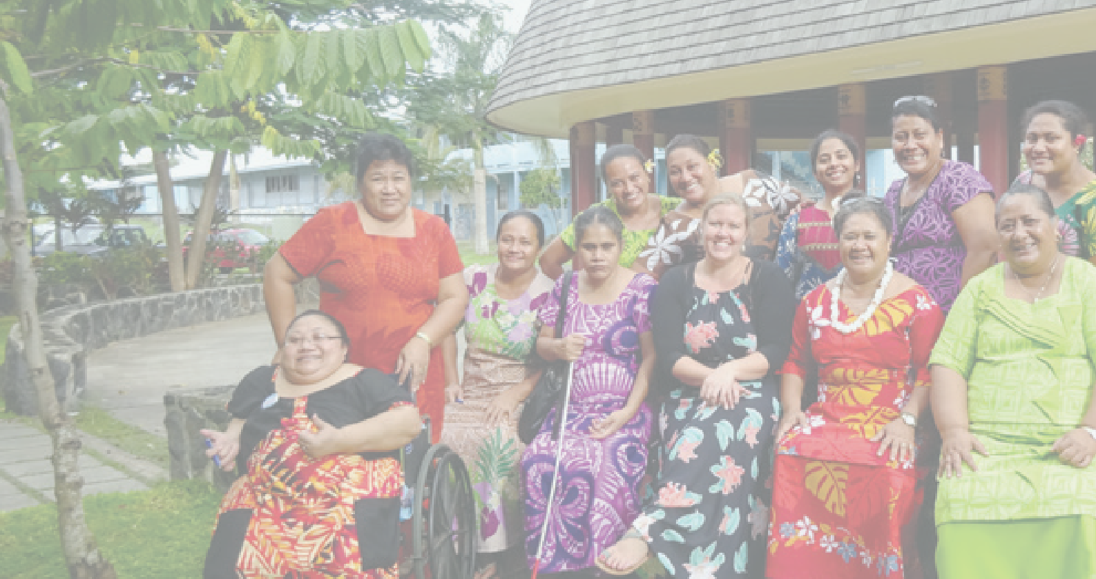References
Armstrong, T. (2012). Neurodiversity in the classroom: Strength-based strategies to helps students with special needs succeed in school and life. Alexandria, VA: Association for Supervision and Curriculum Development.
Boynton Hauerwas, L., Brown, R., & Scott,
A. N. (2013). Specific learning disability and response to intervention: State-level guidance. Exceptional Children,
80(1), 101-120.
CBM. (2012). Inclusion Made Easy:
A Quick Program Guide to Disability in Development. Melbourne:
CBM Australia.
European Agency for Development in Special Needs Education. (2011). Mapping the Implementation of Policy for Inclusive Education:
An exploration of challenges and

opportunities for developing indicators. Odense, Denmark: European Agency for Development in Special Needs Education.
European Agency for Development in Special Needs education, (2011a). Participation in inclusive education – a framework for developing indicators. Odense, Denmark: European Agency for Development in Special Needs Education.
Kyriazopoulou, K. & Weber, H, (eds). (2009). Development of a set of indicators for inclusive education in Europe. Odense, Denmark: European Agency for Development in Special Needs Education. Available online at: http://www.european-agency. org/agency-projects/indicators- for-inclusive-education/indicators- documents/Indicators-EN.pdf

Forlin, C., Sharma, U., Loreman,
T., & Sprunt, B. (2015). Developing indicators for inclusive education in the Pacific Islands. Prospects, 2, 197-211. DOI: 10.1007/s11125-015-9345-2.
Loreman, T., Forlin, C., Chambers, D., Sharma, U., & Deppeler, J. (2014).
Conceptualising and Measuring Inclusive Education. In C. Forlin & T. Loreman (Eds), Measuring Inclusive Education (pp. 3-17). U.K.: Emerald Group Publishing Ltd. DOI 10.1108/S1479-363620140000003006
Loreman, T., Forlin, C., Sharma, U. (2014). Measuring Indicators of Inclusive Education: A Systematic Review of the Literature. In C. Forlin & T. Loreman (Eds), Measuring Inclusive Education (pp. 165-187). U.K.: Emerald group Publishing Ltd. DOI 10.1108/S1479- 363620140000003006

Mellard, D., McKnight, M., & Jordan,
J. (2010). RTI tier structures and instructional intensity. Learning Disabilities Research and Practice, 25(4), 217-225.
Pacific Education Development Framework (PEDF) (2009). Pacific Education Development Framework (PEDF), 2009–2015. Retrieved from http:// www.forumsec.org/resources/uploads/ attachments/documents/Pacific% 20Education%20Development%20 Framework%202009–2015.pdf
Pacific Islands Forum Secretariat (PIFS) (2009). Pacific Regional Strategy on Disability. Suva, Fiji: Pacific Islands Forum Secretariat. Retrieved from http://www. forumsec.org.fj/resources/uploads/ attachments/documents/Pacific%20 Regional%20Strategy%20on%20 Disability.pdf

PDF and PIFS [Pacific Disability Forum and Pacific Islands Forum Secretariat] (2012). Mapping of the disability policy and program frameworks in the Pacific: A report on mapping work completed by the Pacific Disability Forum (PDF) working with the Pacific Islands Forum Secretariat (PIFS). Retrieved from http://aid.dfat.gov.au/aidissues/did/ Documents/mapping–disability– frameworks–pacific.pdf
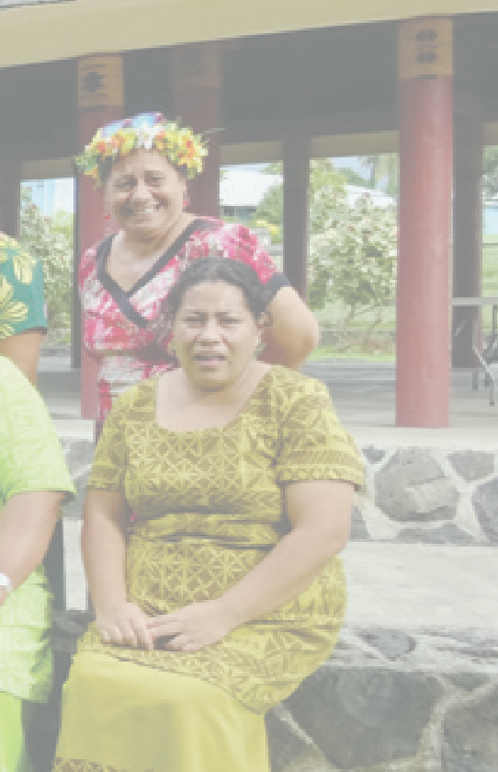
Sharma, U., & Ng, O. (2014). What has worked for bringing out-of-school- children with disability in schools:
A systematic review of literature. Disability, CBR and Inclusive Development, 25 (2). Retrieved from http://dcidj.org/article/view/355
Sharma, U., Forlin, C., Sprunt, B., & Merumeru, L. (submitted). Identifying disability-inclusive indicators currently employed to monitor and evaluate education in the Pacific Island countries.
Sharma, U. Loreman, T. & Macanawai,
S. (2015). Factors contributing to the implementation of inclusive education in Pacific Island countries, International Journal of Inclusive Education, DOI: 10.1080/13603116.2015.1081636.
Sharma, U., Simi, J. & Forlin, C. (2015). Preparedness of pre-service teachers for inclusive education in the Solomon Islands, Australian Journal of Teacher Education, 40(5), 103-116.
Smith, R. M., Gallagher, D., Owen, V., & Skrtic, T. M. (2009). Disability studies in education: Guidelines and ethical practice for educators. In J. Andrzejewski, M. P., Baltodano, & L. Symcox (Eds.), Social justice,
peace, and environmental education (pp. 235–251). New York: Routledge.

Turnbull, A., Turnbull, R., Wehmeyer,
M. L., & Shogren, K. A. (2013). Exceptional lives: Special education in today’s schools (7th ed.). Upper Saddle River,
NJ: Pearson Education.
The Global Fund. (2011). Monitoring
& Evaluating Toolkit (4th Ed.) Retrieved from http://www.theglobalfund.org/ en/me/documents/toolkit/
UNESCO. (2010). Reaching the marginalized EFA Global Monitoring Report. Paris/Oxford: UNESCO/ Oxford University Press. Retrieved from http://unesdoc.unesco.org/ images/0018/001866/186606E.pdf
United Nations. (2015). Draft outcome document of the United Nations summit for the adoption of the post-2015 development agenda. Retrieved from https://sustainabledevelopment. un.org/index.php?menu=1528
United Nations Development Programme (UNDP) (2009). Handbook on planning, monitoring and evaluating for development results. New York: USA. Retrieved from http://www.undp.org/ eo/handbook
United Nations. (2006). Convention
on the Rights of Persons with Disabilities. Retrieved from: http://www.un.org/ disabilities/convention/conventionfull. shtml
WHO & World Bank (2011). World Report on Disability. Retrieved from http://www.who.int/disabilities/ world_report/2011/en/index.html
World Health Organisation. (2011). World Report on Disability. Retrieved from http://whqlibdoc.who.int/ publications/2011/9789240685215_ eng.pdf?ua=1

Associate Professor Umesh Sharma

Contact us

For more information about this program please contact the Principal Investigator:
Associate Professor Umesh Sharma Email: Umesh.Sharma@monash.edu Phone: +61 3 990 54388
29 Ancora Imparo Way,
Faculty of Education, Clayton Campus Monash University
Victoria 3800 Australia

