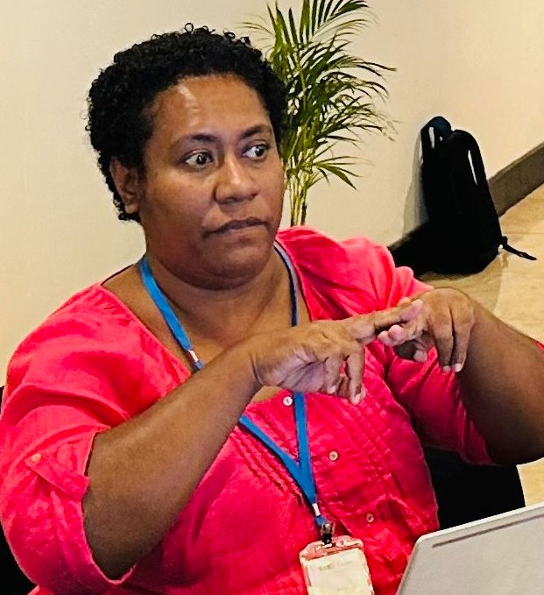

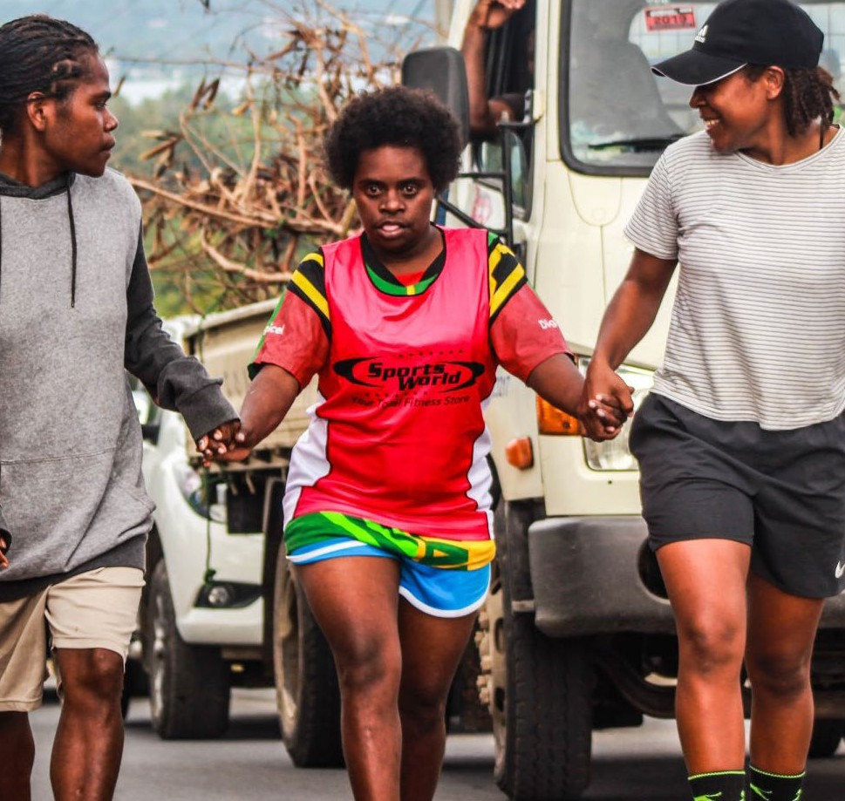

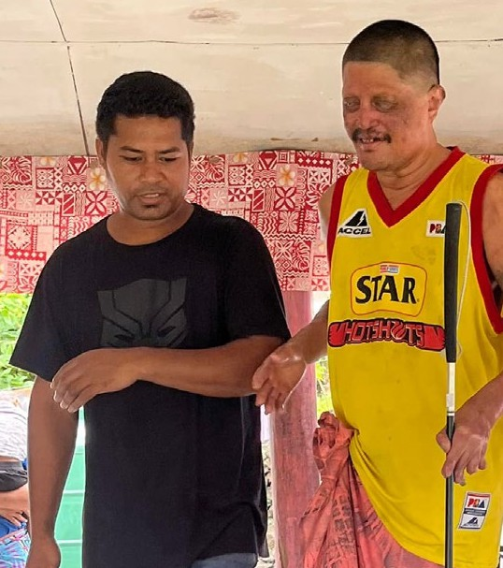


The Pacific Disability-Inclusive Humanitarian and Resilient Development Strategy 2025-2035

TOWARDS 2035
Building Bridges and Embracing Diversity with Disability
Inclusion in Pacific Disasters and Climate Action


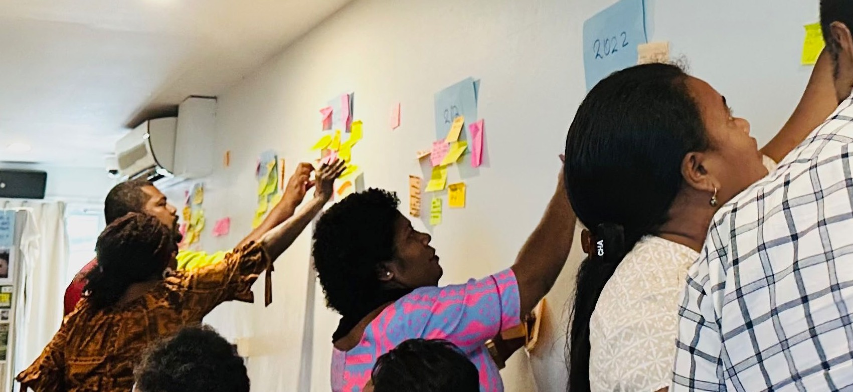

Acknowledgements
We thank and acknowledge all our partners and stakeholders, that have contributed to the development of this Strategy. We particularly thank the individuals and organisations that joined our 2024 July regional convening on the Strategy, regional organisations of persons with disabilities, CBM Australia and the PDF’s former Chief Executive Officer, Mr. Setareki Macanawai, whose vision for a disability-inclusive resilient strategy is articulated in this Strategy.

Contact
Enquiries about the Strategy can be directed to:
Pacific Disability Forum
Ground Floor, Kadavu House, 414 Victoria Parade, Suva, Fiji. infor@pacificdisability.org
GPO Box 18458, Suva, Fiji. (+679) 3312 008.

This publication is supported by the Australian Government funded Women’s Resilience to Disasters Programme, implemented by the UN Women Fiji Multi-Country Office. The views expressed in this publication are the author's alone and are not necessarily of the UN Women and the Australian Government.




Pacific Disability Forum
©Copyright Pacific Disability Forum, 2025
All rights for commercial/profit reproduction, in any form are reserved. PDF authorises the partial, reproduction or translation of this material for scientific, educational or research purposes, provided that PDF and the source document are properly acknowledged.


TABLE OF CONTENTS
04 Acronyms

The 2050 Strategy for the Blue Pacific Continent
10
Pacific Framework for the Rights of Persons with Disabilities (PFRDP), 2016 – 2025.
Regional Framework for Resilient

06 Overview

International Conventions and Commitments
08
Convention on the Rights of Persons with Disabilities (CRPD) - Articles 11, 6, 7 and 8.
Sendai Framework for Disaster Risk Reduction 2015 - 2030.
Paris Agreement.
Conference of the Parties (COP29).

Our 2035 Vision
16
Our Mission Our Outcomes Key Principles
Our Change Areas Our Approach
Development in the Pacific (FRDP).
The Pacific Leaders Gender Equality Declaration (2012).
Pacific Platform for Action on Gender Equality and Women’s Human Rights 2018-2030.
Inter-Agency Standing Committee (IASC) Guidelines on the Inclusion of Persons with Disabilities.
Disability data and measurement.
Intersectionality and horizontal inequalities.
People-centred approach.

Change Area Outcomes And Detailed Actions
20
Change Area 1 – OPDs are well resourced and coordinated.
Change Area 2 – Government- led humanitarian and resilient development systems are fully inclusive.
Change Area 3 – Mainstream Humanitarian Resilient Development.
Change Area 4 – Individuals, Households, Communities and Churches Are Inclusive of persons with disabilities.
Change Area 5 – All services and processes are inclusive and accessible.
Change Area 6 – Evidence based from disability-inclusive and gender- responsive approaches.



4 The Pacific Disability-Inclusive Humanitarian and Resilient Development Strategy 2025-2035

ACRONYMS
CBID Community Based Inclusive Development
CBM Christian Blind Mission
CC Climate Change
CCA Climate Change Adaptation COP21 21st Conference of Parties COP29 29th Conference of Parties
CROP Council of Regional Organisations of the Pacific
CRPD United Nations Convention on the Rights of Persons with Disabilities
CSOs Civil Society Organisations. DRM Disaster Risk Management DRR Disaster Risk Reduction EC Emergency Centre
EOC Emergency Operations Centre
EU European Union EW4ALL Early Warnings for All FBOs Faith-based Organisations
FRDP Regional Framework for Resilient Development in the Pacific
GBViE Gender Based Violence in Emergencies IASC Inter-Agency Standing Committee MEL Monitoring, Evaluation and Learning
OPDs Organisations of Persons with Disabilities
PDF Pacific Disability Forum
PFRPD Pacific Framework for the Rights of Persons with Disabilities
PIFS Pacific Islands Forum Secretariat
PLGED The Pacific Leaders Gender Equality Declaration
PRS Pacific Resilience Standards
PWDs Persons with Disabilities
SDGs Sustainable Development Goals
SimEx Simulation Exercises
SOP Standard Operating Procedure
SPC Secretariat of the Pacific Community SRHR Sexual and Reproductive Health and Rights UN United Nations
US United States
WGSS Washington Group Short Set of Questions

OUR 2035 VISION
Pacific Humanitarian Action & Resilient Development Is Inclusive, Equitable and Accessible for All Persons with Disabilities.

OUR MISSION
To Strengthen the Region’s Organisations Of Persons with Disabilities (OPDs) In Meaningful Engagement in Regional Dialogue, Decision-Making, Policy and Action with Humanitarian and Resilient Development Partners.

OUR SIX CHANGE AREAS

OUR OUTCOMES

1
2
3
4
5
6

OUTCOME 1
Resourcing and Coordination.
Organisations of Persons with
Disabilities (OPDs) are well resourced, coordinated and mobilised to lead disability-inclusive DRR & CC action at national level, with technical support provided.
OUTCOME 2
Strong Relations with Governments and inter- governmental Agencies
Pacific OPDs have strong working relations with countries and territories, and regional organisations and development partners in disaster risk management and climate change (Government, UN agencies, CROP).
OUTCOME 3
Partner Influencing and Change
Humanitarian Partners in civil society and the private sector adapt their policies, services and programmes to
be more inclusive of persons with disabilities.
OUTCOME 4
Communities Inclusion
Pacific Communities (individuals, households, communities and churches and faith-based organisations) are inclusive of persons with disabilities in humanitarian and Resilient Development settings.
OUTCOME 5
Inclusive services and processes.
All services and processes
operating as part of Humanitarian, Resilient Development are inclusive of and accessible to persons with disabilities.
OUTCOME 6
Disability and gender- responsive
Evidence-based approaches
Disability-inclusive approaches to Humanitarian, Resilient Development are based on evidence drawn from disability-inclusive research and MEL processes.




KEY PRINCIPLES
The Strategy is underpinned by seven (7) principles that centre around the principle of Participation, ‘Nothing about us without us.’ There must be an active and central role of persons with disabilities and their representative organisations in all processes and decisions that affect them, including within resilience development.

- Recognition - OPDs are recognised as the key representatives of persons with disabilities and are given a central role in all aspects of resilience development.
- Capacity support - Mainstream actors undertaking efforts to strengthen resilience development provide support for capacity- building of OPDs and persons with disabilities.
- All needs considered- All resilience development activities must consider the needs of persons with disabilities, including persons with a variety of impairments (including groups that are often excluded, such as deaf people, persons with intellectual disabilities and persons with psychosocial disabilities).
- Rights-based - A rights-based approach is taken to all aspects of disability inclusion.
- Identify & Address Barriers On Women and Girls with Disabilities - Identify and address the compounding barriers (including to emergency services) for women and girls with disabilities.
- Inclusion of Children with disabilities, elderly, women, indigenous persons with disabilities - Disability-inclusive resilience development must consider the needs of all, including children with disabilities, the elderly, women, and indigenous persons with disabilities.
- Catalyse - Disability-inclusive disaster risk management and climate change advocacy will catalyse the efforts around OPDs engagement and working with partners to ensure that the preconditions for inclusion are in place to make risk reduction, preparedness, response and recovery work truly inclusive of all persons with disabilities.

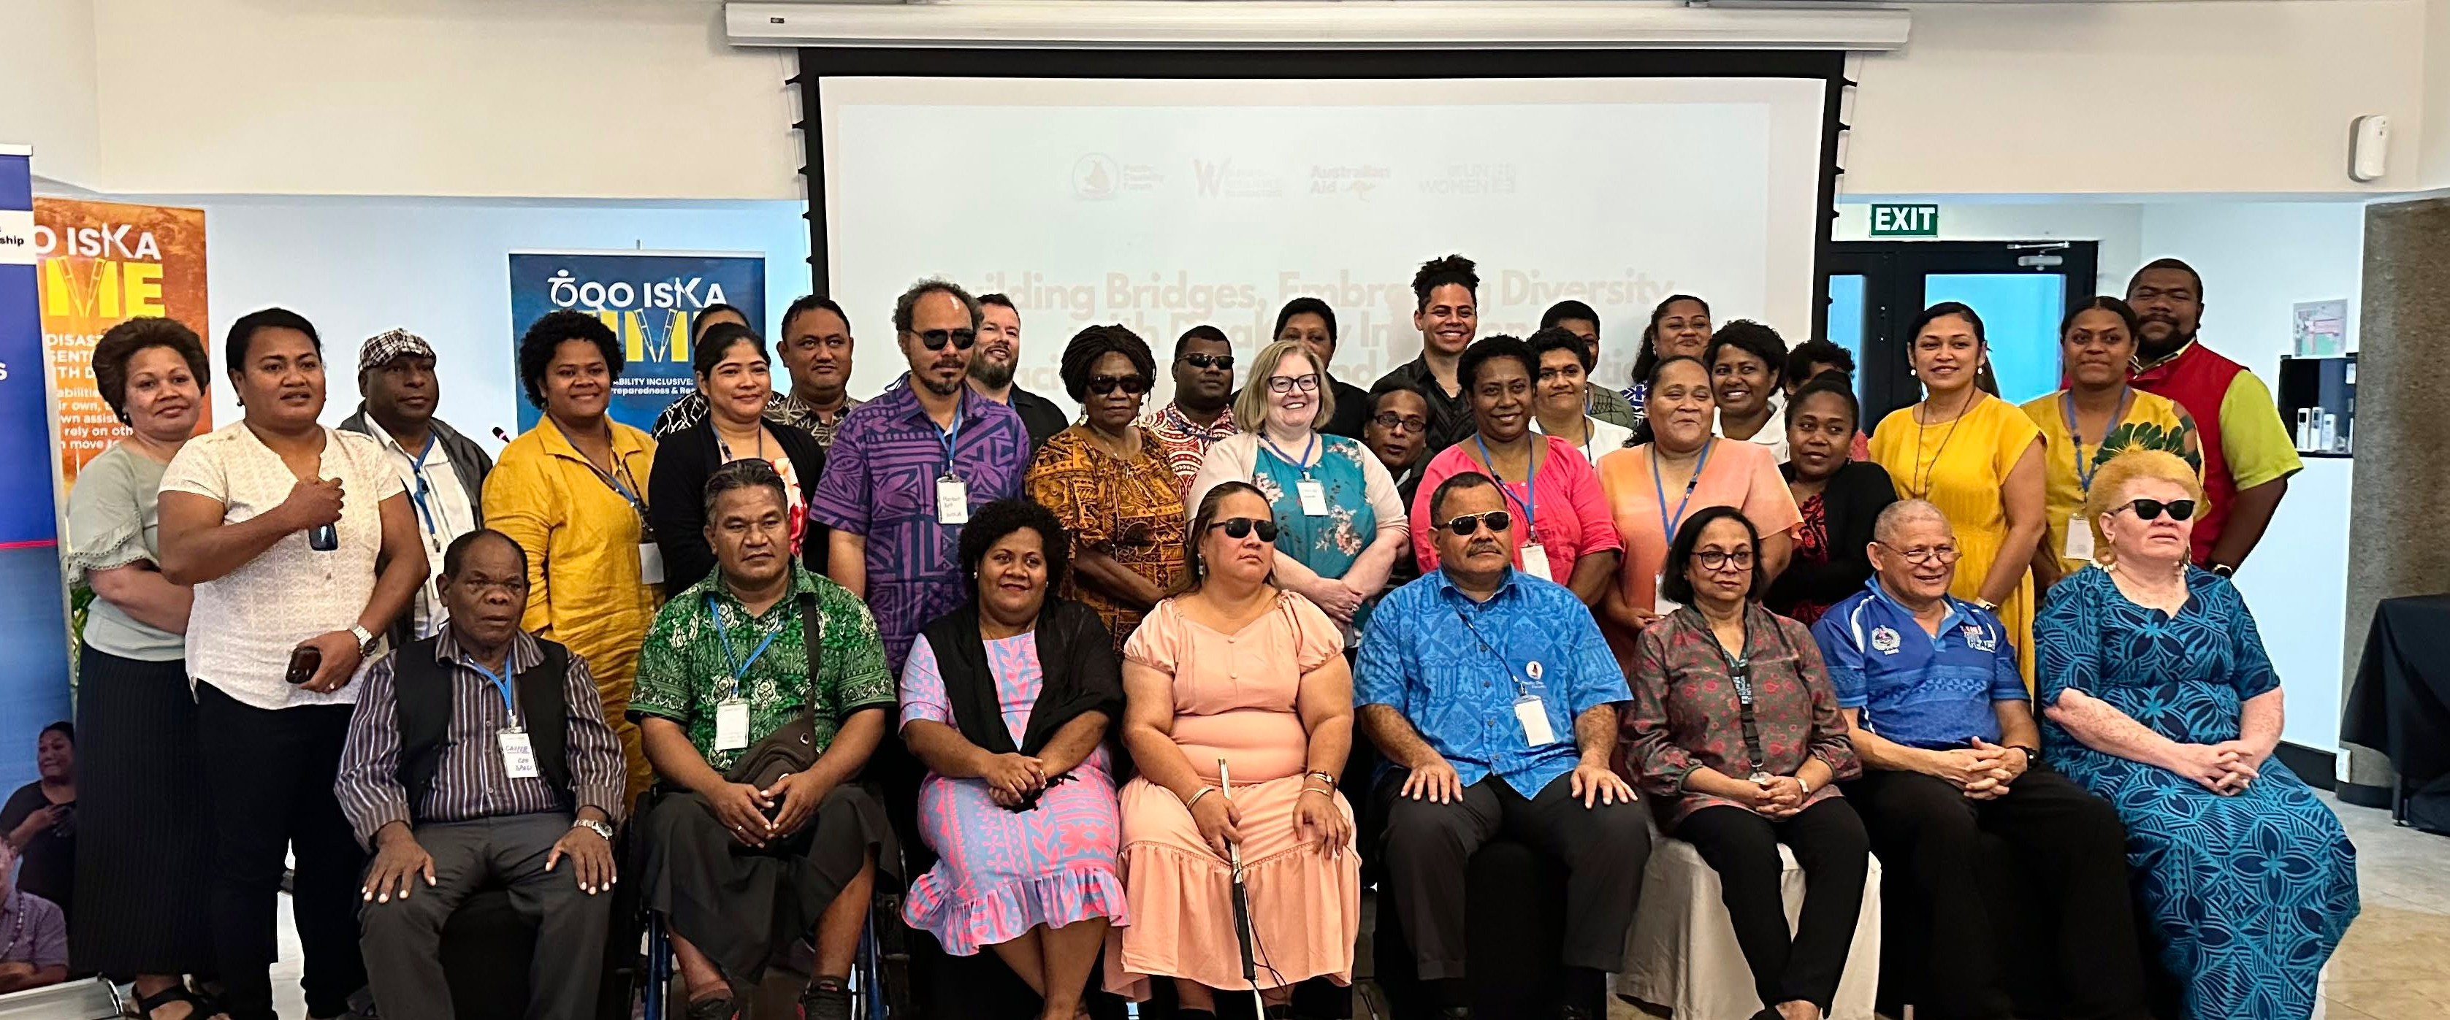
The ‘Pacific Disability-Inclusive Humanitarian and Resilient Development Strategy’ (‘the Strategy’) is our vision for achieving disability inclusion within climate and disaster resilience efforts throughout the Pacific. This cannot be achieved without the help of current and emerging partners, so we see this as a journey of collaboration, where we invite others to work in partnership with us to achieve our vision.
OVERVIEW
This strategy outlines an approach to strengthen disability inclusion in resilient development and includes development processes and actions to address risk and impacts of disasters and climate change while progressing to stronger and resilient communities. This includes Disaster Risk Management (DRM) (including disaster risk reduction, preparedness, response (humanitarian and recovery) as well as actions to address climate change and build resilience.
The Strategy also considers the aspirations that guided the Pacific Disability Forum (PDF) Strategic Plan of 2021- 20251 and in that also recognises and details the thematic visions for persons with disabilities in the 2050 Strategy for the Blue Pacific Continent. It is also aligned with global and regional commitments2 and recognises the challenges of women and girls with disabilities, and the barriers faced by the most impacted persons with disabilities.
A partnership document co-created by the Pacific’s Organisations of Persons with Disabilities (OPDs) with current and emerging partners and stakeholders, and the PDF, the Strategy aims to ensure that there is a strong connection, in realising the 2035 vision for Disability-inclusive Humanitarian and Resilient Development and to join and support us in achieving this vision. They include:
  - Current and emerging partners of member organisations and PDF
  - Mainstream agencies, government and non-government organisations, involved in DRM, including disaster risk reduction (DRR), preparedness, humanitarian response and recovery as well as actions to address climate change and building resilience.
  - Donors and development partners.
There are many key considerations for disability-inclusive and gender-responsive humanitarian, resilient development. These include:
  - “The Pacific is one of the most disaster-prone regions in the world, in terms of the recurrence, severity and scope of hazards and “the Pacific countries rank among the highest in casualties and people affected per number of inhabitants”.3

1“Towards an Inclusive and Resilient Pacific for Persons with Disabilities”
2including the COP29 commitments
3e.g. increases in intensity of tropical cyclones, increases in rainfall and extreme rainfall events leading to flooding.

  - The Pacific is highly vulnerable to the impacts of climate change, which is driving changes in frequency and intensity of extreme climate events which can lead to disaster. It is also increasing average temperatures, including extreme hot days and nights, sea levels rise and ocean acidification. Climate change has already had diverse adverse impacts on human systems, including on water security and food production, health and wellbeing, and cities, settlements and infrastructure.
  - Persons with disabilities are up to four times more likely to die because of a disaster, in comparison to persons without disabilities
  - Less than half of persons with disabilities have participated in DRR activities. Of those, 65.5% persons with disabilities reported that a lack of accessibility prevented them from being included in DRR activities.
  - 81% of persons with disabilities indicated they would have difficulty evacuating to a safer location in the event of a disaster emergency. (CBM Global IAG, 2022)
  - Women and girls with disabilities experience multiple forms of discrimination (intersection of gender and disability) that are exacerbated during a crisis, such as the COVID-19 pandemic.
  - Research on women with disabilities from the Pacific indicates that, despite some helpful laws and policies, women with disabilities are more disadvantaged than men with disabilities or women without disabilities. Women with disabilities are less educated, poorer and more isolated, have lower social status, experience higher rates of unemployment and worse health outcomes, and are more likely to experience violence.4
  - Women and girls with disabilities experience disability differently from men and boys due to discriminatory and unequal gender norms.
  - The amalgamation and increase in violence during emergencies and the lack of disability-inclusiveness preparedness and response efforts, place women and girls with disabilities in a position of extreme vulnerability.5
  - Women and girls with disabilities face additional challenges and barriers in accessing basic hygiene items, critical information and essential services at the onset of a disaster.
  - While data on the impacts of climate change upon persons with disabilities is not available, estimates have suggested 20% among those most at-risk to climate change are persons with disabilities.
  - Climate change is amplifying the risks and exclusion that persons with disabilities already experience in their daily lives. Additionally, climate change is introducing new risks and creating new barriers.6
  - A 2020 survey on climate change and disability found that just 5% of persons with disabilities had been approached or knew of an OPD who had been approached, by local politicians to discuss disability inclusion within climate change actions.7
  - Based on findings from a recent PDF report for the Pacific, climate change is impacting persons with disabilities in two ways: climate change is increasing the negative impacts of pre-existing exclusion; and is creating new risks and negative impacts by forcing a change in agricultural and fishing practices.8 It also articulates the responsibilities of others to fulfil their obligations in achieving full inclusion of persons with disabilities.

4Stubbs, D. and Tawake, S. (2009). Pacific Sisters with disabilities: At the intersection of discrimination. United Nations Development Programme, p. 28. Available at: https://pacificwomen.org/research/pacific-sisters-with-disabilities/.
5https://www.unfpa.org/news/“we-are-experts-disability”-advocate-angeline-chand-urges-inclusive-disaster-preparedness-and 6See https://hrsd.spc.int/sites/default/files/2024-04/PWL-Guidance%20Note-FINAL-15%20Mar%202024.pdf
7See: https://www.ohchr.org/en/instruments-mechanisms/instruments/convention-rights-persons-disabilities
8Ibid

INTERNATIONAL CONVENTIONS AND COMMITMENTS
In crafting a robust disability-inclusive Disaster Risk Reduction (DRR) and Climate Change (CC) strategy, it is essential to draw upon key international frameworks and guidelines that prioritise the rights and inclusion of persons with disabilities. Article 11 of the Convention on the Rights of Persons with Disabilities (CRPD), the Sendai Framework for Disaster Risk Reduction, the Pacific Framework on the Rights of Persons with Disabilities, and the Inter-Agency Standing Committee (IASC) guidelines offer comprehensive principles and directives to ensure the full participation and protection of persons with disabilities in disaster risk reduction and climate change adaptation efforts.

Convention on the Rights of Persons with Disabilities (CRPD) - Articles 11, 6, 7, and 8.
Article 11 of the CRPD underscores the importance of including persons with disabilities in disaster risk reduction and management. It emphasizes the necessity of incorporating accessibility measures, providing appropriate assistance, and ensuring the participation of persons with disabilities in decision-making processes related to disaster preparedness, response, and recovery. Fourteen out of 15 Pacific Island countries have ratified the CRPD. Article 6 specifically focuses on women and girls with disabilities, recognising that “women and girls with disabilities are subject to multiple discrimination,” and states parties should take all appropriate measures to ensure they are guaranteed the exercise and enjoyment of their human rights and fundamental freedoms. Article 7 focuses on children with disabilities, in that all states parties should “take all necessary measures to ensure the full enjoyment by children with disabilities of all human rights and fundamental freedoms on an equal basis with other children.” Article 8 focuses upon awareness raising of the CRPD.

Sendai Framework for Disaster Risk Reduction 2015-2030
The Sendai Framework acknowledges the disproportionate impact of disasters on persons with disabilities and emphasizes the need for inclusive approaches in disaster risk reduction. The Gender Action Plan to Support Implementation of the Sendai Framework for Disaster Risk Reduction 2015–2030 (Sendai GAP) aims to substantially increase gender-responsive disaster risk reduction by 2030. Basically, the guiding principles of the Sendai Framework recognise the need for a gender perspective to be integrated into all disaster risk reduction policies and practices and highlight the importance of women’s participation and leadership.9 The framework also calls for the integration of disability perspectives in all stages of disaster risk management, including risk assessment, early warning systems, preparedness, response, and recovery. It prescribes gender and disability inclusion in DRR frameworks and recognises the various capacities of countries in data collection and reporting the Sendai Framework Monitor, which encourage reporting of sex, age, disability and income disaggregated data.10

9United Nations Office for Disaster Risk Reduction, United Nations Population Fund, and United Nations Entity for Gender Equality and the Empowerment of Women (2024). Gender Action Plan to Support Implementation of the Sendai Framework for Disaster Risk Reduction 2015–2030. United Nations.
10United Nations Office for Disaster Risk Reduction, Gender-Responsive and Disability-Inclusive early Warning and Early Action in the Pacific Region, 2023.

Paris Agreement
The Paris Agreement is a landmark and binding international agreement, agreed and adopted in 2015 under the United Nation’s Framework Convention on Climate Change (UNFCCC) at COP21 in Paris, aimed at combating climate change by limiting global warming to well below 2°C, with efforts to limit the increase to 1.5°C. The binding agreement emphasizes the need for global collaboration in reducing greenhouse gas emissions, adapting to climate impacts, and providing financial and technical support to developing countries.
Persons with disabilities are particularly vulnerable to the impacts of climate change, including extreme weather events, sea-level rise, and changing ecosystems. However, their specific needs and contributions were not initially highlighted in the Paris Agreement itself.
Efforts to integrate disability inclusion into climate action have been reinforced by advocacy from disability organizations and frameworks like the UN Convention on the Rights of Persons with Disabilities (CRPD).

Conference of the Parties (COP29)
The recently concluded Conference of the Parties (COP29) serving as the meeting of the Parties to the Paris Agreement outlined a number of commitments,11 and affirmed the new collective quantified goal on climate finance which is aimed at accelerating the achievement of Article 2 of the Paris Agreement.12 Persons with disabilities in the Pacific, whether as in the least developed countries of Solomon Islands, Tuvalu and Kiribati and the small island developing states, are particularly vulnerable to the adverse effects of climate change. Parties are urged to promote the inclusion and extension of benefits to women and girls, children and youth and persons with disabilities.13 Ensuring the full and effective participation of persons with disabilities are integral to developing effective global climate solutions and will contribute to building resilient and sustainable societies.

11at least USD 300 billion per year by 2035 for developing country Parties for climate action:
10of holding the increase in the global average temperature to well below 2 °C above pre-industrial levels and pursuing efforts to limit the temperature increase to 1.5 °C above pre-industrial levels, recognizing that this would significantly reduce the risks and impacts of climate change;
13“indigenous Peoples, local communities, migrants and refugees, climate-vulnerable communities and people in vulnerable situations.”
“As Pacific Leaders, our vision is for a resilient Pacific region of peace, harmony, security, social inclusion and prosperity, that ensures all Pacific peoples can lead free, healthy and productive lives.”

THE 2050 STRATEGY FOR THE BLUE PACIFIC CONTINENT
Pacific leaders have visioned that our future cannot be left to chance and requires a long-term commitment for 2050.14 Amongst the seven (7) interconnected thematic areas in the 2050 Strategy, two thematic areas connect with the 2035 Strategy. These are:
- People-Centred Development – Thematic Area 2
- Climate Change and Disasters – Thematic Area 5.
In acknowledging several initiatives in realising People-Centred Development, such as the 2012 Pacific Leaders Gender Equality Declaration, and the Pacific Framework for the Rights of Persons with Disabilities, the 2050 strategy outlines four strategic pathways to realise the vision. These are Inclusion and Equity and Resilience and Wellbeing.
With the thematic area of Climate Change and Disasters, the 2050 Strategy outlines the integrated approach to address CC and DRM in the region through the FRDP. However, there “are also issues related to accessing international funding for climate change and disasters” and the two strategic pathways on “Inclusion and Equity” and “Resilience and Wellbeing,” emphasise amongst others, the building of capacity and resilience of communities to effectively address the impacts of climate change and disasters including the gendered impacts.

Pacific Framework for the Rights of Persons with Disabilities (PFRDP), 2016 – 2025.
In line with the CRPD, Governments in the region jointly adopted the 2016-2025 Pacific Framework for the Rights of Persons with Disabilities (PFRDP).15 of which its last year of implementation coincides with the first year of implementation of this Strategy. The Framework highlights the unique challenges faced by persons with disabilities in the Pacific region and outlined strategies for addressing these challenges in the context of DRR and climate change adaptation. It emphasized the importance of ensuring the full participation and empowerment of persons with disabilities in decision-making processes and the implementation of inclusive policies and programs.

Regional Framework for Resilient Development in the Pacific (FRDP) and the Pacific Resilience Standard (PRS).
PDF and OPDs aim to closely work with Council of Regional Organisations of the Pacific (CROP) agencies to ensure disability-inclusive implementation of the Framework for Resilient Development in the Pacific (FRDP). These would be in relation to:

14“As Pacific Leaders, our vision is for a resilient Pacific region of peace, harmony, security, social inclusion and prosperity, that ensures all Pacific peoples can lead free, healthy and productive lives.”
15https://hrsd.spc.int/sites/default/files/2024-04/PWL-Guidance%20Note-FINAL-15%20Mar%202024.pdf

- Integrated actions to address climate change and disasters, whenever possible. This guidance recognises the clear overlap between climate change adaptation and disaster risk reduction, where there are similar tools and resources required to monitor, analyse and address climate and disaster risks. It is important to note that CCA and DRR measures is mutually beneficial as it offsets both climate and disaster related risks. Many Pacific Island Countries and Territories have started taking concrete steps to manage these risks in a more integrated manner. An integrated approach can reduce duplication and optimise use of limited resources and sharing of technical expertise.
- Advocating for more effective mainstreaming of action to address climate change and disaster risks into development planning including policy making, planning, financing, programming and implementation which includes building resilience into governance structures and processes, partnerships, communications and financing. Climate change and disaster risks are cross-cutting thematic priorities and action must also take place at the sectoral level. It is essential to mainstream action to build resilience into development sectors such as health, education, water and sanitation, and agriculture.
- Implement the guiding principles of the FRDP to ensure that every person has equitable access to humanitarian and development assistance, according to his or her specific needs; and to prioritise and respect the needs of the most vulnerable, including persons with disabilities and facilitate their effective participation in planning and implementation.
The Pacific Resilience Standard (PRS)16 is aimed at operationalising the 10 guiding principles of the FRDP. Building on four standards of resilience of Integrate, Include, Inform and Sustain, the PRS is to enable and help partners and stakeholders with ensuring the quality, effectiveness and integrity of resilience building by providing ‘good practice essentials’ and ‘progress criteria.’ These are being considered with the supplementary implementation and monitoring and evaluation plans, of the 2035 strategy.

The Pacific Leaders Gender Equality Declaration (2012).
Regional commitments on gender highlight the disproportionate impact of climate change and disasters on Pacific women with disabilities. In 2023, through the Revitalised Pacific Leaders Gender Equality Declaration, regional leaders “reaffirmed that climate change and disasters, including nuclear contamination have a disproportionate impact on women and girls in all their diversity, particularly women and girls with disabilities, and women living in rural, remote and maritime areas.”17

Pacific Platform for Action on Gender Equality and Women’s Human Rights 2018-2030 (2030)
In affirming, regional commitments to advance gender equality by Pacific Island countries and territories (PICTs) through the Pacific Platform for Action on Gender Equality and Women’s Human Rights 2018-2030 (PPA), the 2024 conference and ministerial recognised the urgent need to understand and address, using intersectional tools, the multiple, severe and converging crises impacting women in the Pacific region – including the climate crisis, gender-based violence and deterioration of physical and psychosocial health for women and girls.18 Commitments include eliminating barriers for women and girls with disabilities , providing comprehensive training for SRHR and GBV service providers, ensuring greater autonomy and ensuring all women and girls can access gender-based violence (GBV) and sexual and reproductive health and rights (SRHR) information and services, including in times of disaster. It is important to acknowledgement of the link between climate change, disaster risks, GBV and SRHR.
In prioritising gender-responsive climate justice, the Pacific has led the world in calling for climate justice, recognising the unequal and gendered impacts of climate change. Pacific small island states are particularly affected, with women and girls in all their diversity, including women and girls with disabilities, bearing the

16See: https://wrd.unwomen.org/practice/resources/pacific-resilience-standards
17Pacific Islands Forum Secretariat, Revitalised Pacific Leaders Gender Equality
18Declaration, (2023), https://www.forumsec.org/wp-content/uploads/2023/11/Gender-Equality- Declaration_web_231123.pdf
Pacific Community, Outcomes Document, 15th Triennial Conference of Pacific Women. 8th Meeting of Pacific Ministers for Women, 22-25 July 2024-Majuro, Republic of Marshall Islands.

greatest burden of these impacts. Council of Regional Organisations of the Pacific (CROP) agencies and their member governments are called upon to work with civil society, development partners and other entities to ensure the collaborative development of an effective regional gender equality ecosystem for the implementation of the recommended actions for the three priority areas.19

Inter-Agency Standing Committee (IASC) Guidelines on the Inclusion of Persons with Disabilities
The IASC guidelines provide practical guidance for humanitarian actors on how to ensure the inclusion of persons with disabilities in all aspects of humanitarian response and coordination. They outline key principles such as non-discrimination, accessibility, participation, and empowerment, and offer specific recommendations for mainstreaming disability inclusion across sectors, including DRR and CC.

Must-Do’s for Effective Disability-Inclusive DRR/CC Strategy:
  - Accessibility - Ensure that all DRR and CC measures are accessible to persons with disabilities, including information, infrastructure, and services.
  - Participation. - Actively involve persons with disabilities in decision-making processes, planning, implementation, and monitoring of DRR and CC initiatives.
  - Capacity Building - Provide training and support to enhance the capacity of persons with disabilities, their organizations, and relevant stakeholders to participate effectively in DRR and CC efforts.
  - Data Collection. - Collect disaggregated data on disability to inform evidence-based policies and programs and to monitor the impact of DRR and CC interventions on persons with disabilities.
  - Coordination - Foster coordination and collaboration among government agencies, humanitarian organizations, civil society, and persons with disabilities’ organizations to ensure a coherent and inclusive approach to DRR and CC.
By integrating the principles and recommendations outlined in these frameworks and guidelines, a disability- inclusive DRR/CC strategy can effectively address the needs and
rights of persons with disabilities, ultimately building more resilient and inclusive communities in the face of disasters and climate change.
Disability and Climate Change / Disaster Risk Reduction
Climate change disproportionately affects persons with disabilities in the Pacific region, as they are at higher risk to the impacts of extreme weather events, sea level rise, and disaster events. These impacts can exacerbate existing disabilities and create new ones, making it more difficult for individuals with disabilities to access necessities such as food, water, and medical care. Additionally, individuals with disabilities in the Pacific may also face barriers to participating in disaster preparedness and response efforts, as well as in building resilience and adapting to future climate change impacts. It is important for governments, organisations, and communities in the Pacific to prioritise the needs of persons with disabilities in their climate change adaptation efforts, as well as disaster risk reduction and response efforts.
Climate-induced disasters, such as floods, droughts, and storms, have a significant impact on persons with disabilities. These individuals may be at an increased risk of harm during such events, as they may have difficulty evacuating or accessing emergency services. Additionally, the destruction of buildings and infrastructure can make it more difficult for persons with disabilities to access necessities, such as food, water, and medical care.

19Priority Area 1: Health Of Women and Girls. Priority Area 2: Gender-Responsive Climate Justice. Priority Area 3: Prevention Of Gender-Based Violence
20Pacific Community, Outcomes Document, 15th Triennial Conference of Pacific Women. 8th Meeting of Pacific Ministers for Women, 22-25 July 2024-Majuro, Republic of Marshall Islands.
21Priority Area 1: Health Of Women and Girls. Priority Area 2: Gender-Responsive Climate Justice. Priority Area 3: Prevention Of Gender-Based Violence

In the aftermath of a disaster, persons with disabilities may also face challenges in accessing housing, healthcare, and other essential services. There is a need for inclusive disaster risk reduction and management that considers the specific needs and vulnerabilities of persons with disabilities. This can include measures such as providing accessible evacuation routes, accessible emergency shelters and other facilities, as well as ensuring that emergency response teams are trained to work with persons with disabilities. It is important to include persons with disabilities in the planning process and to make sure that their needs are considered in the recovery process.
Noting the ongoing work on DRR since 2010, PDF will continue to strengthen its Disability- inclusive Disaster Risk Reduction (Di-DRR) to reducing the impact of disasters on persons with disabilities. It involves considering the needs and heightened risks of persons with disabilities in all aspects of disaster management, from preparedness and early warning systems to response and recovery. It is important to mention that by including persons with disabilities in DRR, it not only benefits them, but also the whole community, since it makes the disaster management more efficient and effective.
It is also important to gradually integrate PDF’s Di-DRR programs with disability inclusive Climate Change Adaptation programs to align with Pacific Joint National Action plans.

Disability data and measurement
The collection and use of standardised disability data allows differences in opportunities and participation between persons with and without disabilities to be measured. Disaggregated disability data should also allow the measurement of differences by impairment type, gender, and age. Under Article 31 of the CRPD, State Parties commit to “collect appropriate information, including statistical and research data, to enable them to formulate and implement policies”.
The Sendai Framework Monitor (SFM) guidance on sex, age, and disability disaggregated data recommends the collection of disability data on people that have an “existing ‘pre- event’ disability” only. While the guidance states one purpose of collecting data is to understand impacts, mortality, and morbidity, the guidance specifically does not address “people who develop a disability from a hazardous event or disaster”. To understand disaster risk, and its impacts, disaggregated data on pre and post-event disability is needed.
Since 2015, four out of 12 Pacific SFM reports have addressed disability data. However, most simply confirm no data is available. Nauru reported the livelihoods of 15 persons with disabilities had been disrupted or destroyed by disasters. Double disaggregation is not possible in the SFM. For example, from those 15 persons with disabilities impacted we cannot say how many were women. The DesInventar Sendai database includes options for reporting against disability, including deaths, missing, and injured persons with disabilities. Currently, only Samoa has included any data for persons with disabilities. This is for three persons with disabilities whose livelihoods were impacted by disaster.
Recent country DRR reports include disability prevalence figures from secondary sources. Tuvalu reports a disability prevalence figure of 4.5%, Papua New Guinea (2019), Marshall Islands, and Federated States of Micronesia (2022) indicate prevalence rates of around 11%.6 Global health and burden of disease data suggest the best estimate of global disability prevalence is 15%. Other country DRR reports reference disability, including in relation to disproportionate risk (Vanuatu, 2022) and “vulnerable” groups (Kiribati, 2019; New Zealand, 2020; Palau, 2022) but provide no data. The report for Fiji (2019) limits reference to the 2018 Rights of Persons with Disabilities Act. No country report indicates any clear application of disability disaggregated data to inform practice or formulate policy.
Between 2015 and 2021, 11 Pacific countries included the Washington Group Short Set of questions on functioning in their census. The Short Set of questions allow disaggregation of census and survey data by disability and are recommended for use in Sustainable Development Goal reporting. Six countries have produced Disability Monographs based on the census data. In 2020, the Pacific Group on Disability Statistics was established as a Washington Group regional group chaired by the Samoan Bureau of Statistics.

The Short Set, and related question sets, are increasingly used in a wide range of programme applications in the Pacific and have the potential to further understandings on differences in participation and opportunities between persons with and without disabilities. However, they are no panacea. The topic of disability data is broader than the disaggregation of population data. With increasing interest in the Short Set, it is important to note what the questions do not do. Alone, the Short Set provides no information on needs, barriers, or impairments. To understand disaster risk, we also need information on these and related disability data issues.

Intersectionality and horizontal inequalities
Increasingly, disability is viewed as one component of social inclusion. A gender equality and social inclusion (GESI) approach is, for example, emphasised in Australian Aid programming in the Pacific. Concerns that GESI does not adequately capture and emphasise disability inclusion have resulted in the promotion of gender equality, disability, and social inclusion (GEDSI) as the preferred approach by disability stakeholders in the region.
A GEDSI approach recognises and responds to inequity and marginalisation based on identity characteristics. For example, gender identity, age, sexual orientation, language, ethnicity, and disability. An effective GEDSI approach looks beyond individual identity characteristics and considers how different characteristics interact. This intersectional approach is essential to understanding disaster risk. For example, how an older man with a visual impairment is impacted by a disaster may be very different from how a female youth who is Autistic may be impacted. Equally, these individuals’ needs in preparing for, and responding to disaster events may be quite different.
Recognising horizontal inequalities is also important. Horizontal inequalities are the differences in participation, opportunities, or disaster risk between different groups of people with a shared identity characteristic. As noted, efforts to improve disability data disaggregation have largely focused on understanding differences between persons with and without disabilities. There have been few efforts to understand the impacts of disaster risk between sub-groups of persons with disabilities. For example, between people with a mobility functioning difficulty and persons with a psychosocial disability.
Understanding disaster risk requires understanding the disproportionate risk that persons with disabilities experience in comparison to persons without disabilities. At the same time, we need to recognise persons with disabilities are not a homogenous group. Increased attention needs to be paid to highly marginalised groups within the disability community, for example, persons with cognitive, intellectual and psychosocial disabilities.
In the Pacific, women with diverse disabilities continue to face multiple jeopardies. This includes increased risks of sexual and gender-based violence during disasters and response. Women and young persons with disabilities also face additional barriers to realising their sexual and reproductive health and rights. These barriers increase during disasters. The need for improving menstrual hygiene management for women with disabilities during disasters was also reported. Incidences of women with disabilities experiencing violence in evacuation centres is a critical concern. Women and girls with disabilities must be included in mainstream and targeted DRR and disaster response programmes directly to eliminate gender-based violence.

People-centred approach
The Strategy has been developed as we want to ensure persons with disabilities have an active and central role as leaders and agents of change within the national and regional dialogue, decision making, policy and action to build resilient development. In the past we feel that we have often been pushed aside, or pulled into others’ priorities, and some efforts by others to ensure disability inclusion have been tokenistic or ticking the box. We are often included only to warm the seats. Further to this, we often feel overwhelmed when many people approach us with their different priorities. This can mean our capacity is stretched, impacting the quality of our influence.
Therefore, this Strategy gives us the following.
- The power not to do everything alone, but to share a vision that others can support us in achieving.
- We want to ensure that other stakeholders’ projects and activities feed into a bigger vision and build to something more sustainable.
- We want to see long term change in legislation and policies in compliance with the CRPD.
- We want others to use the Strategy to help us achieve our ultimate vision of disability-inclusive resilient development within the Pacific in the next 10 years.

Moving Forward with the Aspirations In the Strategic Plan 2021- 2025
The change areas of the Strategy also take forward the aspirations in the PDF Strategic Plan, of which its final year of implementation corresponds with the 1st year of implementation of the Strategy. The areas revolve around the need to deepen and have meaningful partnerships, strengthen the leadership of PWDs in DRR and CC spaces and advocate for the establishment of preconditions to inclusion. Resource mobilisation beyond the PDF and to all the OPDs in the sub-regions are central in Change Area 1 of the Strategy, which has been acknowledged and outlined as a key outcome for the PDF strategic plan of 2021-2025. A detailed resource mobilisation plan is seen as critical to sustainability and progress towards Vision 2035.



OUR 2035 VISION
Pacific Humanitarian Action & Resilient Development is inclusive, equitable and accessible for all persons with disabilities

OUR MISSION
To strengthen the region’s Organisations of Persons with Disabilities (OPDs) in meaningful engagement in regional dialogue, decision- making, policy and action with humanitarian and resilient development partners.

OUR OUTCOMES
Outcome 1 – Resourcing and Coordination.
Organisations of Persons with Disabilities (OPDs) are well resourced, coordinated and mobilised to lead disability-inclusive DRR & CCA action at national level, with technical support provided.
Outcome 2 – Strong Relations with Governments and inter-governmental Agencies
Pacific OPDs have strong working relations with countries and territories, and regional organisations and development partners in disaster risk management and climate change (Government, UN agencies, CROP).
Outcome 3 – Partner Influencing and Change
Humanitarian Partners in civil society and the private sector adapt their policies, services and programmes to be more inclusive of persons with disabilities.
Outcome 4 – Communities Inclusion
Pacific Communities (individuals, households, communities and churches and faith-based organisations) are inclusive of persons with disabilities in humanitarian and resilient development settings
Outcome 5 – Inclusive services and processes.
All services and processes operating as part of Humanitarian, Resilient Development are inclusive of and accessible to persons with disabilities.
Outcome 6 – Disability and gender-responsive Evidence-based approaches
Disability-inclusive approaches to Humanitarian, Resilient Development are based on evidence drawn from disability-inclusive research and MEL processes

KEY PRINCIPLES
The Strategy is underpinned by seven (7) principles that centre around the principle of Participation, ‘Nothing about us without us.’ There must be an active and central role of persons with disabilities and their representative organisations in all processes and decisions that affect them, including within resilience development.
- Recognition of OPDs - OPDs are recognised as the key representatives of persons with disabilities and are given a central role in all aspects of resilience development.
- Capacity support - Mainstream actors undertaking efforts to strengthen resilience development provide support for capacity-building of OPDs and persons with disabilities.
- All needs considered - All resilience development activities must consider the needs of persons with disabilities, including persons with a variety of impairments (including groups that are often excluded, such as deaf people, persons with intellectual disabilities and persons with psychosocial disabilities).
- Rights-based - A rights-based approach is taken to all aspects of disability inclusion.
- Identify & Address Barriers On Women and Girls with Disabilities - Identify and address the compounding barriers (including to emergency services) for women and girls with disabilities.
- Inclusion of Children with disabilities, elderly, women, indigenous persons with disabilities
- Disability-inclusive resilience development must consider the needs of all, including children with disabilities, the elderly, women, and indigenous persons with disabilities.
- Catalyse Efforts for preconditions for inclusion - Disability-inclusive disaster risk management and climate change advocacy will catalyse the efforts around OPDs engagement and working with partners to ensure that the preconditions for inclusion are in place to make risk reduction, preparedness, response and recovery work truly inclusive of all persons with disabilities.

OUR CHANGE AREAS:


02
Government-led humanitarian sustems are fully inclusive

06
Based on evidence from disability-inclusive approaches

CHANGE AREA 1
OPDs are well resourced & coordinated
03
Mainstream Humanitarian resilient developent

05
All services & processes are inclusive & accessible
04
Individuals, households, communities & churches

Our six (6) change areas are listed as follows.
Change Area 1 – Organisations of Persons with Disabilities (OPDs) are well resourced, coordinated and mobilised to lead and oversee the success of the Strategy at regional and national level, with technical support provided.
Change Area 2 – Government-led Humanitarian, Resilient Development processes (including legislation, policies, and coordination mechanisms) are fully inclusive and able to meet the needs of persons with disabilities, and those that are most impacted including those with cognitive and intellectual disabilities and psychosocial disabilities and women and girls with disabilities.
Change Area 3 – Mainstream Humanitarian, Resilient Development actors have policies and practices in place to ensure full inclusion of persons with disabilities.
Change Area 4 – Humanitarian, Resilient Development processes for individuals, households, communities, and churches and faith-based organisations are inclusive of persons with disabilities
Change Area 5 – All services and processes operating as part of Humanitarian, Resilient Development are inclusive of and accessible to persons with disabilities.
Change Area 6 – Disability-inclusive approaches to Humanitarian, Resilient Development are based on evidence drawn from disability-inclusive research and MEL processes.

OUR APPROACH
01
Well Resourced
06
Disability-inclusive approaches
02
Government-led & fully inclusive
2025 - 2035
INCLUSIVE & ACCESSIBLE
05
All services and processes
03
Mainstream
04
Individual households, communities & churches

The 2035 Strategy is driven through a programmatic, and movement-building approach led by the member associations or the regional Organisations of Persons with Disabilities, supported by the Pacific Disability Forum, with partners and stakeholders including state agencies, inter-governmental organisations, civil society and women and human rights organisations, and development partners. Each of the six change areas, move towards outcomes and interconnect with each other in regional collective influencing. Regional collective actions accompany each area for change and seven (7) principles underpin these actions.
Resource mobilisation for all OPDs is central to the success of Vision 2035. Disability inclusion should be genuinely inclusive and not tokenistic. Access to climate finance and resources, to adapt to the adverse effects of climate change, are especially critical for persons with disabilities in the Pacific. With the focus on Change Area 1 in resource mobilisation and strong coordination, optimal functioning of all the remaining five (5) change areas, is expected to occur. These are the influencing of Government humanitarian systems, mainstream humanitarian and resilient development actors, communities and local-level community systems, and all systems and processes.
Reporting on the preconditions to inclusion made available to persons with disabilities in all change areas, as well as reporting on inclusion and participation, are also critical in seeing the enjoyment of rights for persons with disabilities in Pacific Humanitarian Action and Resilient Development.

CHANGE AREAS, OUTCOMES AND DETAILED ACTIONS

The outcomes for each change area, and the detailed actions are further outlined as below.
Change Area 1: Organisations of Persons with Disabilities (OPDs) are well resourced, coordinated and mobilised to lead and oversee the success of the Strategy at regional and national level, with technical support provided.
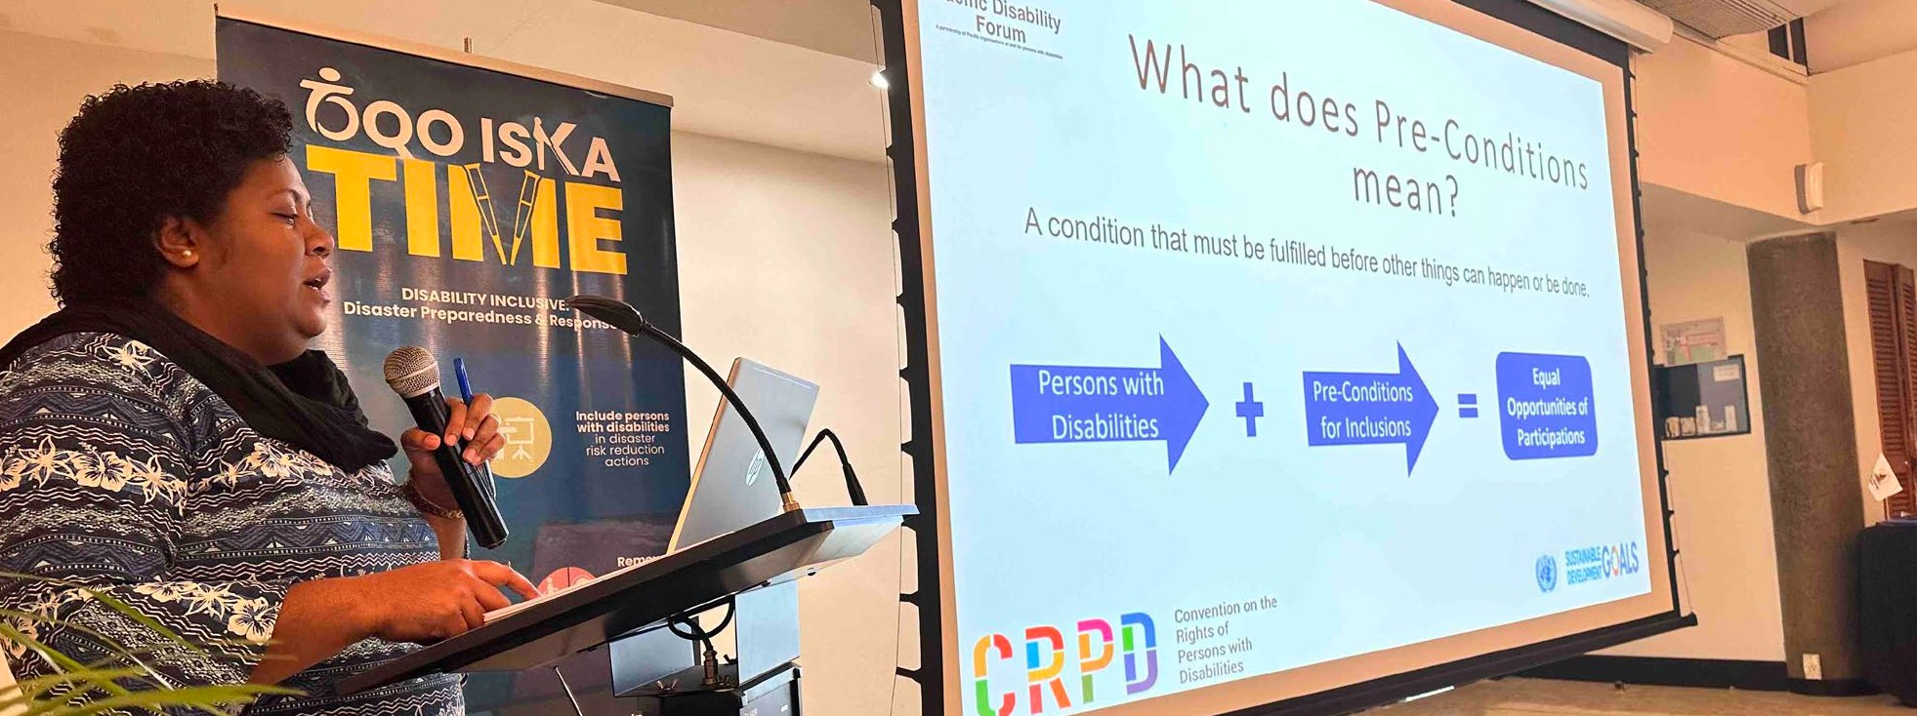


CHANGE AREA 1

Outcome (and actions) | Key Performance Indicators (KPI)
1.1 Improved operational functioning of PDF and OPDs
- Work to enhance resources available to PDF and OPDs for funding applications to appropriate donors.  - Work to enhance coordination mechanisms of PDF and OPDs.  - Ensure the engagement of external partners in resourcing specific impairments OPDs particularly in DRM, Early Warnings for All (EW4ALL), Climate Change (CC) and Heath Pandemics. | - Degree to which there is improved resources through applications.  - Degree to which there is strengthened coordination mechanisms between PDF and OPDs.  - Number of strengthened coordination mechanisms between PDF and OPDs.  - Number of engaged external partners that resource specific impairments for OPDs  in Early Warnings for All, CC and Heath Pandemic.  - Degree to which there is strengthened engagement of external partners  for targeted resourcing of specific impairments.

Outcome (and actions) | Key Performance Indicators (KPI)
- Identify and resource the enhancement of leadership of women and young persons with disabilities and ensuring intergeneration equity of persons with disabilities particularly those with psychosocial disabilities, diverse sexual orientation, intellectual disabilities and deaf blind. | - Number of women, young persons with disabilities and intergenerational PWDs that are leading in the DRM, EW4ALL, CC and Heath Pandemic areas.  - Number of persons with disabilities that are leading particularly those with psychosocial disabilities, diverse sexual orientation, intellectual disabilities and deaf blind.  - Degree to which there is recognition and progress of the leadership of women, young persons with disabilities in DRR and climate spaces.  - Degree to which there is recognition and progress of the leadership of persons with disabilities, particularly those with psychosocial disabilities, diverse sexual orientation, intellectual disabilities and deaf blind.
1.2 Improved technical capacity of OPDs
- PDF to build capacity of OPDs in disability- inclusive Humanitarian Action, Climate Change Adaptation, and DRM.  - Strengthen the capacity of the Disability Resource Team from OPDs to understand Article 1120 and its alignment to other Articles and with SDGs in relation to DRM, EW4ALL, Climate Change and heath pandemics.  - Strengthen OPDs capacity in legal harmonisation and inclusive budgeting in relation to DRM, EW4ALL, Climate Change and heath pandemics.  - Strengthen OPD capacity and influencing to advocate for policy, budget and systems change  - Strengthen OPD capacity to understand and advocate for the preconditions to inclusion. | - Number/percentage of OPD capacity building initiatives undertaken relating to disability-inclusive Humanitarian Action, Gender-based Violence in Emergencies (GBViE), Climate Change Adaptation (CCA) and DRM.  - Number/percentage of OPD participants attending capacity building sessions and ensuring cross disability, and cross gender representation (By sex, age group and other disaggregated variables)  - Number/percentage of OPD participants attending capacity and learning events on Article 11 and its alignment to other Articles and with SDGs in relation to DRM, CC and Heath Pandemic.  - Number/percentage of OPD participants (By sex, age group and other disaggregated variables) attending capacity and learning events on legal harmonisation and inclusive budgeting in relations to DRM, EW4ALL, CC and heath pandemics.  - Number/percentage of OPD participants influencing to advocate for policy, budget and systems change

20Article 11 – Situations of risk and humanitarian emergencies
States Parties shall take, in accordance with their obligations under international law, including international humanitarian law and international human rights law, all necessary measures to ensure the protection and safety of persons with disabilities in situations of risk, including situations of armed conflict, humanitarian emergencies and the occurrence of natural disasters

Outcome (and actions) | Key Performance Indicators (KPI)
- Strengthen OPDs to ensure that gender equality and equity and issues of women and girls with disabilities are enhanced in every process of this strategy.  - Support marginalised impairments such as deaf- blind, cognitive and intellectual disabilities, and psychosocial disabilities and complex impairments  - Strengthen OPDs to ensure targeted and responsive actions for children with disabilities in DRM, EW4ALL, Climate Change and Heath Pandemics. | - Degree to which there is increased understanding of Article 11 and its alignment to other Articles and with SDGs in relation to DRM, EW4ALL, CC and Heath Pandemic.  - Number or percentage of OPDs that report having increased capacity in understanding and localising international commitments.  - Number or percentage of OPDs that report having increased understanding of legal harmonization and inclusive budgeting.  - Degree to which there is strengthened understanding by OPDs of advocating for preconditions to inclusion.  - Degree to which OPDs are finding capacity building initiatives applicable, with observable change in their technical capacity and approach to resilient development.  - Number or percentage of OPDs that undertake gender sensitive training to understand issues of women and girls with disabilities.  - Number or percentage of OPDs increasingly conduct their own gender analysis.  - Degree to which OPDs are increasingly confident in conducting their own gender- responsive training.  - Number and percentage of OPDs that report the increasing and meaningful  participation of women with disabilities in the operationalisation of their own organisation.  - Degree to which there is increased support by PDF and OPDs for marginalised impairments such as deaf- blind, cognitive and intellectual disabilities, and psychosocial disabilities  - Number of participants from marginalised impairments such as deaf- blind, cognitive and intellectual disabilities, and psychosocial disabilities, participate in cross-learning events.  - Number of capacity support activities for and by OPDs for responsive actions for children with disabilities in DRM, EW4ALL, Climate Change and Heath Pandemic.
1.3 OPDs have tools and strategies in place to influence stakeholders

Outcome (and actions) | Key Performance Indicators (KPI)
- PDF supports OPDs in developing tools to support disability inclusion in DRM, EW4ALL, Climate Change and Heath Pandemic.  - PDF support OPDs in developing evidence- based advocacy strategies to influence change at national level.  - Support targeted focus to OPDs in the North Pacific and French Pacific, to support internal capacities as a movement, including CRPD  focused advocacy. | - Number of tools developed to support disability inclusive disaster planning, response and recovery.  - Number and percentage of OPDs with evidence- based advocacy and movement building strategies on DRM, EW4ALL, CC and Heath Pandemic.  - Number and nature of occasions where North and French Pacific OPDs have increased connections and advocacy opportunities with US base and Japan, French and EU resources and donors.
- Strengthened PDF efforts in ensuring that information is simplified and translated and translations cost is embedded in the budget, to enable the meaningful participation and recognition of leadership of persons with disabilities in DRM, EW4ALL, CC and Heath Pandemic spaces. | - Number and type of accessible, informative and cost-effective translations and local-language documentation.  - Number and percentage of OPDs and members report meaningful participation in spaces for DRM, EW4ALL, CC and Heath Pandemic spaces.
1.4 Strengthened representation and diversity within the cross-disability movement
- Support gender equity and participation of women, young persons with disabilities within the cross-disability movement.  - Support OPDs to ensure that issues of children with disabilities are reflected in their programs and that organisation of parents of children with disabilities are engaged.  - Support OPDs to ensure that issues for older persons with disabilities are reflected in their programs | - Number and nature of women and children with diverse disabilities participating and contributing during all stages of the program cycle.  - Degree to which there is improved participation of women, children and older persons with disabilities in program planning, decision making, and evaluation and movement building.  - Number and nature of occasions which promote the participation of children, women, young and older persons with diverse disability within the movement.  - Number and percentage of OPDs that ensure that programs are inclusive of older persons with  disabilities.

Change Area 2: Government-led Humanitarian & Resilient Development processes (including legislation, policies, and coordination mechanisms) are fully inclusive and able to meet the needs of persons with disabilities, and those that are most impacted including those with psychosocial disabilities, women and girls with disabilities, intellectual disabilities and deaf and blind.
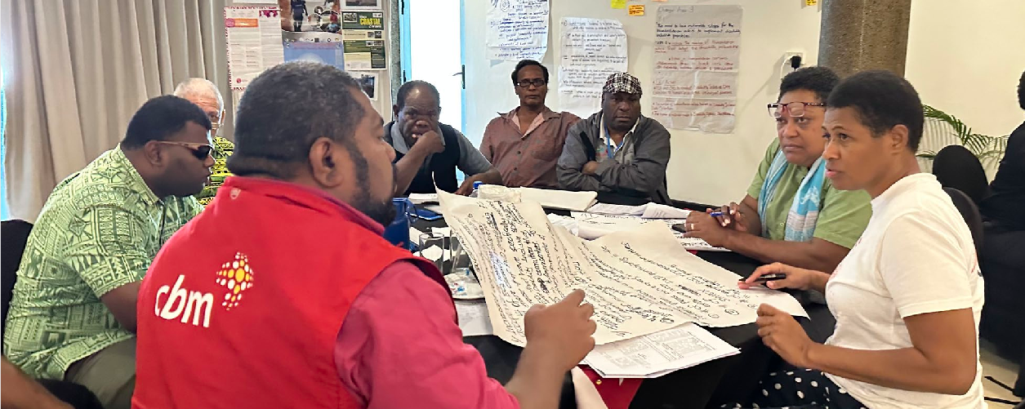


CHANGE AREA 2

Outcome (and actions) | Key Performance Indicators (KPI)
2.1 Perspectives of OPDs are represented in cluster coordination mechanisms
- PDF with OPDs to map out and ensure active participation within the cluster space.  - PDF to provide technical advice for OPDs to ensure their active participation within national cluster coordination  - PDF to ensure urgent processes are in place within the secretariat to support OPDs in responding to emergencies particularly in strengthening of OPDs to advocate for inclusive EOC and and the relevant government authority to tap into the expertise of partners  - PDF to tap into the expertise of partners such as resource mobilisation for the designing, planning, implementation and evaluation of inclusive programs in DRM, EW4ALL, CC and Health Pandemics. | - Number of regional and national cluster meetings attended by OPDs and PDF.  - Number and percentage of OPDs that report having greater influence within regional clusters in providing positive action to ensure disability inclusion.  - Number and percentage of OPDs representatives actively participating in regional and national clusters.  - Number of emergency procedures and advocacy plans in place for OPDs for emergency response.  - Number of cross-learning between partners, OPDS and PDF for resource mobilisation, and DRR and CC movement building.  - Number and type of initiatives that show strengthened partnerships in resource mobilisation between the OPDs, PDF and partners.

Outcome (and actions) | Key Performance Indicators (KPI)
2.2 Increased commitment of governments to disability- inclusive humanitarian resilient development processes
- Regional collaboration to support the partnership with development partners, UN agencies and SPC to conduct regional analysis of public policy and budgetary provisions in relation to Disability Inclusion in DRM, EW4ALL, CC and health pandemics.  - Explore ways to highlight obligation and commitment of Governments in respect of disability inclusion in disasters in line with CRPD and SDG  - Use of the regional architecture and processes as a means of mobilising goverment resources to commit and support disability-inclusive humanitarian resilient development processes.  - PDF and OPDs to rollout advocacy strategy in the Pacific, including high-level advocacy to target public policy and budget allocations.  - Implementation of national program advocacy to ensure disability inclusion at national and sub-national level. That in all advocacy processes to ensure the  highlighting of issues relating to the under- represented groups including women and young persons with disabilities. | - Degree to which there is a partnership in place between PDF with OPDs, SPC and UN agencies to complete a regional analysis.  - Number and instances of dialogue targeting national public policy and budget that result in inclusive change.  - Number and percentage of governments that are displaying gender-responsive disability-inclusive humanitarian resilient development processes.  - Number and description of national inclusive programs.  - Number and type of initiatives that highlight obligation and commitment of governments in respect of disability\- inclusion in disasters in line with CRPD and SDG.  - Number of national program advocacies that are gender-responsive and disability- inclusive.
2.3 Improved government capacity to facilitate disability-inclusive humanitarian processes
- PDF and OPDs to rollout capacity building with relevant government officials in the following areas of data collection in DRM, EW4ALL, CC and health pandemics. | - Number of national capacity building initiatives for government officials.  - Number of government officials participate in capacity building initiatives.  - Number of government officials that are embedding and implementing more disability-inclusive humanitarian approaches and processes.  - Number/type of disability-inclusive change in government responses during national disaster response processes.

Outcome (and actions) | Key Performance Indicators (KPI)
- OPDs and PDF to increase advocacy efforts on the recognition and mainstreaming of intersectional challenges faced by women and girls with disabilities including under-represented groups when developing laws and policies on DRM, EW4ALL, CC and health pandemics.  Intersectional challenges include but not limited to GBViE, SRHR, menstrual hygiene, mental health and psychosocial support, equal distribution of relief supplies. | - Number of advocacy efforts for government on intersectional challenges faced by women and girls with disabilities and under-represented groups.
- PDF in consultation with OPDs to advocate for inclusive SOPs for the implementation of national DRM, EW4ALL, CC and  health pandemic and other humanitarian emergencies. | - Number of advocacy actions for inclusive SOPs in the implementation of national DRM, EW4ALL, CC and health pandemics and other humanitarian emergencies.
- PDF in consultation with OPDs to advocate for the leadership of women and persons with disabilities to be recognised in the humanitarian space. Persons  with disabilities need to be seen and recognised as actors not only recipients of humanitarian supplies. | - Number and percentage of OPDs that advocate for the leadership of women and persons with disabilities to be recognised in the humanitarian space.
- PDF to work in partnership with relevant partners to implement international, regional initiatives and frameworks to ensure inclusion, equity and equality and resourcing e.g. revitalised PLGED, PPA, 2050 Blue Pacific Strategy etc. | - Number of partnerships on the implementation of international regional initiatives and frameworks to ensure inclusion, equity and equality and resourcing e.g. Revitalized gender  declaration, Women’s Platform for Action, Blue Pacific Strategy.
- PDF in solidarity with partners to influence funding mechanisms and national climate change programs in the Pacific. | - Number of partnerships to influence funding mechanisms.  - Degree to which funding mechanisms are influenced.

Change Area 3: Mainstream Humanitarian, Resilient Development actors have policies and practices in place to ensure full inclusion of persons with disabilities.

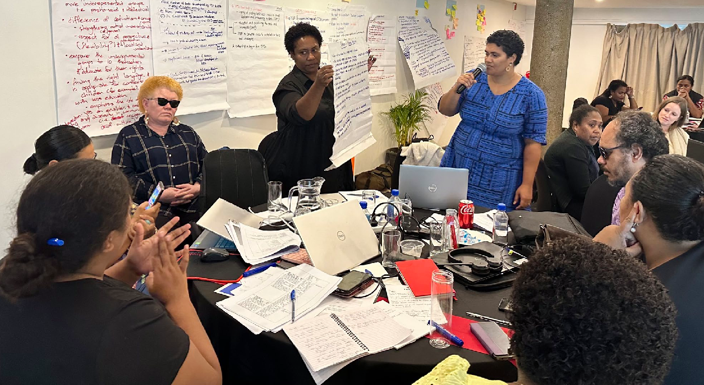


CHANGE AREA 3

Outcome (and actions) | Key Performance Indicators (KPI)
3.1 Increased commitment of resilience/humanitarian actors to disability-inclusive humanitarian resilient development practices
- Work to enhance information sharing in relation to policies and practice.  - PDF and OPDs to rollout advocacy plan in the Pacific with humanitarian partners at regional and at national level | - Number/type of gender-responsive disability-inclusive policies and practices in place by humanitarian actors.  - Number of inclusion of persons with disabilities in humanitarian resilient development policy and practice processes.  - Number and percentage of OPDs that report the increased usage of humanitarian partner advocacy plans.  - Number of national inclusive programs with humanitarian partners.  - Number of OPD pilot programs partnering with humanitarian stakeholders, to improve humanitarian partners’ practice.

Outcome (and actions) | Key Performance Indicators (KPI)
3.2 Improved capacity of regional humanitarian / resilience actors implementing inclusive humanitarian/resilience practice.
- PDF and OPDs to rollout capacity building with relevant regional and national humanitarian/ resilience partners in the following areas:  » Preconditions to inclusion and the approach in emergencies are  recognised and applied in the Pacific.  » Preconditions to inclusion in emergencies = Disability Gender-based  Violence in Emergencies. | - Number of national and regional disability inclusion capacity building initiatives for humanitarian partners.  - Number of regional and national humanitarian partners participating in disability inclusion capacity building initiatives.  - Number of humanitarian partners that report disability-inclusive change in disaster planning and response processes
- Number of humanitarian partners that report the utilisation and analysis of the Washington Group Short Set of Questions (WGSS), equality and non-discrimination in emergencies, social protection in emergencies and the role of Community Based Inclusive Development (CBID) in Emergencies
- Number of regional humanitarian actors that adopt the preconditions to inclusion approach in emergencies.
- Support the most marginalised groups,  i.e psychosocial disability, cognitive and intellectual disability, persons with deaf blindness. | - Number/type of advocacy events/occasions which promote an increased understanding and focus on psychosocial disability, cognitive and intellectual disability, persons with deaf blindness, children and older persons with disability, with OPDs.
- Localisation and socialisation of commitments (CRPD) as well as the intersection with the FRDP and PRS and the impact on regional OPDs and partners. | - Number of regional and national partners localise and socialise commitments.
- Engagement with feminist movements and women-led groups in having a feminist lens and gender-responsive praxis to strengthen focus on Disability Gender- based Violence in Emergencies (DGBViE). | - Number and percentage of OPDs that actively engage with feminist movements and adopt a gender-responsive praxis.  - Number and examples of strengthened OPD engagement with women-led groups to address and strengthen focus on DGBViE.

Change Area 4: Humanitarian, Resilient Development processes for individuals, households, communities, and churches and faith-based organisations are inclusive of persons with disabilities
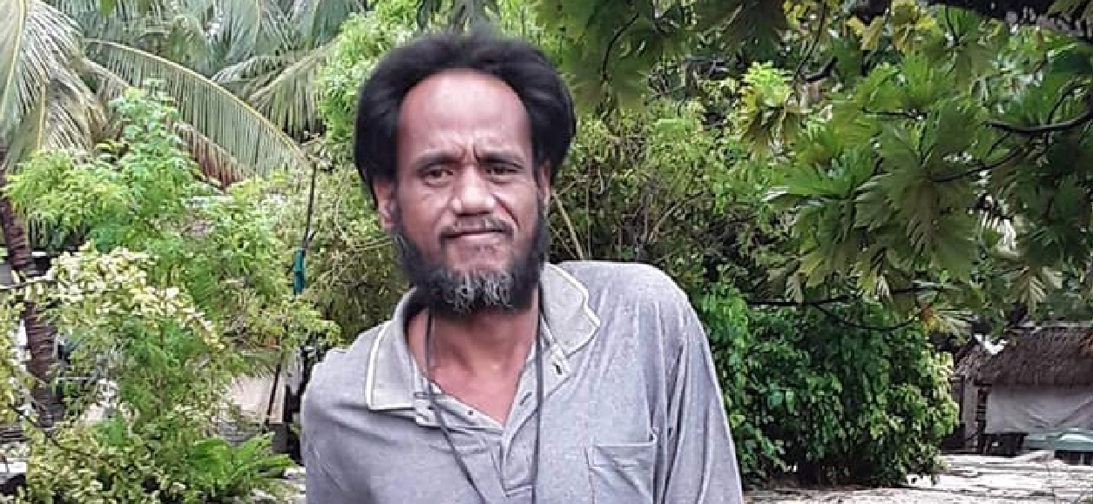


CHANGE AREA 4

Outcome (and actions) | Key Performance Indicators (KPI)
4.1 Increased collaboration between OPDs and community- based DRR and CCA programs
- PDF and OPDs to work with community- based DRR and CCA programs at national and community levels in the development of national disability-inclusive community- based disaster plans together with EW4ALL, Climate change and Heath Pandemic. aligned to national plan.  - Development of disability-inclusive community disaster/ resilience plans articulating roles of community development stakeholders, community gatekeepers, families and persons with disabilities. | - Number of community-based DRR and CCA partners that report having strengthened disability-inclusive change disaster response processes.  - Degree to which partners have strengthened response processes to be more disability-inclusive.  - Number of disability-inclusive community disaster plans developed.  - Number and percentage of ECs retrofitted or rebuilt to ensure disability inclusiveness.  - Number of PWDs going/accessing ECs  - Number and percentage of ECs that have specifically assigned spaces and disability- inclusive SOPs22  - Number/percentage of village committees that have PWD representation e.g. DRR, Education

22Reasonable Accommodation measured

Outcome (and actions) | Key Performance Indicators (KPI)
4.2 Improved capacity of community development stakeholders, community gatekeepers and families in supporting disability-inclusive practices.
- PDF and OPDs to work with humanitarian/ resilience partners to ensure meaningful participation of persons with disabilities in the community through partners programs  » Capacity building and visibility of community development stakeholders,  community gatekeepers and families in areas of:  » Capacity building of community development stakeholders’ in  preconditions to inclusion; Equality and Non-Discrimination in Emergencies; Social Protection in Emergencies; Role of CBID in Emergencies; Data collection in disasters; Supporting marginalised impairments such as deaf blind, cognitive/intellectual disabilities and psychosocial disabilities; Gender equity and children with disabilities | - Number and type of capacity building initiatives for community development stakeholders, community gatekeepers and families, to support disability-inclusive practice.  - Degree to which partners show improved capacity to support disability-inclusive practises.  - Number of people directly benefitting from attending capacity building sessions by sex, age group and other variables and disability disaggregation.  - Number of church buildings that are disability friendly  - Number/percentage of community partners that report increase in number of PWDs in church activities  - Number of DRM/ Resilience community plans that are disability-inclusive  - Number of churches and FBOs partnering with OPDs
- Ensure input of disability perspective on all areas of life in policy and service  implementation particularly in faith-based organisations | - Number of structured arrangements in place to consult with stakeholders.  - Number and type of inclusion and representation of persons with disabilities in policy and service implementation at the community level, including in faith-based organisations.
4.3 Communities develop and implement inclusive resilience plan
- Number of plans developed and implemented in collaboration with OPDs and PWDs
- Number of PWDs participating in the Simulation Exercise (SimEx) that simulates an emergency situation.
- Number of PWD representatives involved in the response planning

Change Area 5: All services and processes operating as part of Humanitarian, Resilient Development are inclusive of and accessible to persons with disabilities.
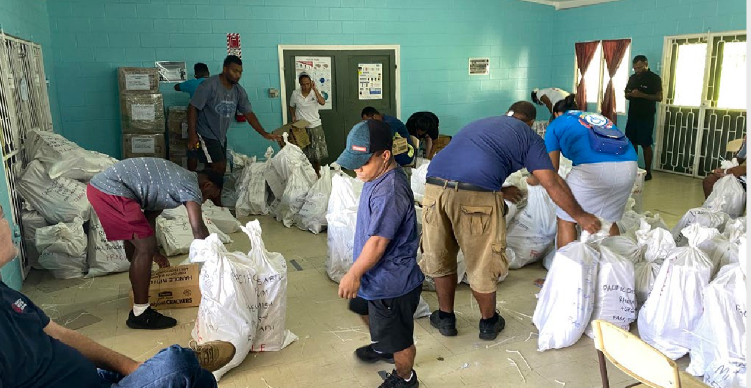



CHANGE AREA 5

Outcome (and actions) | Key Performance Indicators (KPI)
5.1 Disaster/ Climate response programs are inclusive of persons with disabilities
- Assessments on disaster and climate risk responses are inclusive of the practical, social and emotional needs of persons with disabilities.  - Post-disaster response program designs are accessible and inclusive of the needs and practicalities of persons with disabilities | - Number of needs assessments drafted and operationalised that are inclusive and relevant for PWDs  - Degree to which needs assessments are inclusive and relevant for PWDs.  - Degree to which post- disaster response program designs are inclusive and meet the needs of persons with disabilities.  - Number of persons with disabilities directly benefiting by sex, age group and other variables and disability  disaggregation) and being included in post- disaster response with their needs being met and services are accessible.

Outcome (and actions) | Key Performance Indicators (KPI)
Adoption of Disability-inclusive Policies  Development and use of a checklist by PDF to measure partner capacity to respond to persons with disability needs. | - Number and percentage of actors/ organisations adopting disability-inclusive policies.  - Number of services that are accessible to information.  - Degree to which there is an increase in accessibility to information, communication, and support services.  - Degree to which there is inclusion and representation of PWDs in decision-making processes.
Increased Awareness and Acceptance of Disability Inclusion: | - Number and percentage of emergency evacuation centres and education centres with disability inclusion.  - Number of persons with disabilities accessing these centres.  - Number and percentage of centres with specific spaces for accessibility. Presence of SOPs and reasonable accommodation measures for disability.  - Number and percentage of village committees with persons with disabilities representation.
Faith-Based Organisation Engagement | - Number/percentage of church buildings that are disability friendly.  - Degree to which there is increase in church and FBO partnerships with OPDs in community development and resilience implementation  - Number of plans developed and implemented with organisations of persons with disability  - Number of persons with disabilities participating in simulation exercises (SimEx).  - Number of persons with disabilities representatives involved in response plans.  - Number of persons with disabilities in leadership positions in faith-based organisations.

Change Area 6: Disability-inclusive approaches to Humanitarian, Resilient Development are based on evidence drawn from disability-inclusive research and MEL processes
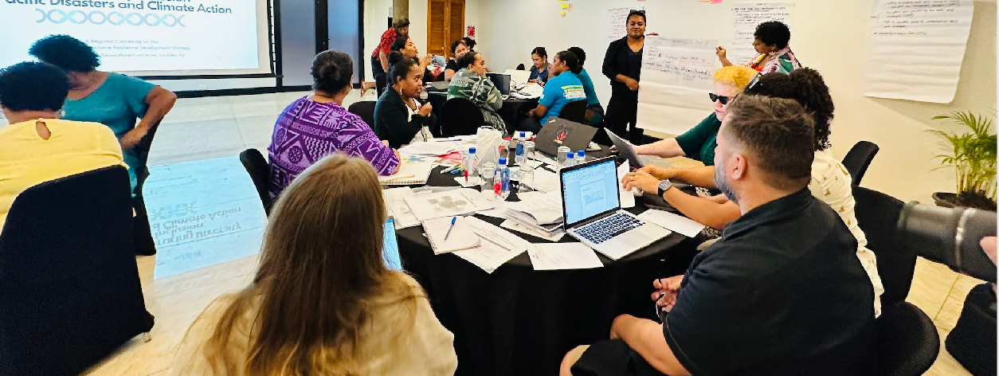


CHANGE AREA 6

Monitoring, Evaluation and Learning (MEL).
The MEL Plan supports reporting towards the 2035 vision and monitors progress towards the six outcomes and thematic change areas. To create change in the various areas, qualitative and quantitative (disability disaggregated and other variables) data will need to be collected, strengthened and shared. It is essential to ensure the meaningful participation of persons with disabilities, with participation across the cross- disability movement, at all levels in these processes, including as data collectors, informants and in research teams. Capturing the different experiences through the various ways of storytelling will show the change and provide evidence for good and best practice. Regular self-assessments to measure the work of OPDs will also be done.
The Plan will also detail and assess the progress, results and impact against commitments such as that in the 2050 Strategy, the current and upcoming Pacific Framework for the Rights of Persons with Disabilities (PFRPD), and the revitalised Pacific Leaders Gender Equality Declaration.
OPDs will play a critical role in this change area by identifying and prioritising specific research areas based on gaps in the evidence base needed to support advocacy and programming in disability-inclusive resilient development. OPDs will also provide advice on inclusive methodologies and processes and participate directly in research activities where these align with OPDs’ priorities. Drawing too on work with partners, the MEL plan is to cover reporting on Preconditions, Inclusion and Participation.
The 2035 strategy is to undergo annual reviews and reporting, with a mid-term evaluation, that will guide the implementation of the remaining five years of the strategy. Reporting will be coordinated by the PDF. The detailed MEL Plan will be set out in a supplementary MEL document. It will be guided by the seven key principles of this Strategy and, as far as is practicable, the four standards of the PRS3.

22Such as Pacific Women Lead (PWL), https://hrsd.spc.int/sites/default/files/2024-04/PWL-Guidance%20Note-FINAL-15%20Mar%20 2024.pdf
23-24four standards of resilience of Integrate, Include, Inform and Sustain.

Outcome (and actions) | Key Performance Indicators (KPI)
6.1 Evidence is collected to support and inform learning and action on disability-inclusive approaches to humanitarian resilient development locally and regionally.
- Evidence is built on disability-inclusive approaches to humanitarian and resilient development.  - Relevant and practical research and evaluation undertaken, and evidence drawn is inclusive of persons with disabilities.  - Post-disaster response program designs are accessible and inclusive of the needs and practicalities of persons with disabilities. | - Number of mechanisms in place to assess the relevance and practicality of research and evaluation for PWDs.  - Degree to which there are improved responses on disability-inclusive approaches.  - Degree to which M&E is undertaken and lessons-learnt operationalised  - Number and percentage of OPDs and PDF that • document, report and share lessons learned on disability-inclusive approaches to humanitarian resilient development.  - Degree to which there is timely, practical research and evaluation conducted, which contributes to building the knowledge base on disability-inclusive humanitarian resilient development.

iEuropean Commission .
iiCBM Global IAG. (2022). ‘Our Lessons: An approach to disability-inclusive disaster risk reduction based on consultations with persons with disabilities in the asia and pacific region.
iiiibid
ivExcerpt from Submission High-level Political Forum 2019 Submission Paper by the Stakeholder Group of Persons with Disabilities vPDF – Pacific Disability Forum. (2022). Disability and Climate Change in the Pacific: Findings from Kiribati, Solomon Islands, and Tuvalu’. viCBM Global. 2022. ‘Our Lessons: An Approach to Disability-Inclusive Disaster Risk Reduction Based on Consultations with Persons with disabilities in the Asia and Pacific Region’
viiPacific Disability Forum (2022) Disability and Climate Change in the Pacific: Findings from Kiribati, Solomon Islands and Tuvalu.

